TECHNOLOGICAL INSTITUTE OF THE PHILIPPINES
938 Aurora Blvd. Cubao, Quezon City

In partial fulfillment of the requirements for
Information Management – ITE014

Project Compilation
AMC CoopMart: A Membership-Based Digital Grocery Cooperative System
Group Project

Submitted by:
Kalaw, James Andre L.
Detera, Juliana Ysabel D.C.
Ituralde, Josh Andrei A.
Semilla, Mia Ysabel R.
Palijado, Jennard Joseph R.

DS22S1

Submitted to:
Dr. Rosmina Joy Cabautan
Instructor

April 2026
- Company Background
The AMC Cooperative Store is a small, community-based grocery outlet in Quezon City operating under a cooperative model, where members collectively own and manage the business to provide affordable goods and shared economic benefits. Like most cooperatives in the Philippines, it is typically registered under the Cooperative Development Authority, and its operations are supported not only by its local members but also by a broader network of cooperatives across Metro Manila, which contribute through shared resources, membership systems, and cooperative federations that strengthen inter-coop collaboration and sustainability.
The system will be implemented using Oracle 19c SQL to manage member records, product inventory, orders, payments, delivery options, profit distribution, and member engagement.

- Problem Statement
The management of cooperative operations, particularly in community-based grocery stores, often relies on manual or fragmented systems that create inefficiencies in handling member records, product inventory, orders, payments, and delivery processes. These limitations can lead to data inconsistencies, delays in transaction processing, and difficulty in tracking essential business activities. As a result, cooperatives may struggle to maintain accurate records, ensure transparency, and provide timely and reliable services to their members.
Furthermore, the absence of a centralized and integrated database system weakens the cooperative’s ability to manage profit distribution and sustain active member engagement. Without an organized system, monitoring financial performance and member participation becomes challenging, which can affect decision-making and overall operational efficiency. Therefore, there is a need to develop a comprehensive database-driven system using Oracle 19c SQL that streamlines operations, improves data accuracy, enhances transparency, and supports better management of cooperative activities.

- Project Description
AMC CoopMart is a database-driven cooperative grocery management system designed to streamline operations and enhance member experience using Oracle 19c SQL. The system utilizes a compiled cooperative dataset composed of multiple tables such as Member, Product, Orders, Payments, Delivery, Dividend Payout, and Engagement records. Each module is directly mapped to structured attributes (e.g., member_id, product_id, order_id) to ensure data consistency, integrity, and efficient relational database management.
The system will allow:
Member Management (Member Table)
Stores and manages member information using attributes such as member_id, name, contact details, membership status, and share capital contribution, ensuring proper identification and ownership tracking within the cooperative.
Product Inventory Management (Product Table)
Maintains product records including product_id, product_name, category, price, and stock_quantity, allowing real-time inventory monitoring and updates.
Order Processing (Orders Table)
Handles transactions using order_id, member_id, order_date, total_amount, and order_status, linking members to their purchases and maintaining a complete transaction history.
Payment Management (Payments Table)
Records financial transactions through payment_id, order_id, payment_method, payment_status, and payment_date, supporting digital payments like GCash and bank transfers with verification tracking.
Delivery and Pickup System (Delivery Table)
Manages logistics using delivery_id, order_id, delivery_type, delivery_status, and delivery_date, enabling members to choose between pickup or delivery with status monitoring.
Profit Distribution System (Dividend/Payout Table)
Tracks cooperative earnings and member benefits using fields like member_id, total_profit_share, dividend_amount, and payout_method, ensuring transparent and accurate profit allocation.
Member Engagement Module (Engagement Table)
Captures participation through engagement_id, member_id, activity_type (e.g., votes, suggestions), feedback, and engagement_date, allowing analysis of member involvement and support for cooperative decision-making.

- Project Objectives (General Objective - Specific Objectives)

General Objective
To design and implement AMC CoopMart, a database-driven cooperative grocery management system using Oracle 19c SQL that efficiently manages member records, inventory, transactions, and cooperative services while enhancing transparency, operational efficiency, and member engagement.

Specific Objectives
- To develop a member management system that records and maintains accurate member information and share capital contributions.
- To create a product inventory system that monitors stock levels, pricing, and product details in real time.
- To implement an order processing module that allows members to browse products, place orders, and track transactions.
- To design a payment management system that supports digital payment methods and ensures secure and verified transactions.
- To establish a delivery and pickup system that enables members to select convenient order fulfillment options with tracking features.
- To develop a profit distribution module that calculates and allocates dividends, cashback, and other member benefits accurately.
- To integrate a member engagement module that allows participation in voting, feedback, and product suggestions.
- To ensure data integrity, security, and consistency through proper database design and relational structure in Oracle 19c SQL.

- Significance of the Study
The development of AMC CoopMart provides a structured and centralized database system that directly addresses inefficiencies in managing cooperative grocery operations such as fragmented member records, inaccurate inventory tracking, and unorganized transaction processing. By integrating modules for members, products, orders, payments, delivery, and profit distribution into a single Oracle 19c SQL database, the system ensures data accuracy, real-time updates, and reliable record-keeping. This enables faster transaction processing, reduces human errors, and improves transparency in financial reporting, particularly in tracking dividends and member benefits.
This study is significant to the following stakeholders:
Cooperative Members
Members benefit from a more convenient and transparent system where they can easily purchase products, track orders, make secure payments, and monitor their dividends, cashback, and participation records. It enhances their overall experience and strengthens trust in the cooperative.
Cooperative Management
The system provides management with accurate and real-time data for decision-making, including inventory levels, sales performance, and member activity. It improves operational efficiency, financial monitoring, and the ability to implement fair profit distribution.
System Administrators
Administrators benefit from a well-structured database that simplifies data management, ensures data integrity, and allows efficient monitoring of system operations, user activities, and transaction records.
Suppliers and Partners
Although indirectly involved, suppliers benefit from improved inventory tracking and demand forecasting, allowing better coordination in product supply and reducing stock shortages or overstocking.
Future Researchers and Developers
This project serves as a reference for developing database-driven systems using Oracle 19c SQL, particularly in cooperative or retail environments. It demonstrates how relational databases can be applied to solve real-world business problems.
Academic Institutions and Students
The study provides a practical example of applying database concepts, system design, and cooperative principles, making it a useful learning tool for students in information technology and data-related fields.

- Business Policies
- Membership Policy
Only registered members are allowed to access and use the system. Members must provide accurate information and contribute share capital to gain full cooperative privileges.
- Pricing and Purchasing Policy
Products are offered at member-exclusive prices. All purchases must be recorded in the system, and members are responsible for reviewing their orders before confirmation.
- Payment Policy
The system supports digital payment methods such as GCash and bank transfers. All payments must undergo verification before order processing is completed.
- Order Fulfillment Policy
Members may choose between pickup and delivery options. Delivery schedules and status updates must be followed as indicated in the system.
- Profit Distribution Policy
Dividends, cashback, and other benefits are distributed based on member participation, share capital, and recorded transactions, ensuring fairness and transparency.
- Data Privacy and Security Policy
All member and transaction data are securely stored and managed. Unauthorized access, modification, or misuse of data is strictly prohibited.
- Member Engagement Policy
Members are encouraged to participate in voting, feedback, and product suggestions. Decisions made through the system reflect the collective interest of the cooperative.

- System Analysis Design

VII.a. Entity Relationship Diagram
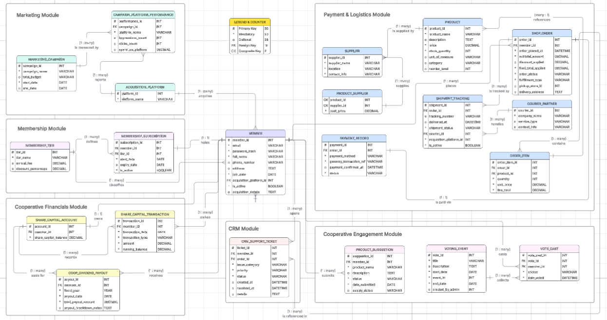

VII.b. Context Diagram
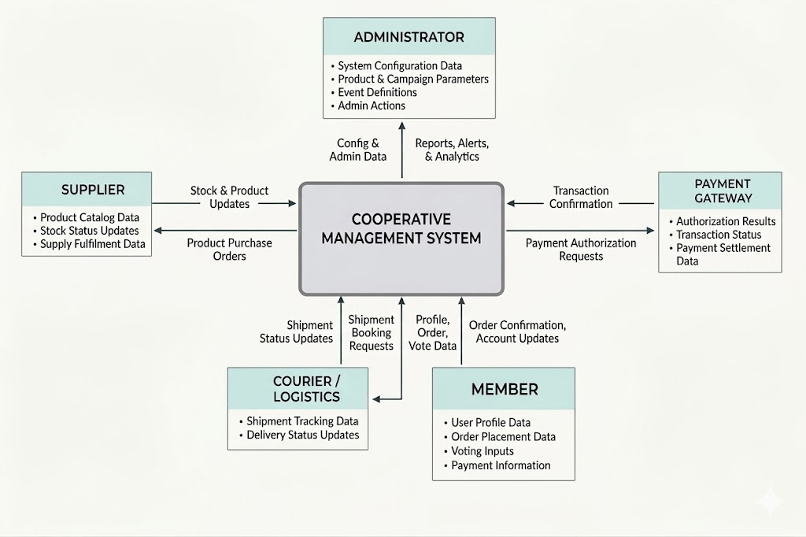

VII.c. Data Flow Diagram
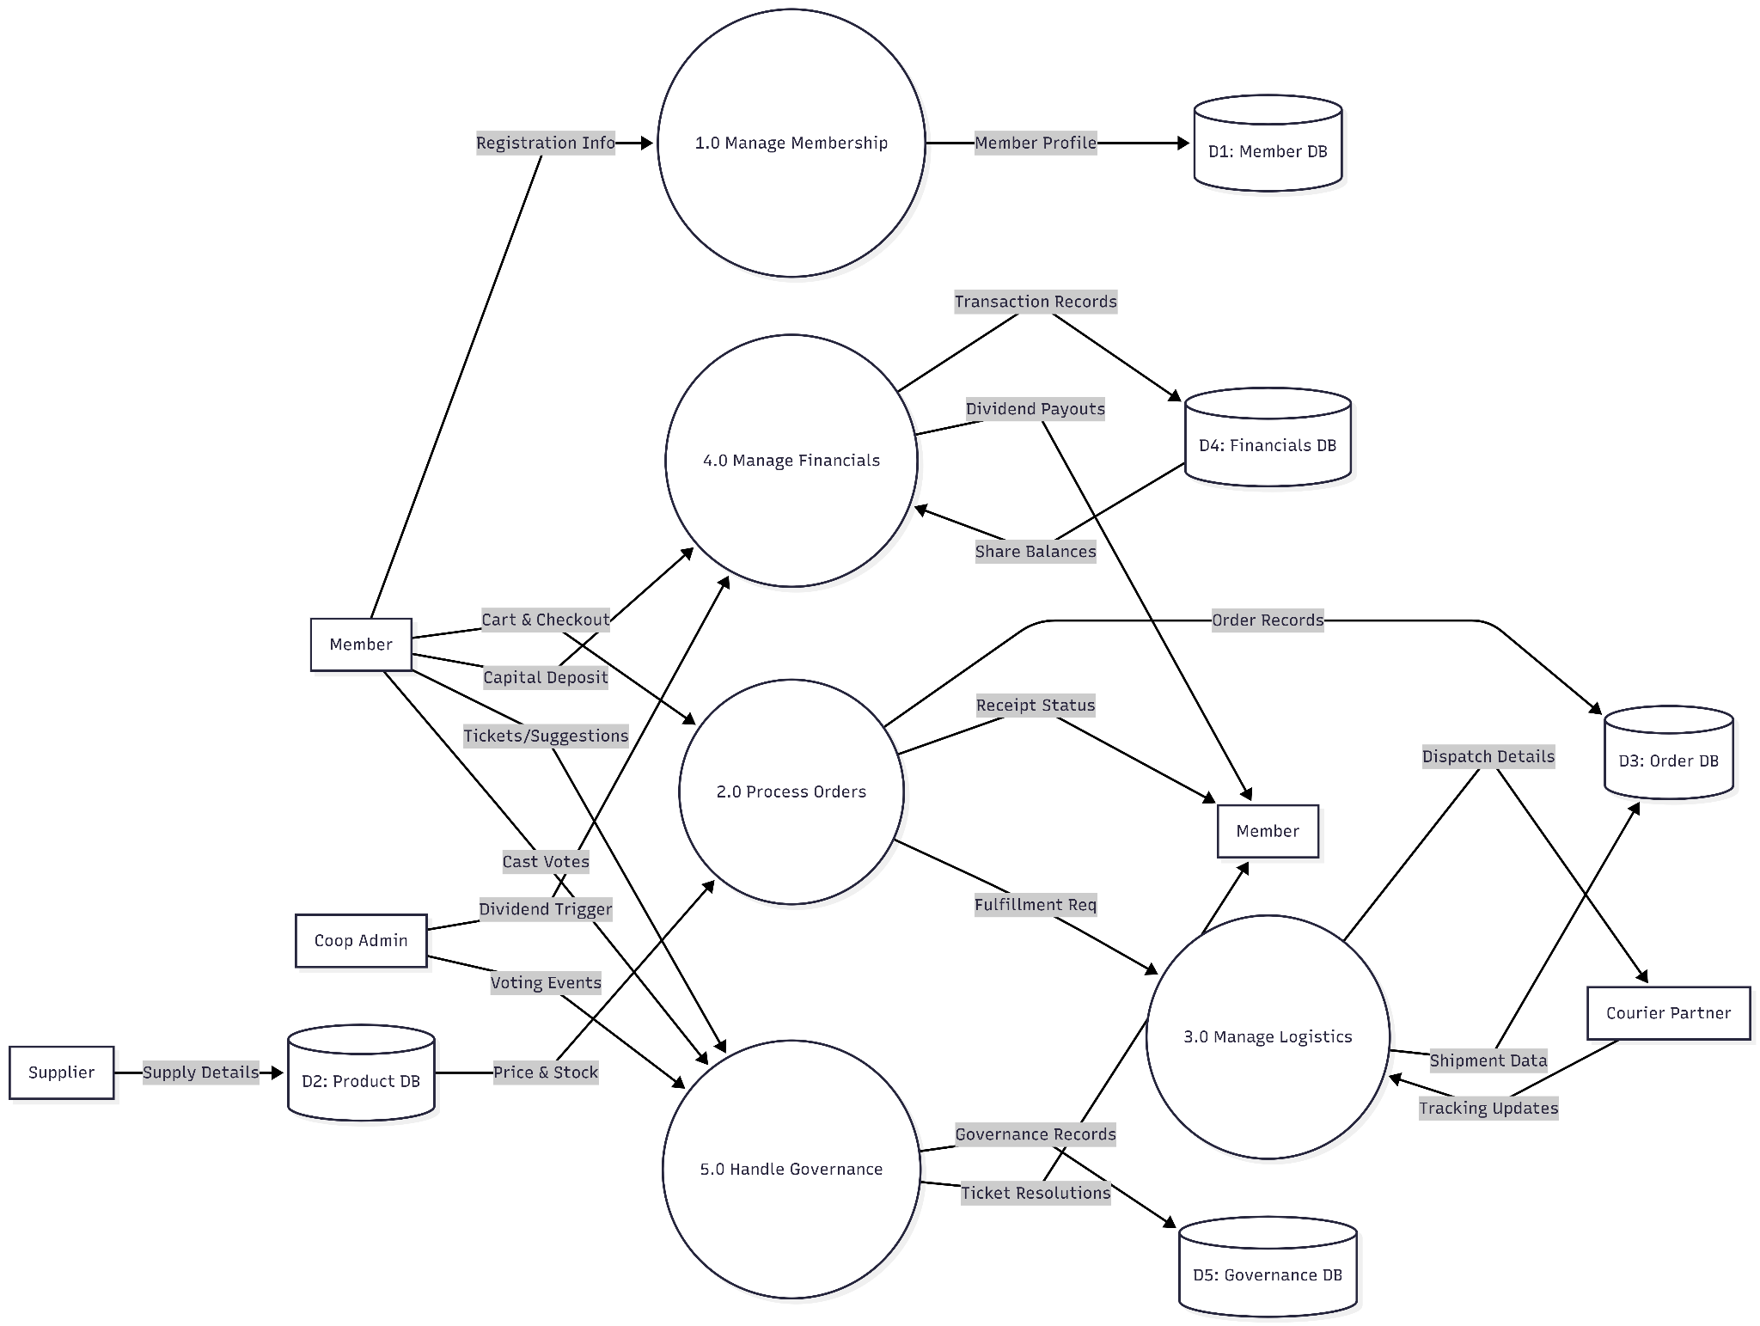

VII.d. Database Design/Dictionary/Schema

MEMBERSHIP MODULE

TABLE 1 — MEMBER
Column Name | Data Type | Not Null? | Constraints | Sample Value
member_id | INT | YES | PK, AUTO_INCREMENT | 101
email | VARCHAR(150) | YES | UNIQUE | juan@email.com
password_hash | VARCHAR(255) | YES | NOT NULL | hashed_pw_123
full_name | VARCHAR(120) | YES |  | Juan Dela Cruz
phone_number | VARCHAR(20) | NO | UNIQUE | 09123456789
address | TEXT | NO |  | Quezon City
join_date | DATE | YES | DEFAULT CURRENT_DATE | 2025-01-15
acquisition_platform_id | INT | NO | FK → Acquisition_Platform | 2
is_active | BOOLEAN | YES | DEFAULT TRUE | 1 (TRUE)
acquisition_details | TEXT | NO |  | Ad Campaign

TABLE 2 — MEMBERSHIP_TIER
Column Name | Data Type | Not Null? | Constraints | Sample Value
tier_id | INT | YES | PK | 1
tier_name | VARCHAR(50) | YES |  | Gold
annual_fee | DECIMAL(10,2) | YES |  | 1200.00
discount_percentage | DECIMAL(5,2) | YES |  | 5.00

TABLE 3 — MEMBERSHIP_SUBSCRIPTION
Column Name | Data Type | Not Null? | Constraints | Sample Value
subscription_id | INT | YES | PK | 11
member_id | INT | YES | FK → Member | 101
tier_id | INT | YES | FK → Membership_Tier | 1
start_date | DATE | YES |  | 2025-01-01
expiry_date | DATE | YES |  | 2026-01-01
is_active | BOOLEAN | YES | DEFAULT TRUE | 1 (TRUE)

MARKETING MODULE

TABLE 4 — ACQUISITION_PLATFORM
Column Name | Data Type | Not Null? | Constraints | Sample Value
platform_id | INT | YES | PK | 2
platform_name | VARCHAR(100) | YES |  | Facebook

TABLE 5 — MARKETING_CAMPAIGN
Column Name | Data Type | Not Null? | Constraints | Sample Value
campaign_id | INT | YES | PK | 20
campaign_name | VARCHAR(120) | YES |  | Back-to-School Promo
total_budget | DECIMAL(12,2) | YES |  | 50000.00
start_date | DATE | YES |  | 2025-05-01
end_date | DATE | YES |  | 2025-05-30

TABLE 6 — CAMPAIGN_PLATFORM_PERFORMANCE
Column Name | Data Type | Not Null? | Constraints | Sample Value
performance_id | INT | YES | PK | 1
campaign_id | INT | YES | FK → Marketing_Campaign | 20
platform_name | VARCHAR(100) | YES |  | Facebook
impressions_count | INT | YES |  | 10000
clicks_count | INT | YES |  | 850
spend_on_platform | DECIMAL(12,2) | YES |  | 12000.00

PAYMENT & LOGISTICS MODULE

TABLE 7 — PRODUCT
Column Name | Data Type | Not Null? | Constraints | Sample Value
product_id | INT | YES | PK | 501
product_name | VARCHAR(120) | YES |  | Rice 5kg
description | TEXT | NO |  | Premium rice
price | DECIMAL(10,2) | YES |  | 250.00
stock_quantity | INT | YES |  | 200
unit_of_measure | VARCHAR(20) | YES |  | bag
category | VARCHAR(80) | YES |  | Grocery
reorder_level | INT | YES |  | 30

TABLE 8 — SUPPLIER
Column Name | Data Type | Not Null? | Constraints | Sample Value
supplier_id | INT | YES | PK | 77
supplier_name | VARCHAR(150) | YES |  | ABC Rice Supply
location | VARCHAR(150) | NO |  | Bulacan
contact_info | VARCHAR(150) | NO | UNIQUE | 0912333333

TABLE 9 — PRODUCT_SUPPLIER
Column Name | Data Type | Not Null? | Constraints | Sample Value
product_id | INT | YES | PK/FK → Product | 501
supplier_id | INT | YES | PK/FK → Supplier | 77
cost_price | DECIMAL(10,2) | YES |  | 210.00
(Composite PK: product_id + supplier_id)

TABLE 10 — SHOP_ORDER
Column Name | Data Type | Not Null? | Constraints | Sample Value
order_id | INT | YES | PK | 9001
member_id | INT | YES | FK → Member | 101
order_placed_at | DATETIME | YES |  | 2025-06-01 10:00
subtotal_amount | DECIMAL(12,2) | YES |  | 500.00
discount_applied | DECIMAL(12,2) | YES |  | 20.00
final_total_applied | DECIMAL(12,2) | YES |  | 480.00
order_status | VARCHAR(50) | YES |  | Paid
fulfillment_type | VARCHAR(50) | YES |  | Delivery
pickup_store_id | VARCHAR | NO |  | NULL
delivery_address | TEXT | NO |  | Quezon City

TABLE 11 — ORDER_ITEM
Column Name | Data Type | Not Null? | Constraints | Sample Value
order_item_id | INT | YES | PK | 1
order_id | INT | YES | FK → Shop_Order | 9001
product_id | INT | YES | FK → Product | 501
quantity | INT | YES |  | 2
unit_price | DECIMAL(10,2) | YES |  | 250.00
line_total | DECIMAL(12,2) | YES |  | 500.00

TABLE 12 — PAYMENT_RECORD
Column Name | Data Type | Not Null? | Constraints | Sample Value
payment_id | VARCHAR | YES | PK | X7B9Q2
order_id | INT | YES | FK → Shop_Order  UNIQUE | 9001
payment_method | VARCHAR(50) | YES |  | GCash
gateway_transaction_ref | VARCHAR(150) | NO | UNIQUE | GC123ABC
payment_confirmed_at | DATETIME | NO |  | 2025-06-01 10:05
status | VARCHAR(40) | YES |  | Confirmed

TABLE 13 — SHIPMENT_TRACKING
Column Name | Data Type | Not Null? | Constraints | Sample Value
shipment_id | VARCHAR(30) | YES | PK | S9A2F1
order_id | INT | YES | FK → Shop_Order | 9001
courier_id | INT | YES | FK → Courier_Partner | 12
tracking_number | VARCHAR(120) | YES | UNIQUE | JNT123456
dispatched_at | DATETIME | NO |  | 2025-06-02
delivered_at | DATETIME | NO |  | 2025-06-03
shipment_status | VARCHAR(50) | YES |  | Delivered

TABLE 14 — COURIER_PARTNER
Column Name | Data Type | Not Null? | Constraints | Sample Value
courier_id | INT | YES | PK | 12
company_name | VARCHAR(120) | YES |  | J&T Express
service_type | VARCHAR(80) | YES |  | Standard
contact_info | VARCHAR(120) | NO |  | hotline

COOPERATIVE ENGAGEMENT MODULE

TABLE 15 — PRODUCT_SUGGESTION
Column Name | Data Type | Not Null? | Constraints | Sample Value
suggestion_id | INT | YES | PK | 1
member_id | INT | YES | FK → Member | 101
product_name | VARCHAR(120) | YES |  | Cooking Oil
description | TEXT | NO |  | Suggest bulk buying
status | VARCHAR(50) | YES |  | Pending
date_submitted | DATE | YES |  | 2025-04-10
supply_status | VARCHAR(50) | NO |  | Approved

TABLE 16 — VOTING_EVENT
Column Name | Data Type | Not Null? | Constraints | Sample Value
vote_id | INT | YES | PK | 10
title | VARCHAR(150) | YES |  | Add New Supplier
description | TEXT | NO |  | Members vote
start_date | DATE | YES |  | 2025-05-01
end_date | DATE | YES |  | 2025-05-07
created_by_admin | INT | YES |  | 1

TABLE 17 — VOTE_CAST
Column Name | Data Type | Not Null? | Constraints | Sample Value
vote_cast_id | INT | YES | PK | 501
vote_id | INT | YES | FK → Voting_Event | 10
member_id | INT | YES | FK → Member | 101
choice | VARCHAR(50) | YES |  | Yes
date_voted | DATETIME | YES |  | 2025-05-02

CRM MODULE

TABLE 18 — CRM_SUPPORT_TICKET
Column Name | Data Type | Not Null? | Constraints | Sample Value
ticket_id | INT | YES | PK | 77
member_id | INT | YES | FK → Member | 101
order_id | INT | NO | FK → Shop_Order | 9001
issue_category | VARCHAR(80) | YES |  | Delivery Delay
priority | VARCHAR(20) | YES |  | High
status | VARCHAR(50) | YES |  | Open
created_at | DATETIME | YES |  | 2025-06-01
resolved_at | DATETIME | NO |  | NULL
details | TEXT | NO |  | Item late

COOPERATIVE FINANCIALS MODULE

TABLE 19 — SHARE_CAPITAL_ACCOUNT
Column Name | Data Type | Not Null? | Constraints | Sample Value
account_id | INT | YES | PK | 1
member_id | INT | YES | FK → Member | 101
share_capital_balance | DECIMAL(12,2) | YES |  | 5000.00

TABLE 20 — SHARE_CAPITAL_TRANSACTION
Column Name | Data Type | Not Null? | Constraints | Sample Value
transaction_id | INT | YES | PK | 1
member_id | INT | YES | FK → Member | 101
transaction_date | DATE | YES |  | 2025-03-01
transaction_type | VARCHAR(50) | YES |  | Deposit
amount | DECIMAL(12,2) | YES |  | 1000.00
running_balance | DECIMAL(12,2) | YES |  | 5000.00

TABLE 21 — COOP_DIVIDEND_PAYOUT
Column Name | Data Type | Not Null? | Constraints | Sample Value
payout_id | INT | YES | PK | 1
member_id | INT | YES | FK → Member | 101
fiscal_year | NUMBER(4) | YES |  | 2025
payout_date | DATE | YES |  | 2026-01-10
total_payout_amount | DECIMAL(12,2) | YES |  | 850.00
payout_breakdown_notes | TEXT | NO |  | Based on shares

Descriptions:

MEMBERSHIP MODULE
Manages membership tiers, subscriptions, and member records.

Table 1: MEMBER
Table Purpose: Stores personal and account details of cooperative members.
Attributes:
member_id – Unique identifier of the member.
email – Used for login and communication.
password_hash – Stores encrypted password.
full_name – Member’s full name.
phone_number – Member’s contact number.
address – Member’s residential address.
join_date – Date the member registered.
acquisition_platform_id – Platform where member came from.
is_active – Indicates if the member account is active.
acquisition_details – Additional information about the platform.
Relationships:
acquisition_platform_id (many : 1) ACQUISITION_PLATFORM → (0..many : 1)
Many members may come from one platform, but each member may reference one platform.
member_id (1 : many) SHOP_ORDER → (0..many : 1)
One member may place many orders, but each order belongs to one member.
member_id (1 : many) PRODUCT_SUGGESTION → (0..many : 1)
One member may submit many suggestions, but each suggestion belongs to one member.
member_id (1 : many) VOTE_CAST → (0..many : 1)
One member may cast many votes, but each vote belongs to one member.
member_id (1 : many) CRM_TICKET → (0..many : 1)
One member may file many tickets, but each ticket belongs to one member.
member_id (1 : 1) SHARE_CAPITAL_ACCOUNT → (1 : 1)
Each member must have one share capital account, and each account belongs to one member.

Table 2: MEMBERSHIP_TIER
Table Purpose: Defines available membership levels and benefits.
Attributes:
tier_id – Unique identifier of the tier.
tier_name – Name of the membership level.
annual_fee – Cost of maintaining membership.
discount_percentage – Discount applied to purchases.
Relationships:
tier_id (1 : many) MEMBERSHIP_SUBSCRIPTION → (0..many : 1)
One tier may apply to many subscriptions, but each subscription references one tier.

Table 3: MEMBERSHIP_SUBSCRIPTION
Table Purpose: Tracks the membership level assigned to each member.
Attributes:
subscription_id – Unique identifier of the subscription.
member_id – Member who owns the subscription.
tier_id – Membership tier assigned.
start_date – When membership started.
expiry_date – When membership ends.
is_active – Indicates if subscription is valid.
Relationships:
member_id (many : 1) MEMBER → (0..many : 1)
Many subscriptions may belong to one member.
tier_id (many : 1) MEMBERSHIP_TIER → (0..many : 1)
Many subscriptions may reference one tier.

MARKETING MODULE
Tracks promotional campaigns and analyzes how members are acquired.

Table 4: ACQUISITION_PLATFORM
Table Purpose: Stores platforms where users are acquired.
Attributes:
platform_id – Unique identifier of the platform.
platform_name – Name of the acquisition platform.
Relationships:
platform_id (1 : many) MEMBER → (0..many : 1)
One platform can acquire many members, but each member comes from one platform.

Table 5: MARKETING_CAMPAIGN
Table Purpose: Stores marketing campaigns used to attract users.
Attributes:
campaign_id – Unique identifier of the campaign.
campaign_name – Name of the campaign.
total_budget – Allocated budget.
start_date – Campaign start date.
end_date – Campaign end date.
Relationships:
campaign_id (1 : many) CAMPAIGN_PLATFORM_PERFORMANCE → (0..many : 1)
One campaign can have multiple performance records across platforms.

Table 6: CAMPAIGN_PLATFORM_PERFORMANCE
Table Purpose: Tracks campaign performance per platform.
Attributes:
performance_id – Unique identifier.
campaign_id – Reference to campaign.
platform_id – Reference to platform.
impressions – Number of views.
clicks – Number of clicks.
spend_on_platform – Amount spent.
Relationships:
campaign_id (many : 1) MARKETING_CAMPAIGN
platform_id (many : 1) ACQUISITION_PLATFORM

PAYMENT & LOGISTICS MODULE
Handles products, orders, payments, and deliveries.

Table 7: PRODUCT
Table Purpose: Stores product information available for sale.
Attributes:
product_id – Unique identifier.
product_name – Name of product.
description – Product details.
base_price – Price before adjustments.
stock_quantity – Available stock.
category – Product category.
Relationships:
product_id (1 : many) ORDER_ITEM → (0..many : 1)
product_id (1 : many) PRODUCT_SUPPLIER → (0..many : 1)

Table 8: SUPPLIER
Table Purpose: Stores supplier information.
Attributes:
supplier_id – Unique identifier.
supplier_name – Name of supplier.
contact_info – Contact details.
Relationships:
supplier_id (1 : many) PRODUCT_SUPPLIER → (0..many : 1)

Table 9: PRODUCT_SUPPLIER
Table Purpose: Links products and suppliers (many-to-many).
Attributes:
product_id – Reference to product.
supplier_id – Reference to supplier.
cost_price – Cost from supplier.
Relationships:
product_id (many : 1) PRODUCT
supplier_id (many : 1) SUPPLIER

Table 10: SHOP_ORDER
Table Purpose: Stores customer orders.
Attributes:
order_id – Unique identifier.
customer_id – Reference to member.
order_date – Date of order.
subtotal_amount – Total price.
discount_applied – Discount used.
final_total – Final amount paid.
fulfillment_status – Order status.
pickup_store_id – Store reference (if applicable).
delivery_address – Delivery details.
Relationships:
order_id (1 : many) ORDER_ITEM → (0..many : 1)
order_id (1 : 1) PAYMENT_RECORD → (0..1 : 1)

Table 11: ORDER_ITEM
Table Purpose: Stores individual items within an order.

Attributes:
order_item_id – Unique identifier.
order_id – Reference to order.
product_id – Reference to product.
quantity – Quantity ordered.
unit_price – Price per item.
line_total – Total cost.
Relationships:
order_id (many : 1) SHOP_ORDER
product_id (many : 1) PRODUCT

Table 12: PAYMENT_RECORD
Table Purpose: Stores payment details for orders.
Attributes:
payment_id – Unique identifier.
order_id – Reference to order.
payment_method – Mode of payment.
payment_timestamp – Date/time of payment.
status – Payment status.
gateway_confirmed_at – Confirmation timestamp.
Relationships:
order_id (1 : 1) SHOP_ORDER

Table 13: SHIPMENT_TRACKING
Table Purpose: Tracks delivery status of orders.
Attributes:
shipment_id – Unique identifier.
order_id – Reference to order.
courier_id – Reference to courier.
tracking_number – Tracking code.
dispatched_at – Dispatch date.
delivered_at – Delivery date.
shipment_status – Status of shipment.
Relationships:
order_id (1 : 1) SHOP_ORDER
courier_id (many : 1) COURIER_PARTNER

Table 14: COURIER_PARTNER
Table Purpose: Stores delivery partner information.
Attributes:
courier_id – Unique identifier.
company_name – Courier name.
service_area – Coverage area.
contact_info – Contact details.
Relationships:
courier_id (1 : many) SHIPMENT_TRACKING → (0..many : 1)

COOPERATIVE ENGAGEMENT MODULE
Encourages member participation through suggestions and voting.

Table 15: PRODUCT_SUGGESTION
Table Purpose: Stores product suggestions from members.
Attributes:
suggestion_id – Unique identifier.
member_id – Reference to member.
product_name – Suggested product name.
description – Details of suggestion.
status – Approval status.
date_submitted – Submission date.
supply_status – Approval supply
Relationships:
suggestion_id (1 : many) VOTE_CAST → (0..many : 1)

Table 16: VOTING_EVENT
Table Purpose: Stores voting events for suggestions.
Attributes:
vote_id – Unique identifier.
suggestion_id – Reference to suggestion.
description – Event details.
start_date – Start of voting.
end_date – End of voting.
created_by_admin – Admin reference.
Relationships:
vote_id (1 : many) VOTE_CAST → (0..many : 1)

Table 17: VOTE_CAST
Table Purpose: Stores individual votes from members.
Attributes:
vote_id – Reference to voting event.
member_id – Reference to member.
choice – Vote choice.
date_voted – Date of vote.
Relationships:
vote_id (many : 1) VOTING_EVENT
member_id (many : 1) MEMBER

CRM MODULE
Handles member concerns and service requests.

Table 18: CRM_SUPPORT_TICKET
Table Purpose: Stores customer support concerns.
Attributes:
ticket_id – Unique identifier.
member_id – Reference to member.
order_id – Related order (optional).
issue_category – Type of issue.
priority_level – Urgency level.
status – Ticket status.
created_at – Creation date.
resolved_at – Resolution date.
Relationships:
member_id (many : 1) MEMBER
order_id (many : 1) SHOP_ORDER

COOPERATIVE FINANCIALS MODULE
Manages share capital and dividend payouts.

Table 19: SHARE_CAPITAL_ACCOUNT
Table Purpose: Stores member share capital balances.
Attributes:
account_id – Unique identifier.
member_id – Reference to member.
share_capital_balance – Total balance.
Relationships:
account_id (1 : many) SHARE_CAPITAL_TRANSACTION → (0..many : 1)

Table 20: SHARE_CAPITAL_TRANSACTION
Table Purpose: Tracks changes in share capital.
Attributes:
transaction_id – Unique identifier.
account_id – Reference to account.
transaction_date – Date of transaction.
transaction_type – Type (deposit/withdrawal).
amount – Transaction amount.
running_balance – Updated balance.
Relationships:
account_id (many : 1) SHARE_CAPITAL_ACCOUNT

Table 21: COOP_DIVIDEND_PAYOUT
Table Purpose: Stores dividend payouts to members.
Attributes:
payout_id – Unique identifier.
member_id – Reference to member.
fiscal_year – Year of payout.
total_payout_amount – Amount received.
payout_date – Date released.
payout_breakdown_notes – Additional details.
Relationships:
member_id (many : 1) MEMBER.

VII.e. Table Structure (Described each table using SQL)

CREATING AND DESCRIBING TABLES

Database Table Creation Phasing (Dependency Resolution)
The tables are created in a specific and sequential order due to Referential Integrity because tables are linked together using Foreign Keys a "child" table cannot be created until the "parent" table it references already exists.
To prevent execution errors, the database schema generation is divided into four distinct phases based on dependency levels:
Phase 1: Independent Tables (No Foreign Keys)
These are the foundational "parent" tables of the database. They hold core entity data and reference lookup values. Because they do not rely on any other tables to exist, they must be created first.
- TABLE 2 - MEMBERSHIP_TIER
- TABLE 4 - ACQUISITION_PLATFORM
- TABLE 5 - MARKETING_CAMPAIGN
- TABLE 7 - PRODUCT
- TABLE 8 - SUPPLIER
- TABLE 14 - COURIER_PARTNER
- TABLE 16 - VOTING_EVENT
Phase 2: First-Level Dependencies
These are "child" tables that rely only on the tables created in Phase 1. For example, the system cannot register a MEMBER until the ACQUISITION_PLATFORM list is already established.
- TABLE 1 - MEMBER (Relies on ACQUISITION_PLATFORM)
- TABLE 6 - CAMPAIGN_PLATFORM_PERFORMANCE (Relies on MARKETING_CAMPAIGN)
- TABLE 9 - PRODUCT_SUPPLIER (Relies on PRODUCT and SUPPLIER)
Phase 3: Second-Level Dependencies
These tables require the existence of the First-Level Dependency tables. In this system, Phase 3 primarily consists of tables that rely on the MEMBER table being fully established, as these are actions or accounts owned by those members.
- TABLE 3 - MEMBERSHIP_SUBSCRIPTION (Relies on MEMBER and MEMBERSHIP_TIER)
- TABLE 10 - SHOP_ORDER (Relies on MEMBER)
- TABLE 15 - PRODUCT_SUGGESTION (Relies on MEMBER)
- TABLE 17 - VOTE_CAST (Relies on VOTING_EVENT and MEMBER)
- TABLE 19 - SHARE_CAPITAL_ACCOUNT (Relies on MEMBER)
- TABLE 20 - SHARE_CAPITAL_TRANSACTION (Relies on MEMBER)
- TABLE 21 - COOP_DIVIDEND_PAYOUT (Relies on MEMBER)

Phase 4: Final Dependencies
These are the most interconnected tables in the database, often acting as intersection tables or deep-level transactional records. They rely on the existence of tables from Phases 1, 2, and 3. For example, an ORDER_ITEM cannot exist until both the PRODUCT (Phase 1) and the SHOP_ORDER (Phase 3) are successfully created.
- TABLE 11 - ORDER_ITEM (Relies on SHOP_ORDER and PRODUCT)
- TABLE 12 - PAYMENT_RECORD (Relies on SHOP_ORDER)
- TABLE 13 - SHIPMENT_TRACKING (Relies on SHOP_ORDER and COURIER_PARTNER)
- TABLE 18 - CRM_SUPPORT_TICKET (Relies on MEMBER and SHOP_ORDER)

MEMBERSHIP MODULE
TABLE 1 - MEMBER

CREATE TABLE MEMBER (
member_id NUMBER GENERATED BY DEFAULT AS IDENTITY PRIMARY KEY,
email VARCHAR2(150) NOT NULL UNIQUE,
password_hash VARCHAR2(255) NOT NULL,
full_name VARCHAR2(120) NOT NULL,
phone_number VARCHAR2(20) UNIQUE,
address VARCHAR2(4000),
join_date DATE DEFAULT SYSDATE NOT NULL,
acquisition_platform_id NUMBER,
is_active NUMBER(1) DEFAULT 1 NOT NULL CHECK (is_active IN (0,1)),
CONSTRAINT fk_member_platform FOREIGN KEY (acquisition_platform_id)
REFERENCES ACQUISITION_PLATFORM(platform_id)
);

DESCRIBE MEMBER;

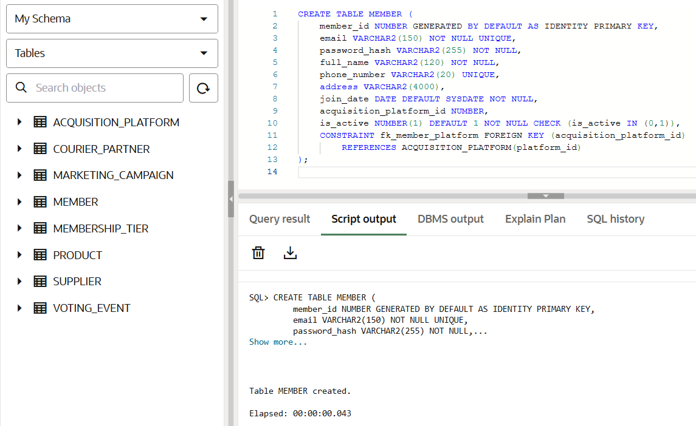
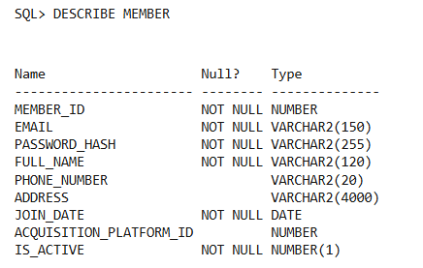

TABLE 2 - MEMBERSHIP_TIER

CREATE TABLE MEMBERSHIP_TIER (
tier_id NUMBER GENERATED BY DEFAULT AS IDENTITY PRIMARY KEY,
tier_name VARCHAR2(50) NOT NULL,
annual_fee NUMBER(10,2) NOT NULL,
discount_percentage NUMBER(5,2) NOT NULL
);

DESCRIBE MEMBERSHIP_TIER;

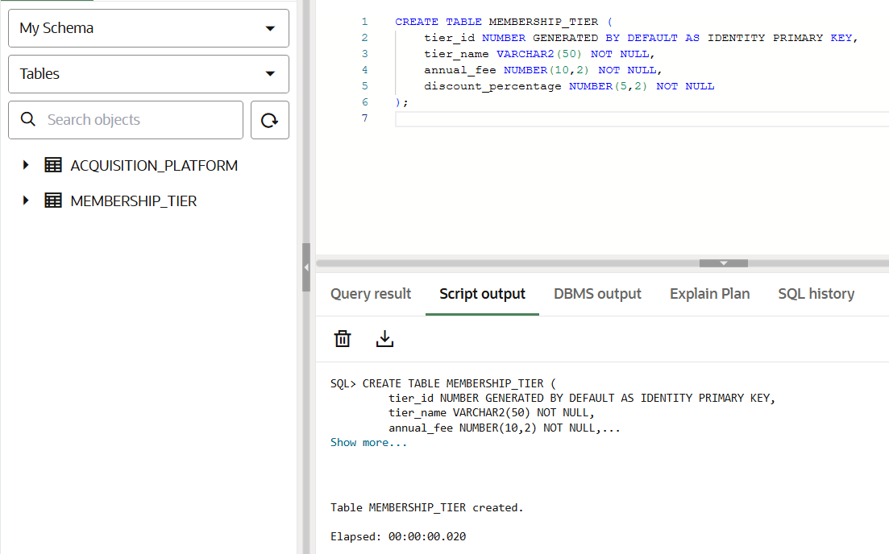
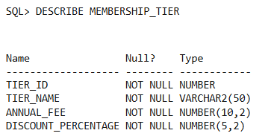

TABLE 3 - MEMBERSHIP_SUBSCRIPTION

CREATE TABLE MEMBERSHIP_SUBSCRIPTION (
subscription_id NUMBER GENERATED BY DEFAULT AS IDENTITY PRIMARY KEY,
member_id NUMBER NOT NULL,
tier_id NUMBER NOT NULL,
status VARCHAR2(30) NOT NULL,
start_date DATE NOT NULL,
expiry_date DATE NOT NULL,
is_active NUMBER(1) DEFAULT 1 NOT NULL CHECK (is_active IN (0,1)),
CONSTRAINT fk_sub_member FOREIGN KEY (member_id)
REFERENCES MEMBER(member_id),
CONSTRAINT fk_sub_tier FOREIGN KEY (tier_id)
REFERENCES MEMBERSHIP_TIER(tier_id)
);


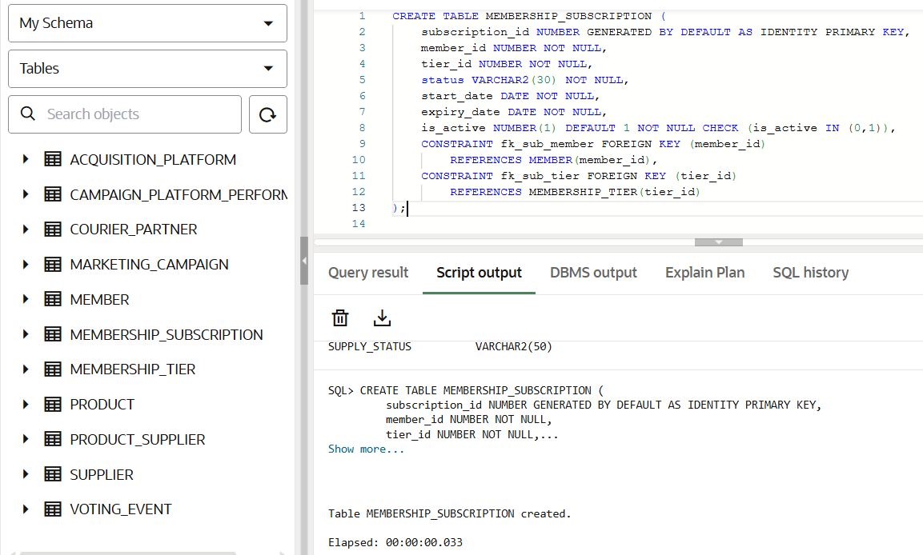

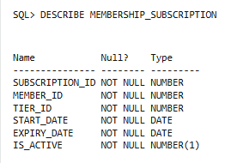

MARKETING MODULE

TABLE 4 - ACQUISITION_PLATFORM


CREATE TABLE ACQUISITION_PLATFORM (
platform_id NUMBER GENERATED BY DEFAULT AS IDENTITY PRIMARY KEY,
platform_name VARCHAR2(100) NOT NULL,
details VARCHAR2(4000)
);

DESCRIBE ACQUISITION_PLATFORM;

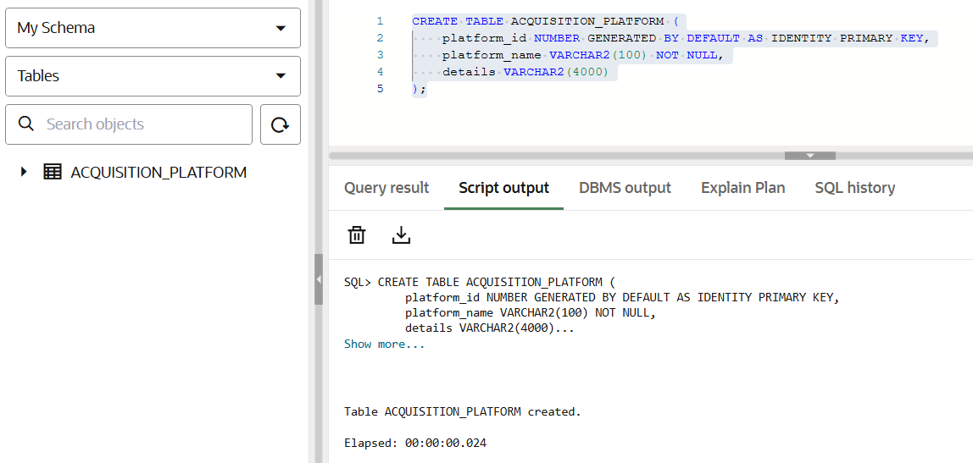
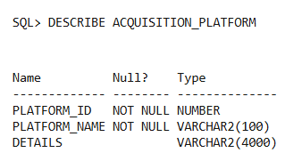

TABLE 5 - MARKETING_CAMPAIGN
CREATE TABLE MARKETING_CAMPAIGN (
campaign_id NUMBER GENERATED BY DEFAULT AS IDENTITY PRIMARY KEY,
campaign_name VARCHAR2(120) NOT NULL,
total_budget NUMBER(12,2) NOT NULL,
start_date DATE NOT NULL,
end_date DATE NOT NULL
);

DESCRIBE MARKETING_CAMPAIGN;

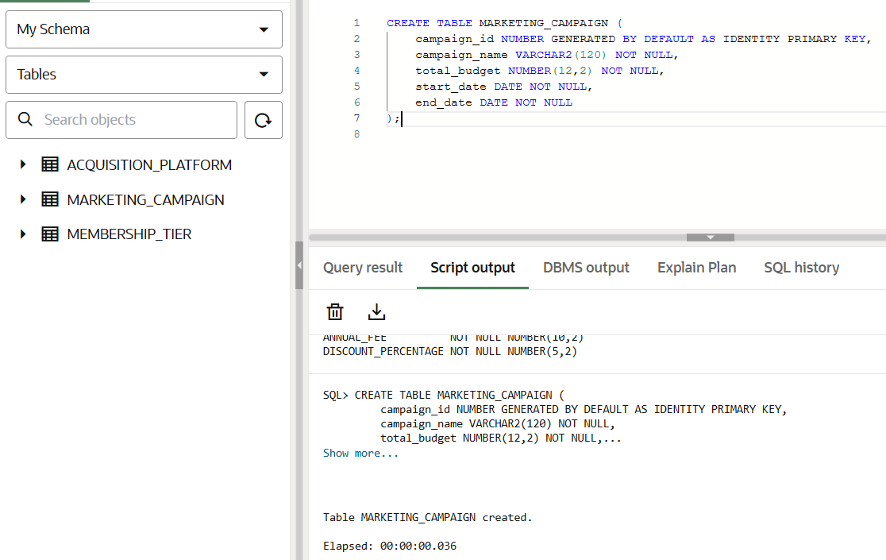
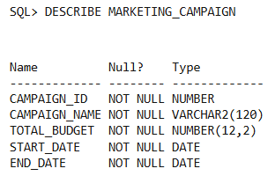

TABLE 6 - CAMPAIGN_PLATFORM_PERFORMANCE

CREATE TABLE CAMPAIGN_PLATFORM_PERFORMANCE (
performance_id NUMBER GENERATED BY DEFAULT AS IDENTITY PRIMARY KEY,
campaign_id NUMBER NOT NULL,
platform_name VARCHAR2(100) NOT NULL,
impressions_count NUMBER NOT NULL,
clicks_count NUMBER NOT NULL,
spend_on_platform NUMBER(12,2) NOT NULL,
CONSTRAINT fk_perf_campaign FOREIGN KEY (campaign_id)
REFERENCES MARKETING_CAMPAIGN(campaign_id)
);

DESCRIBE CAMPAIGN_PLATFORM_PERFORMANCE;

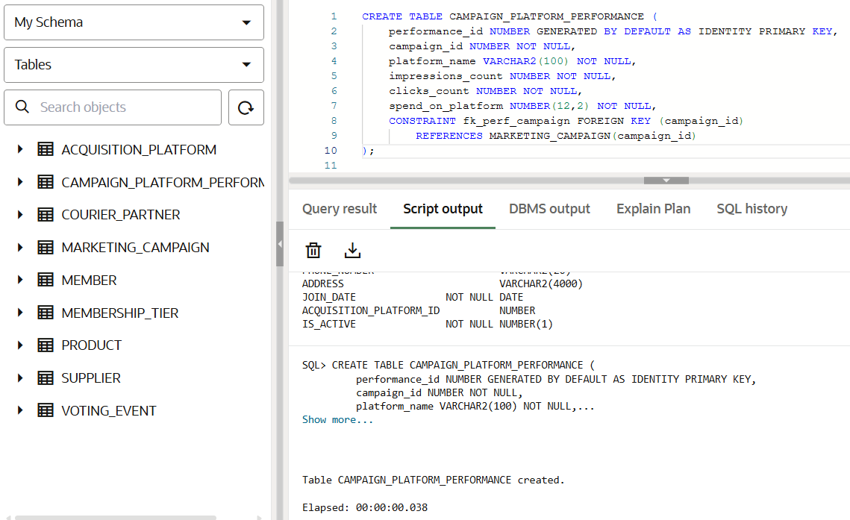
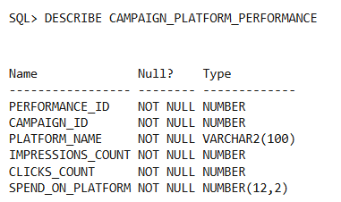

PAYMENT & LOGISTICS MODULE

TABLE 7 - PRODUCT
CREATE TABLE PRODUCT (
product_id NUMBER GENERATED BY DEFAULT AS IDENTITY PRIMARY KEY,
product_name VARCHAR2(120) NOT NULL,
description VARCHAR2(4000),
price NUMBER(10,2) NOT NULL,
stock_quantity NUMBER NOT NULL,
unit_of_measure VARCHAR2(20) NOT NULL,
category VARCHAR2(80) NOT NULL,
reorder_level NUMBER NOT NULL
);

DESCRIBE PRODUCT;

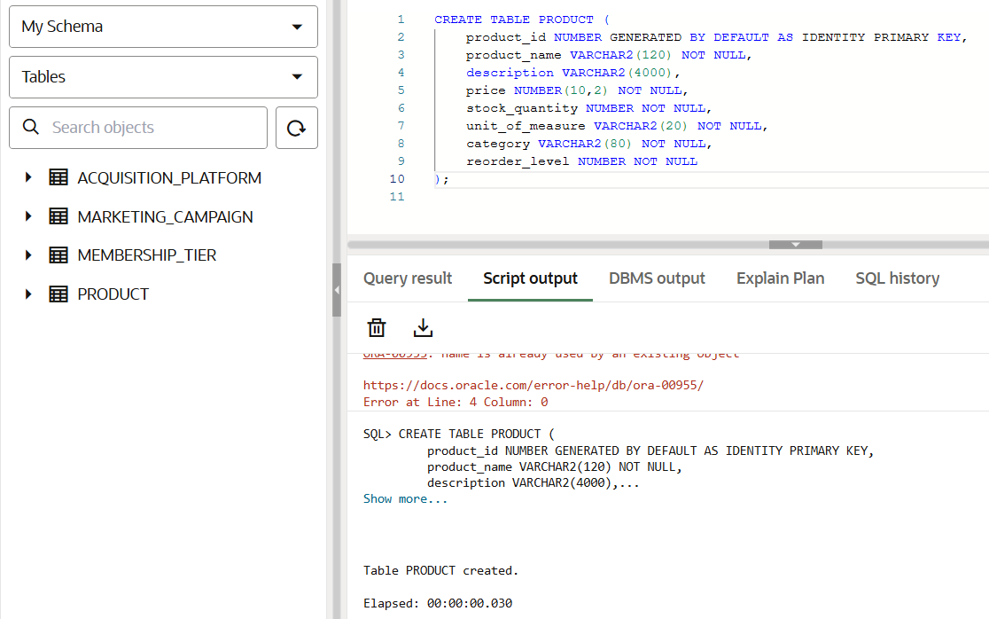
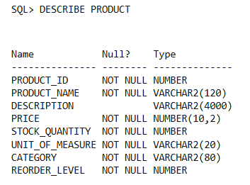

TABLE 8 - SUPPLIER

CREATE TABLE SUPPLIER (
supplier_id NUMBER GENERATED BY DEFAULT AS IDENTITY PRIMARY KEY,
supplier_name VARCHAR2(150) NOT NULL,
location VARCHAR2(150),
contact_info VARCHAR2(150) UNIQUE
);

DESCRIBE SUPPLIER;

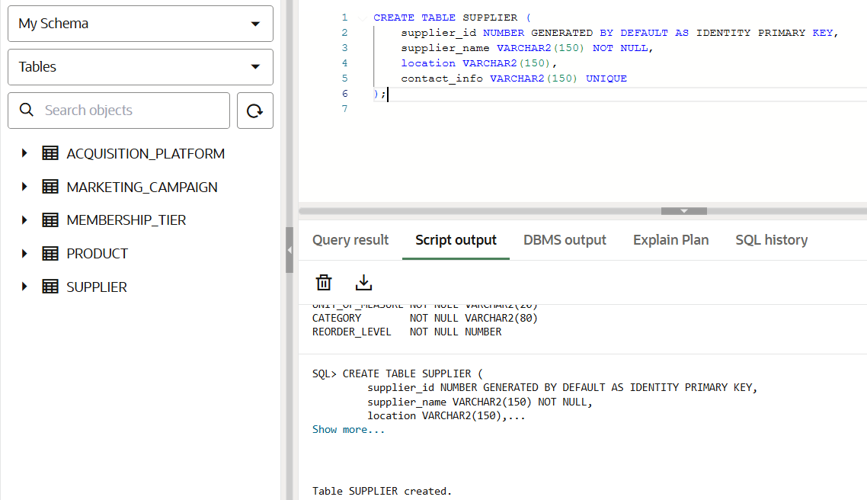
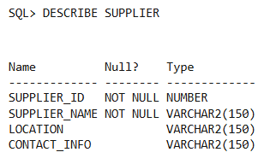

TABLE 9 - PRODUCT_SUPPLIER

Note: The PRODUCT_SUPPLIER table requires a composite key because it resolves a "many-to-many" relationship between products and suppliers. Since a single supplier can provide many different products, and a single product can be sourced from many different suppliers, neither ID is unique on its own. By combining both the product_id and supplier_id together as one key, the database ensures that each specific product-supplier pairing is unique, preventing you from accidentally creating duplicate pricing records for the same item from the same vendor.

CREATE TABLE PRODUCT_SUPPLIER (
product_id NUMBER NOT NULL,
supplier_id NUMBER NOT NULL,
cost_price NUMBER(10,2) NOT NULL,
PRIMARY KEY (product_id, supplier_id),
CONSTRAINT fk_ps_product FOREIGN KEY (product_id)
REFERENCES PRODUCT(product_id),
CONSTRAINT fk_ps_supplier FOREIGN KEY (supplier_id)
REFERENCES SUPPLIER(supplier_id)
);

DESCRIBE PRODUCT_SUPPLIER;

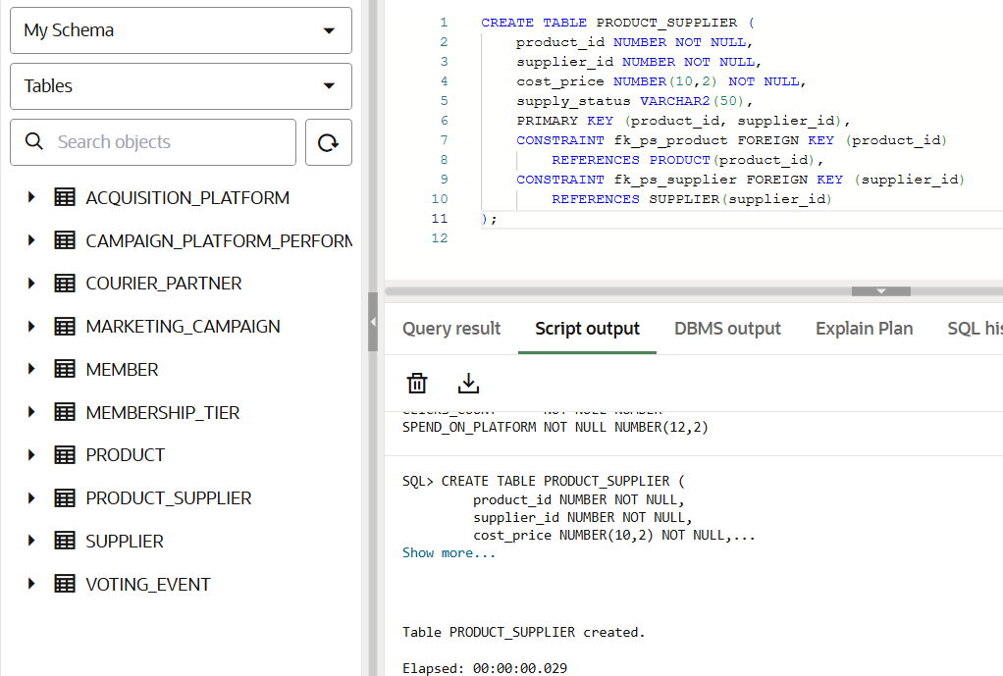
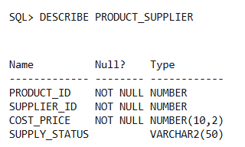

TABLE 10 - SHOP_ORDER

CREATE TABLE SHOP_ORDER (
order_id NUMBER GENERATED BY DEFAULT AS IDENTITY PRIMARY KEY,
member_id NUMBER NOT NULL,
order_placed_at TIMESTAMP NOT NULL,
subtotal_amount NUMBER(12,2) NOT NULL,
discount_applied NUMBER(12,2) NOT NULL,
final_total_applied NUMBER(12,2) NOT NULL,
order_status VARCHAR2(50) NOT NULL,
fulfillment_type VARCHAR2(50) NOT NULL,
pickup_store_id NUMBER,
delivery_address VARCHAR2(4000),
CONSTRAINT fk_order_member FOREIGN KEY (member_id)
REFERENCES MEMBER(member_id)
);

DESCRIBE SHOP_ORDER;

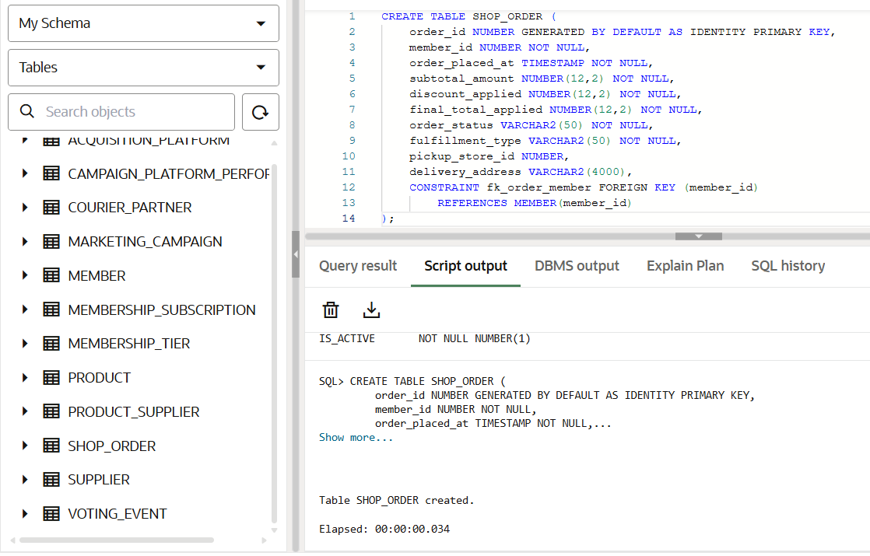
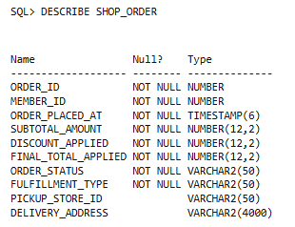
TABLE 11 - ORDER_ITEM

CREATE TABLE ORDER_ITEM (
order_item_id NUMBER GENERATED BY DEFAULT AS IDENTITY PRIMARY KEY,
order_id NUMBER NOT NULL,
product_id NUMBER NOT NULL,
quantity NUMBER NOT NULL,
unit_price NUMBER(10,2) NOT NULL,
line_total NUMBER(12,2) NOT NULL,
CONSTRAINT fk_orderitem_order FOREIGN KEY (order_id)
REFERENCES SHOP_ORDER(order_id),
CONSTRAINT fk_orderitem_product FOREIGN KEY (product_id)
REFERENCES PRODUCT(product_id)
);

DESCRIBE ORDER_ITEM;

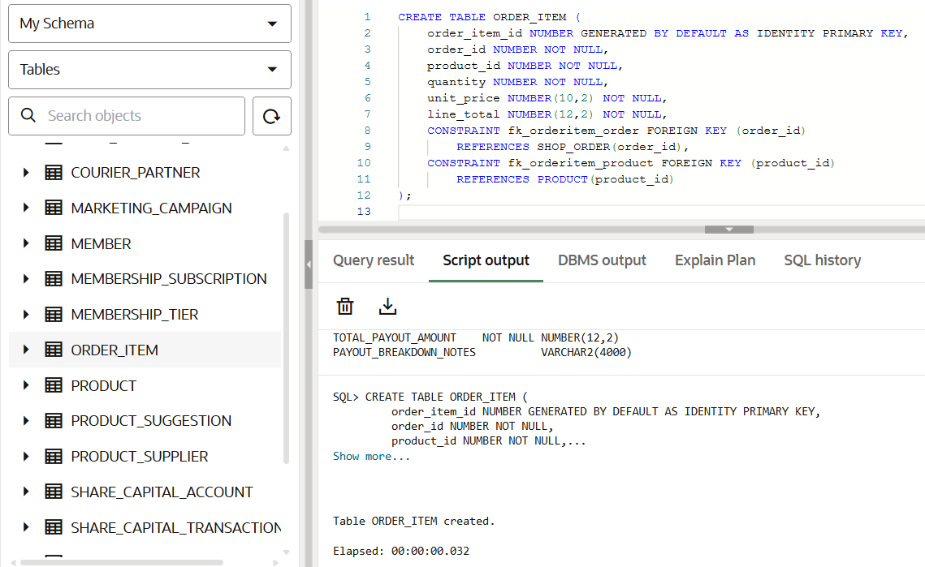
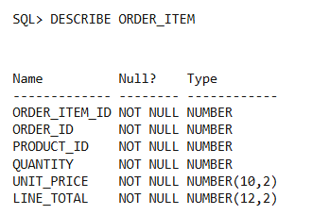

TABLE 12 - PAYMENT_RECORD

CREATE TABLE PAYMENT_RECORD (
payment_id VARCHAR2(20) PRIMARY KEY,
order_id NUMBER NOT NULL,
payment_method VARCHAR2(50) NOT NULL,
gateway_transaction_ref VARCHAR2(150) UNIQUE,
payment_confirmed_at TIMESTAMP,
status VARCHAR2(40) NOT NULL,
CONSTRAINT fk_pay_order FOREIGN KEY (order_id)
REFERENCES SHOP_ORDER(order_id)
);

DESCRIBE PAYMENT_RECORD;

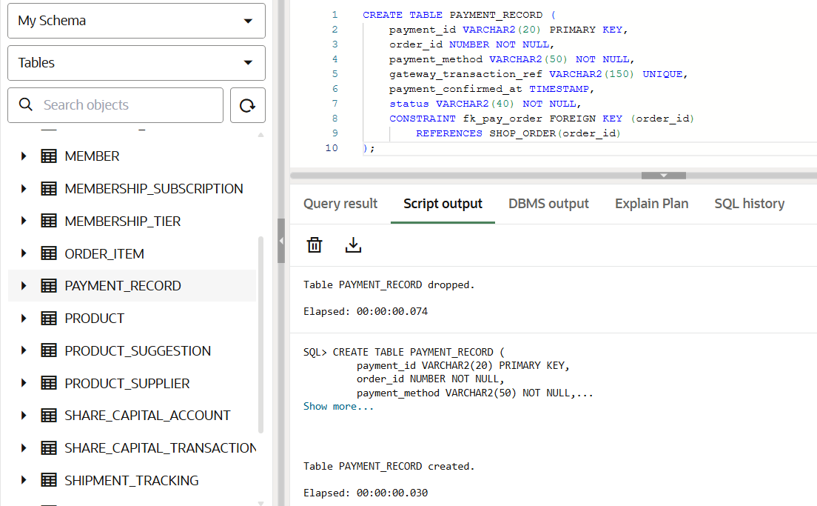
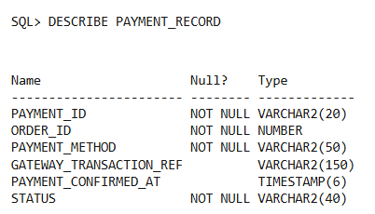

TABLE 13 - SHIPMENT_TRACKING

CREATE TABLE SHIPMENT_TRACKING (
shipment_id VARCHAR2(30) PRIMARY KEY,
order_id NUMBER NOT NULL,
courier_id NUMBER NOT NULL,
tracking_number VARCHAR2(120),
dispatched_at TIMESTAMP,
delivered_at TIMESTAMP,
shipment_status VARCHAR2(50) NOT NULL,
CONSTRAINT fk_shipment_order FOREIGN KEY (order_id)
REFERENCES SHOP_ORDER(order_id),
CONSTRAINT fk_shipment_courier FOREIGN KEY (courier_id)
REFERENCES COURIER_PARTNER(courier_id)
);

DESCRIBE SHIPMENT_TRACKING;
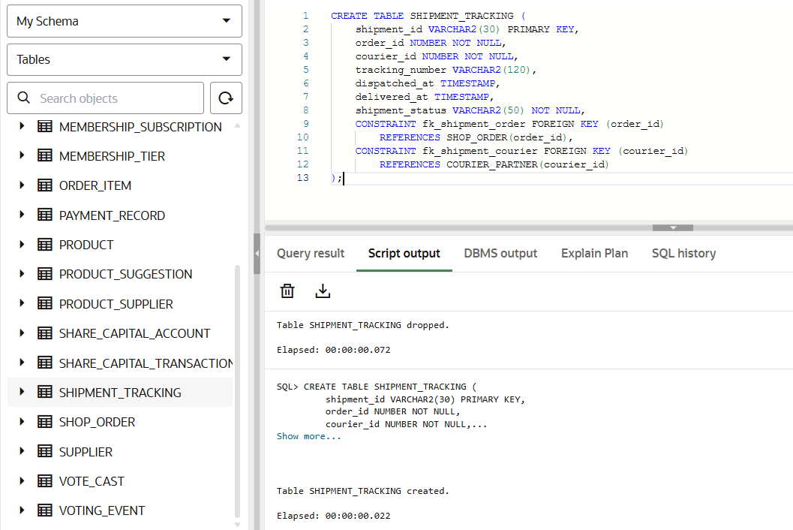
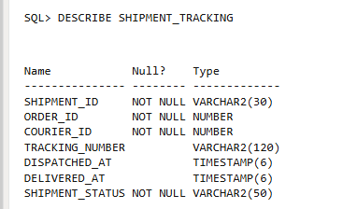

TABLE 14 - COURIER_PARTNER

CREATE TABLE COURIER_PARTNER (
courier_id NUMBER GENERATED BY DEFAULT AS IDENTITY PRIMARY KEY,
company_name VARCHAR2(120) NOT NULL,
service_type VARCHAR2(80) NOT NULL,
contact_info VARCHAR2(120)
);

DESCRIBE COURIER_PARTNER;

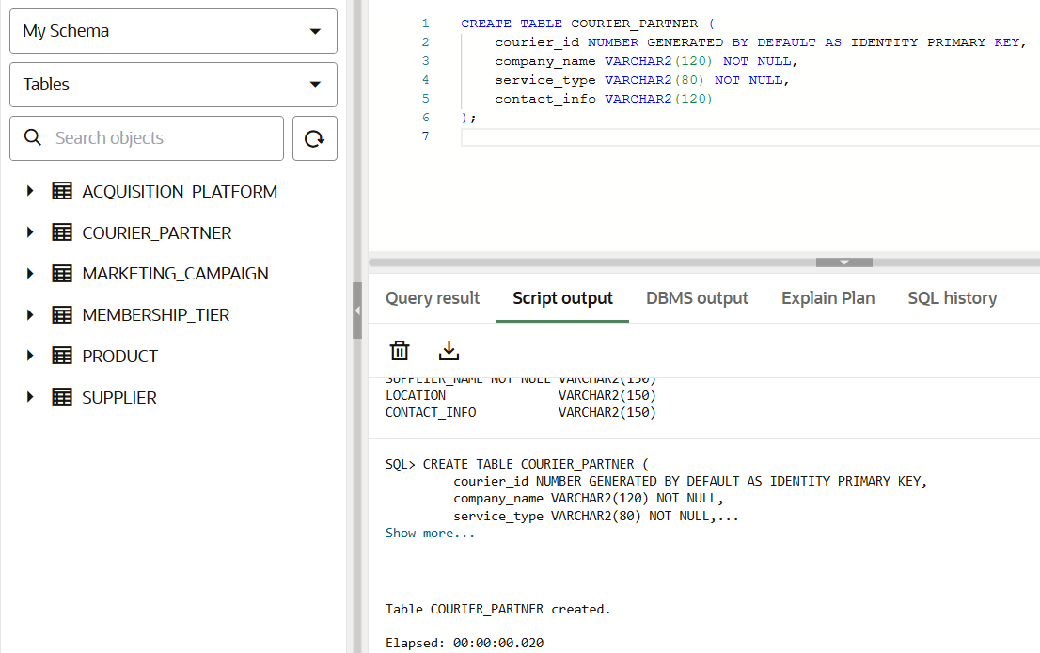
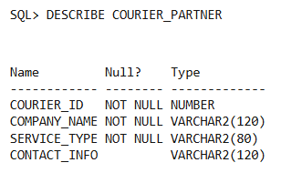

COOPERATIVE ENGAGEMENT MODULE

TABLE 15 - PRODUCT_SUGGESTION

CREATE TABLE PRODUCT_SUGGESTION (
suggestion_id NUMBER GENERATED BY DEFAULT AS IDENTITY PRIMARY KEY,
member_id NUMBER NOT NULL,
product_name VARCHAR2(120) NOT NULL,
description VARCHAR2(4000),
status VARCHAR2(50) NOT NULL,
date_submitted DATE NOT NULL,
supply_status VARCHAR2(50),
CONSTRAINT fk_suggestion_member FOREIGN KEY (member_id)
REFERENCES MEMBER(member_id)
);

DESCRIBE PRODUCT_SUGGESTION;

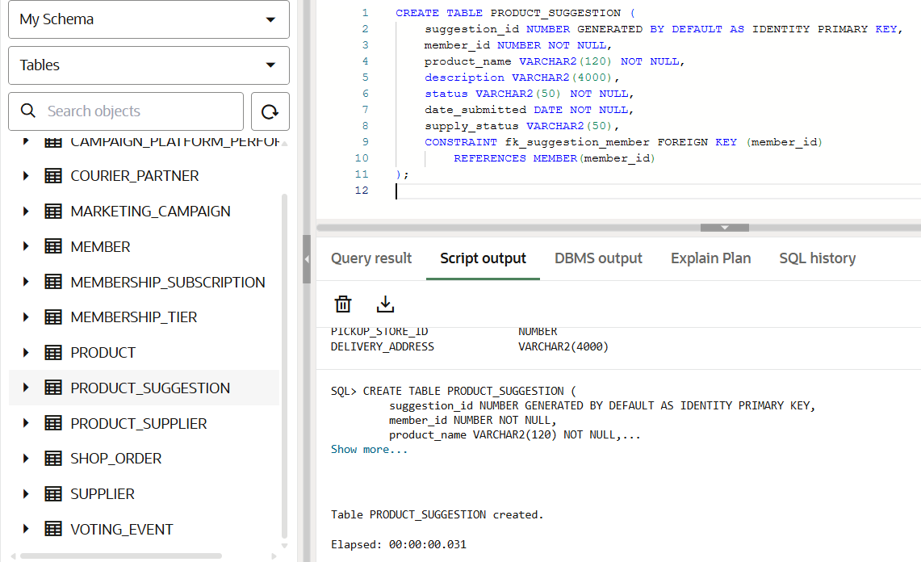
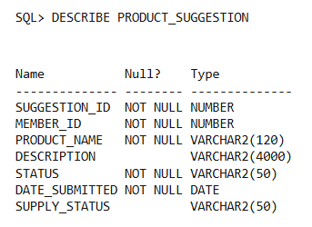

TABLE 16 - VOTING_EVENT
CREATE TABLE VOTING_EVENT (
vote_id NUMBER GENERATED BY DEFAULT AS IDENTITY PRIMARY KEY,
title VARCHAR2(150) NOT NULL,
description VARCHAR2(4000),
start_date DATE NOT NULL,
end_date DATE NOT NULL,
created_by_admin NUMBER NOT NULL
);

DESCRIBE VOTING_EVENT;

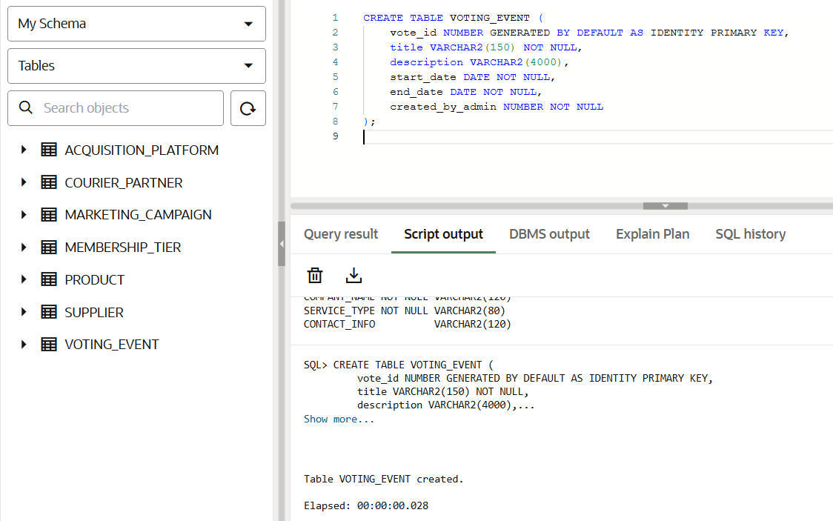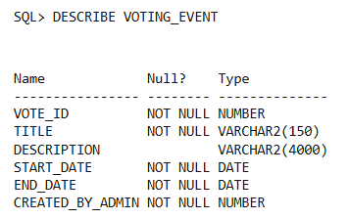

TABLE 17 - VOTE_CAST

CREATE TABLE VOTE_CAST (
vote_cast_id NUMBER GENERATED BY DEFAULT AS IDENTITY PRIMARY KEY,
vote_id NUMBER NOT NULL,
member_id NUMBER NOT NULL,
choice VARCHAR2(50) NOT NULL,
date_voted TIMESTAMP NOT NULL,
CONSTRAINT fk_vote_event FOREIGN KEY (vote_id)
REFERENCES VOTING_EVENT(vote_id),
CONSTRAINT fk_vote_member FOREIGN KEY (member_id)
REFERENCES MEMBER(member_id)
);

DESCRIBE VOTE_CAST;

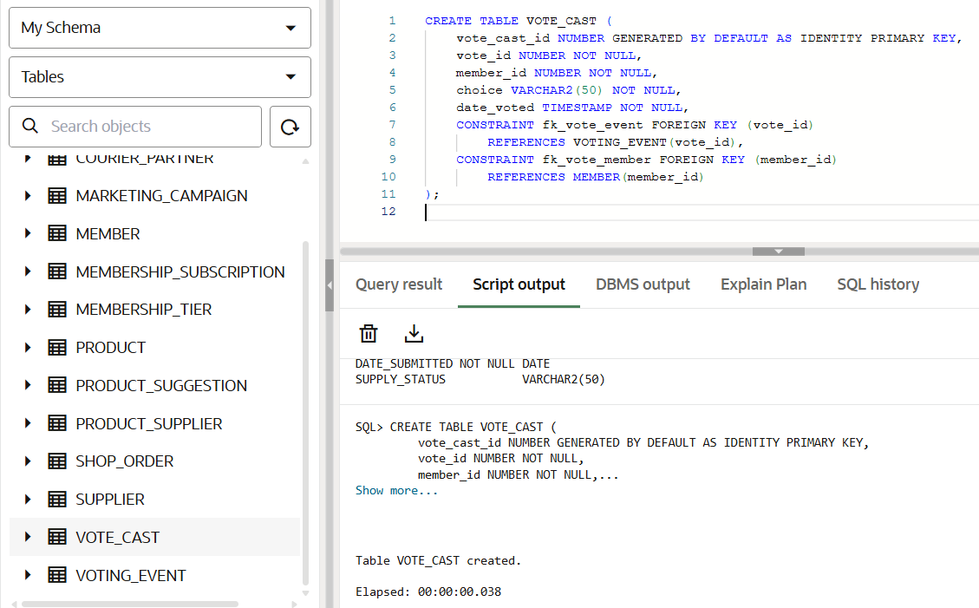
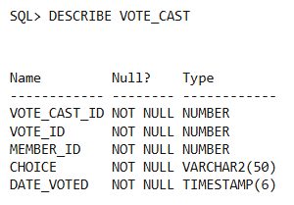
CRM MODULE

TABLE 18 - CRM_SUPPORT_TICKET

CREATE TABLE CRM_SUPPORT_TICKET (
ticket_id NUMBER GENERATED BY DEFAULT AS IDENTITY PRIMARY KEY,
member_id NUMBER NOT NULL,
order_id NUMBER,
issue_category VARCHAR2(80) NOT NULL,
priority VARCHAR2(20) NOT NULL,
status VARCHAR2(50) NOT NULL,
created_at TIMESTAMP NOT NULL,
resolved_at TIMESTAMP,
details VARCHAR2(4000),
CONSTRAINT fk_ticket_member FOREIGN KEY (member_id)
REFERENCES MEMBER(member_id),
CONSTRAINT fk_ticket_order FOREIGN KEY (order_id)
REFERENCES SHOP_ORDER(order_id)
);

DESCRIBE CRM_SUPPORT_TICKET;

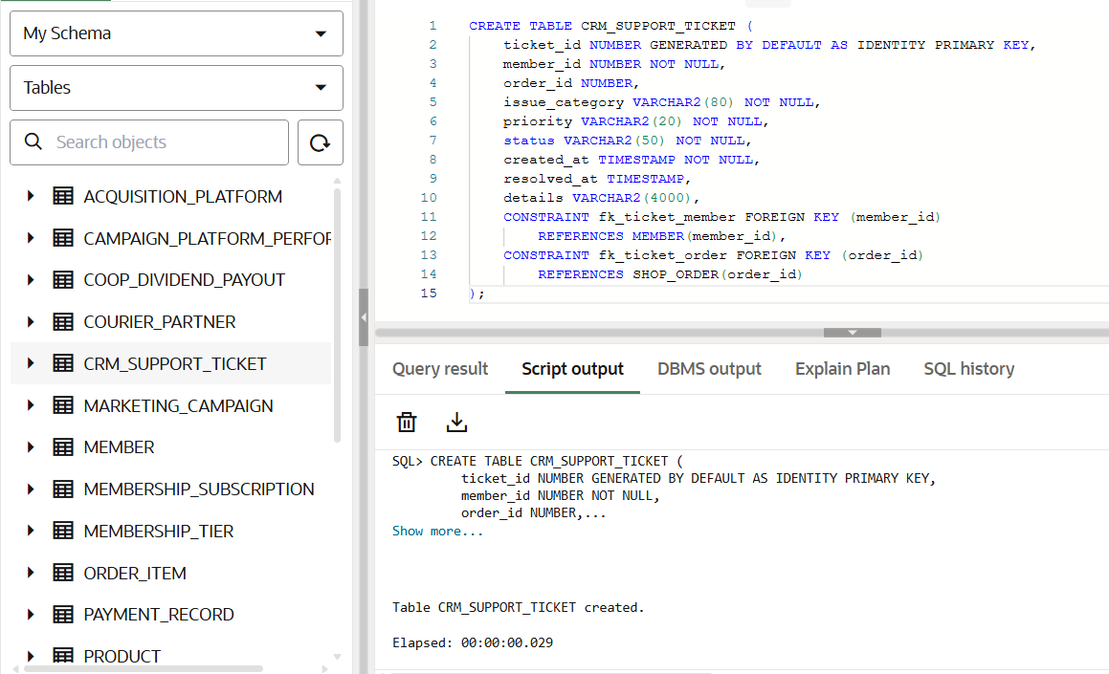
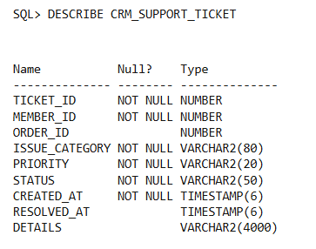

COOPERATIVE FINANCIALS MODULE

TABLE 19 - SHARE_CAPITAL_ACCOUNT
CREATE TABLE SHARE_CAPITAL_ACCOUNT (
account_id NUMBER GENERATED BY DEFAULT AS IDENTITY PRIMARY KEY,
member_id NUMBER NOT NULL UNIQUE,
share_capital_balance NUMBER(12,2) NOT NULL,
CONSTRAINT fk_account_member FOREIGN KEY (member_id)
REFERENCES MEMBER(member_id)
);

DESCRIBE SHARE_CAPITAL_ACCOUNT;

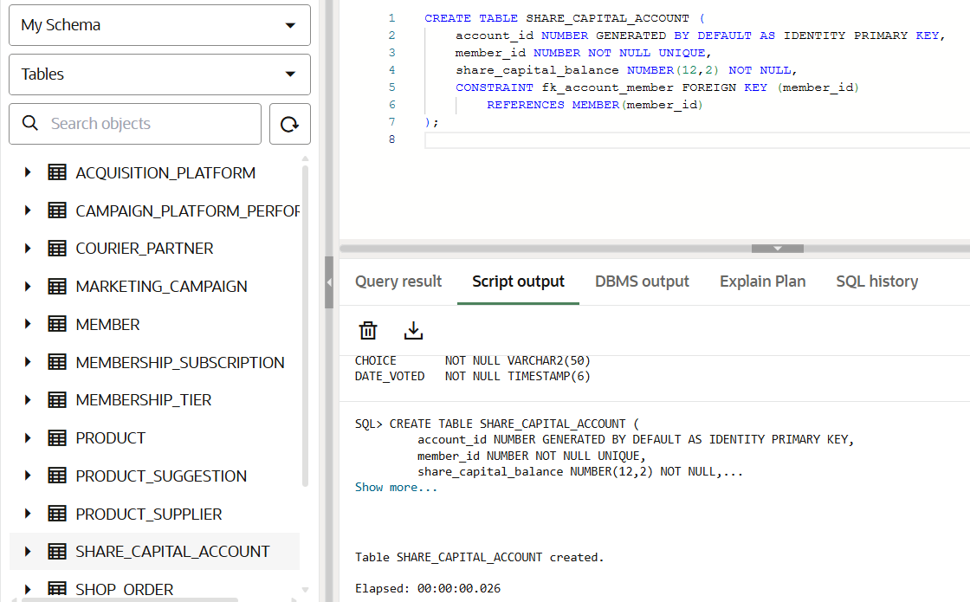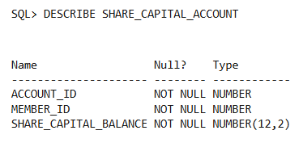

TABLE 20 - SHARE_CAPITAL_TRANSACTION

CREATE TABLE SHARE_CAPITAL_TRANSACTION (
transaction_id NUMBER GENERATED BY DEFAULT AS IDENTITY PRIMARY KEY,
member_id NUMBER NOT NULL,
transaction_date DATE NOT NULL,
transaction_type VARCHAR2(50) NOT NULL,
amount NUMBER(12,2) NOT NULL,
running_balance NUMBER(12,2) NOT NULL,
CONSTRAINT fk_transaction_member FOREIGN KEY (member_id)
REFERENCES MEMBER(member_id)
);

DESCRIBE SHARE_CAPITAL_TRANSACTION;

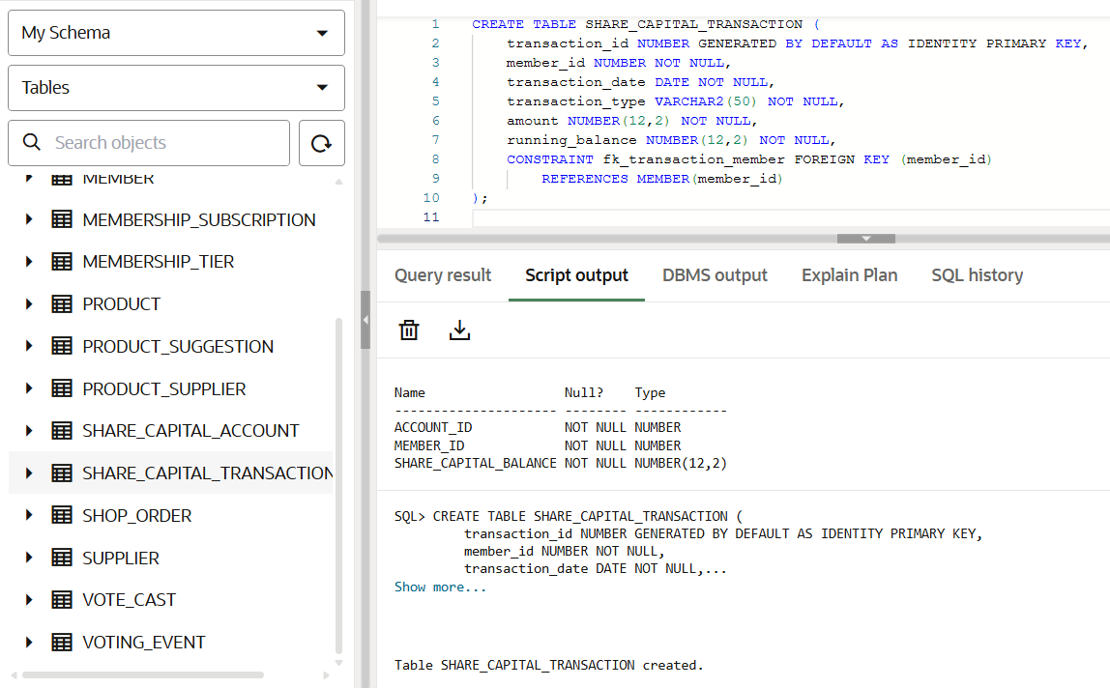
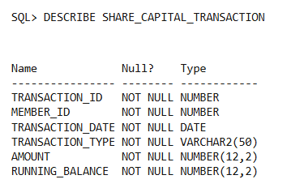

TABLE 21 - COOP_DIVIDEND_PAYOUT

CREATE TABLE COOP_DIVIDEND_PAYOUT (
payout_id NUMBER GENERATED BY DEFAULT AS IDENTITY PRIMARY KEY,
member_id NUMBER NOT NULL,
fiscal_year NUMBER(4) NOT NULL,
payout_date DATE NOT NULL,
total_payout_amount NUMBER(12,2) NOT NULL,
payout_breakdown_notes VARCHAR2(4000),
CONSTRAINT fk_dividend_member FOREIGN KEY (member_id)
REFERENCES MEMBER(member_id)
);

DESCRIBE COOP_DIVIDEND_PAYOUT;


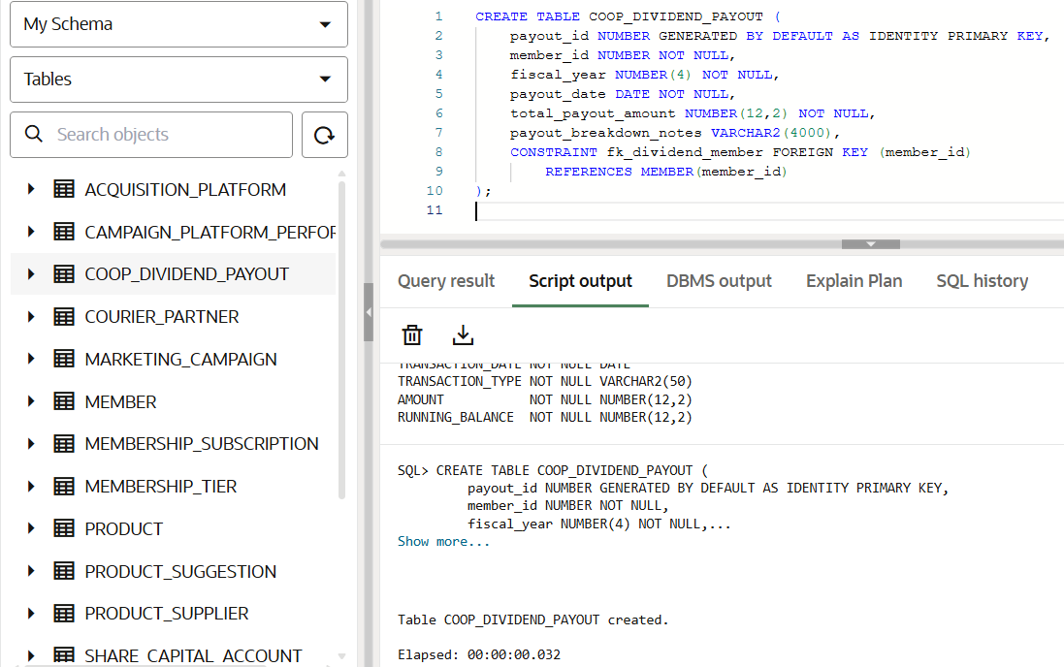

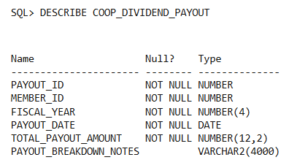

INSERTING VALUES INTO THE TABLES

Data Population Sequencing
Just as the structural initialization (creation) of a relational database must follow a strict hierarchy, the population of that database via Data Manipulation Language (DML) operations, specifically INSERT statements. It must adhere to the same dependency sequence.
This requirement is enforced by Referential Integrity Constraints. When a system attempts to insert a record into a "child" table, the database engine actively validates the existence of the corresponding "parent" record via the foreign key. If the parent record does not yet exist, the database will reject the transaction to prevent orphaned data (yielding an ORA-02291: integrity constraint violation error in Oracle SQL).
Therefore, data insertion must follow a "Top-Down" hierarchical approach across the four established phases.

MEMBERSHIP MODULE
TABLE 1 - MEMBER

INSERT INTO MEMBER (member_id, email, password_hash, full_name, phone_number, address, join_date, acquisition_platform_id, is_active, acquisition_details) VALUES (101, 'jayden.s99@gmail.com', 'JaydenS_99', 'Jayden Santos', '9171112233', 'Quezon City', TO_DATE('15/01/2025', 'DD/MM/YYYY'), 2, 1, 'Main Office Registration');
INSERT INTO MEMBER (member_id, email, password_hash, full_name, phone_number, address, join_date, acquisition_platform_id, is_active, acquisition_details) VALUES (102, 'sophie_reyes05@yahoo.com', 'SophReyes05', 'Sophia Reyes', '9182223344', 'Makati', TO_DATE('10/02/2025', 'DD/MM/YYYY'), 1, 1, 'Organic Google Search');


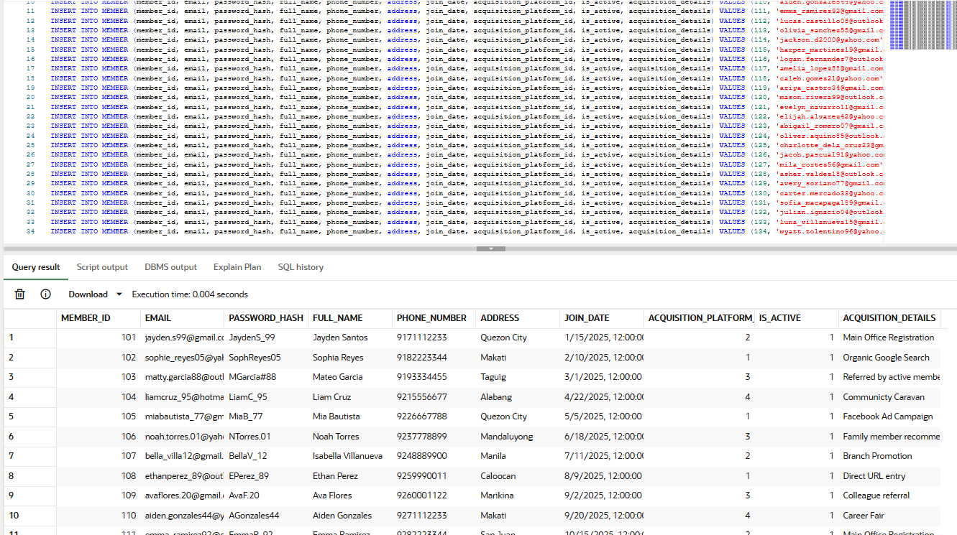
TABLE 2 - MEMBERSHIP_TIER

INSERT INTO MEMBERSHIP_TIER (tier_id, tier_name, annual_fee, discount_percentage) VALUES (1, 'Bronze', 1200, 5);
INSERT INTO MEMBERSHIP_TIER (tier_id, tier_name, annual_fee, discount_percentage) VALUES (2, 'Silver', 1200, 10);
INSERT INTO MEMBERSHIP_TIER (tier_id, tier_name, annual_fee, discount_percentage) VALUES (3, 'Gold', 1200, 15);

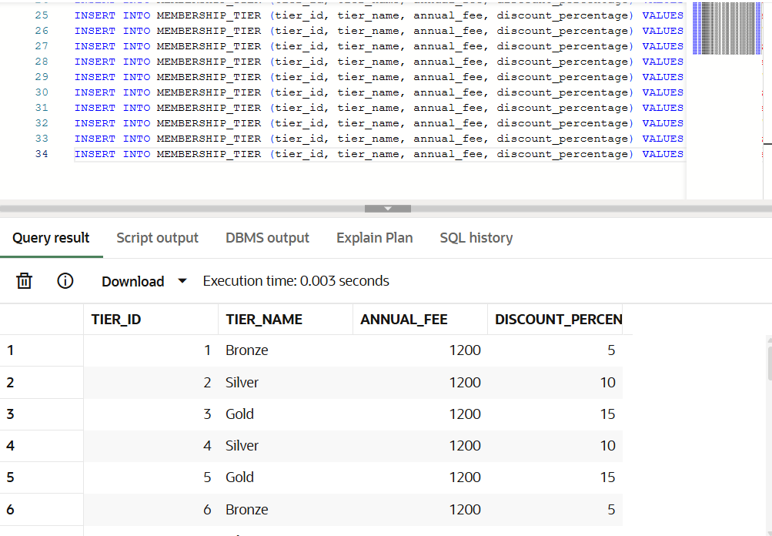

TABLE 3 - MEMBERSHIP_SUBSCRIPTION


INSERT INTO MEMBERSHIP_SUBSCRIPTION (subscription_id, member_id, tier_id, start_date, expiry_date, is_active) VALUES (1, 101, 1, TO_DATE('15/01/2025', 'DD/MM/YYYY'), TO_DATE('15/01/2026', 'DD/MM/YYYY'), 1);
INSERT INTO MEMBERSHIP_SUBSCRIPTION (subscription_id, member_id, tier_id, start_date, expiry_date, is_active) VALUES (2, 102, 2, TO_DATE('10/02/2025', 'DD/MM/YYYY'), TO_DATE('10/02/2026', 'DD/MM/YYYY'), 1);
INSERT INTO MEMBERSHIP_SUBSCRIPTION (subscription_id, member_id, tier_id, start_date, expiry_date, is_active) VALUES (3, 103, 3, TO_DATE('01/03/2025', 'DD/MM/YYYY'), TO_DATE('01/03/2026', 'DD/MM/YYYY'), 1);

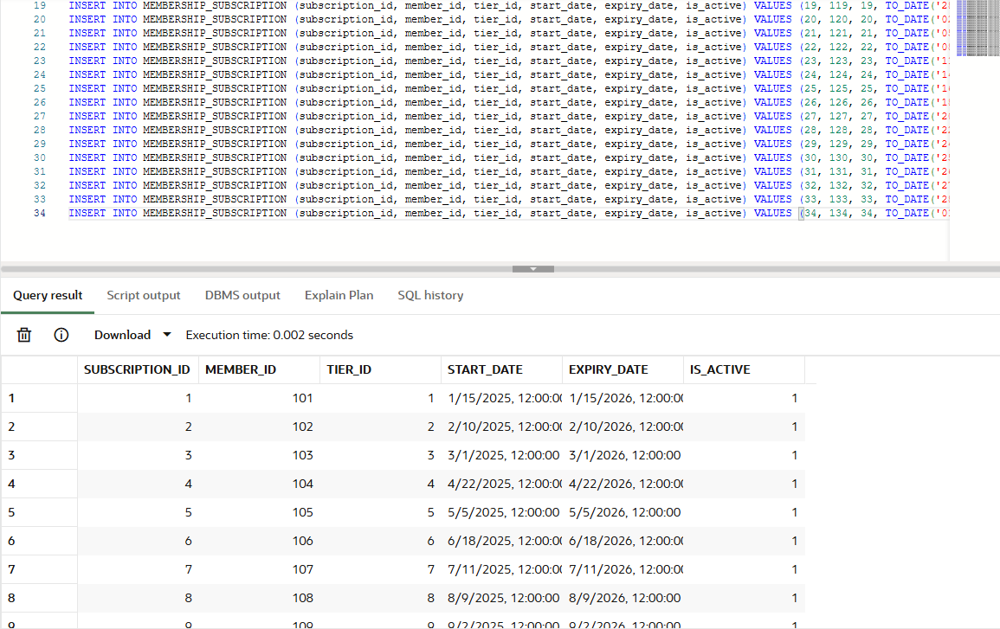

MARKETING MODULE

TABLE 4 - ACQUISITION_PLATFORM

INSERT INTO ACQUISITION_PLATFORM (platform_id, platform_name)
VALUES (1, 'Website signup');

INSERT INTO ACQUISITION_PLATFORM (platform_id, platform_name)
VALUES (2, 'Walk in');

INSERT INTO ACQUISITION_PLATFORM (platform_id, platform_name)
VALUES (3, 'Referral');

INSERT INTO ACQUISITION_PLATFORM (platform_id, platform_name)
VALUES (4, 'Community event');

INSERT INTO ACQUISITION_PLATFORM (platform_id, platform_name)
VALUES (5, 'Social media');

Note: The table was created and inserted with only 5 rows instead of 35 because the platform_id column was set to PRIMARY KEY, which must not contain duplicate values. The primary purpose of this is because the values of this table were to classify different platforms for each member from which they came, and it will connect it to the acquisition_platform_id in the MEMBERS table. The values of the numbers are the following:

1 | Website signup
2 | Walk-in
3 | Referral
4 | Community event
5 | Social media

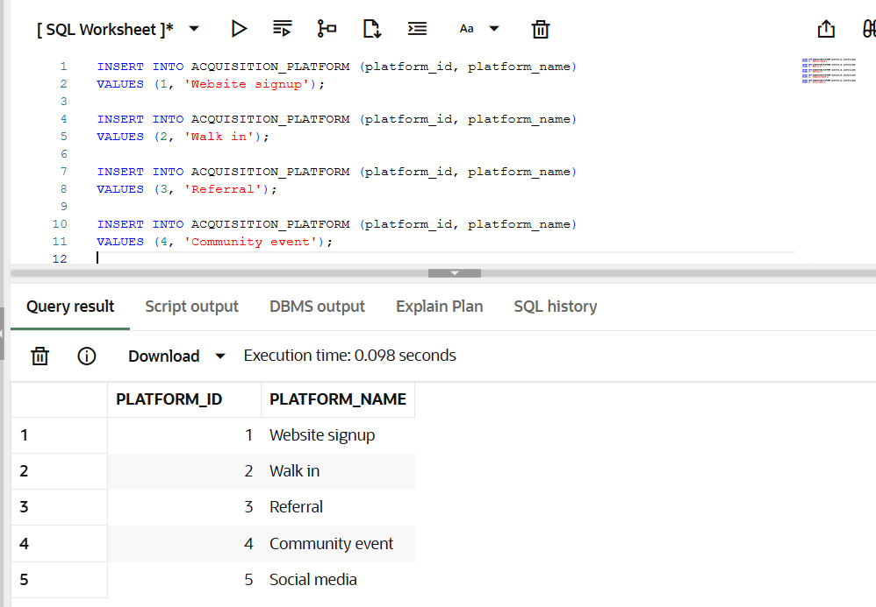

TABLE 5 - MARKETING_CAMPAIGN

INSERT INTO MARKETING_CAMPAIGN (campaign_id, campaign_name, total_budget, start_date, end_date) VALUES (1, 'Organic Search Web Surge', 45000, TO_DATE('01/01/2024', 'DD/MM/YYYY'), TO_DATE('25/01/2024', 'DD/MM/YYYY'));
INSERT INTO MARKETING_CAMPAIGN (campaign_id, campaign_name, total_budget, start_date, end_date) VALUES (2, 'Main Office Walk-In Fest', 12500, TO_DATE('10/01/2024', 'DD/MM/YYYY'), TO_DATE('05/02/2024', 'DD/MM/YYYY'));
INSERT INTO MARKETING_CAMPAIGN (campaign_id, campaign_name, total_budget, start_date, end_date) VALUES (3, 'Bring-A-Colleague Month', 15000, TO_DATE('15/02/2024', 'DD/MM/YYYY'), TO_DATE('10/03/2024', 'DD/MM/YYYY'));

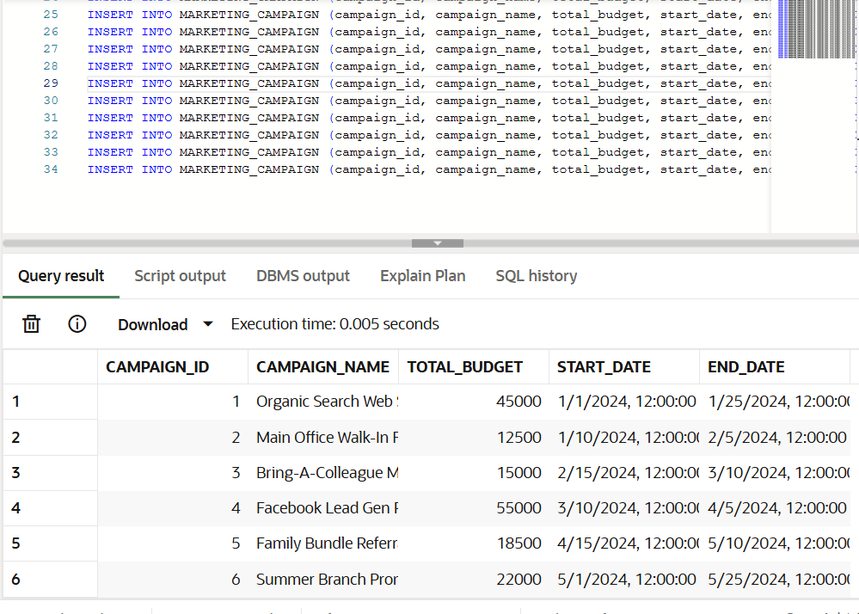

TABLE 6 - CAMPAIGN_PLATFORM_PERFORMANCE

INSERT INTO CAMPAIGN_PLATFORM_PERFORMANCE (performance_id, campaign_id, platform_name, impressions_count, clicks_count, spend_on_platform) VALUES (1, 1, 'Walk in', 15000, 850, 6000);
INSERT INTO CAMPAIGN_PLATFORM_PERFORMANCE (performance_id, campaign_id, platform_name, impressions_count, clicks_count, spend_on_platform) VALUES (2, 2, 'Website signup', 120500, 4100, 25000);
INSERT INTO CAMPAIGN_PLATFORM_PERFORMANCE (performance_id, campaign_id, platform_name, impressions_count, clicks_count, spend_on_platform) VALUES (3, 3, 'Referral', 32000, 2100, 10500);

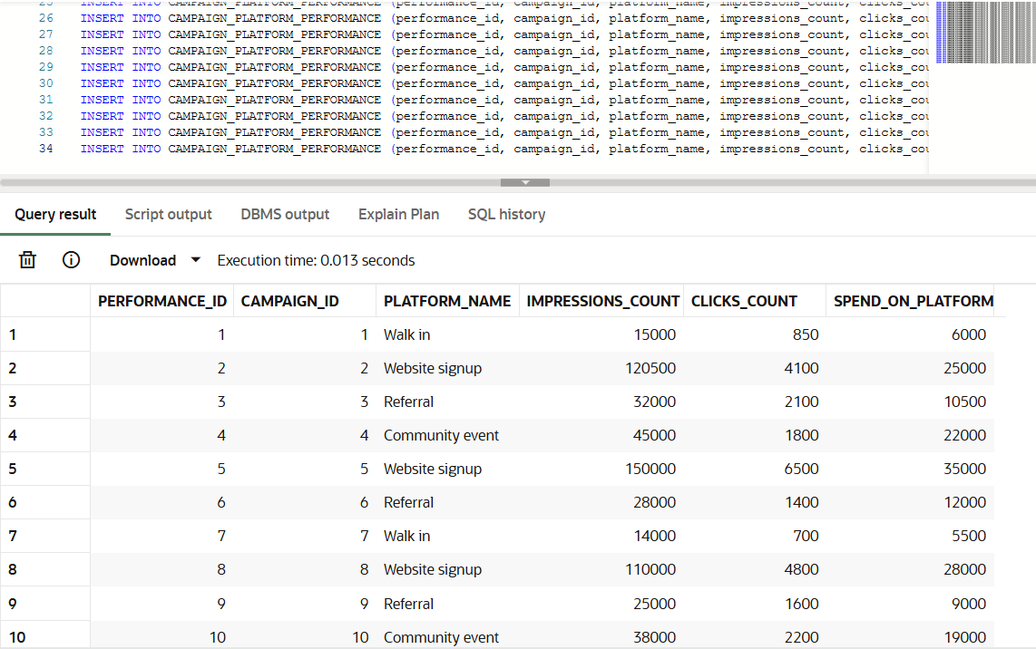

PAYMENT & LOGISTICS MODULE

TABLE 7 - PRODUCT

SET DEFINE OFF; -- THIS WAS USED TO TREAT "&" FUNCTION AS A NORMAL TEXT

INSERT INTO PRODUCT (product_id, product_name, description, price, stock_quantity, unit_of_measure, category, reorder_level) VALUES (42, 'Harvester''s Jasmine Rice', 'Premium quality fragrant rice', 250, 200, '5kg bag', 'Grocery', 30);
INSERT INTO PRODUCT (product_id, product_name, description, price, stock_quantity, unit_of_measure, category, reorder_level) VALUES (815, 'Magnolia Fresh Milk', 'Fresh whole milk', 95, 150, '1L carton', 'Dairy', 20);
INSERT INTO PRODUCT (product_id, product_name, description, price, stock_quantity, unit_of_measure, category, reorder_level) VALUES (23, 'C2 Green Tea Apple', 'Organic green tea drink', 120, 100, '1.5L bottle', 'Beverages', 15);

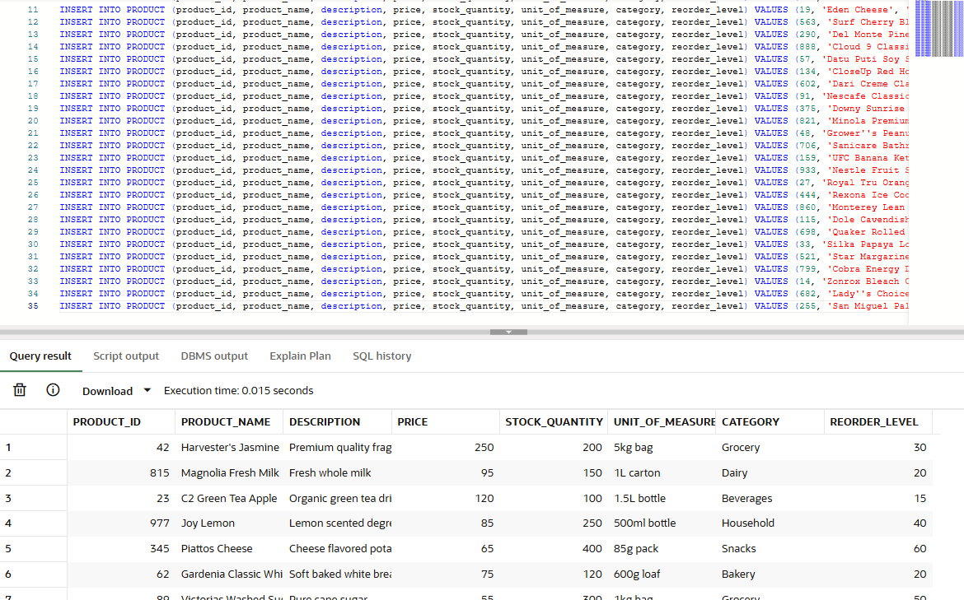

TABLE 8 - SUPPLIER

SET DEFINE OFF; -- THIS WAS USED TO TREAT "&" FUNCTION AS A NORMAL TEXT

INSERT INTO SUPPLIER (supplier_id, supplier_name, location, contact_info) VALUES (88, 'Sunnywood Superfoods Corp.', 'Quezon City', '9171112233');
INSERT INTO SUPPLIER (supplier_id, supplier_name, location, contact_info) VALUES (305, 'Magnolia Dairy Corporation', 'Quezon City', '9182223344');
INSERT INTO SUPPLIER (supplier_id, supplier_name, location, contact_info) VALUES (512, 'URC Beverage Division', 'Pasig City', '9193334455');

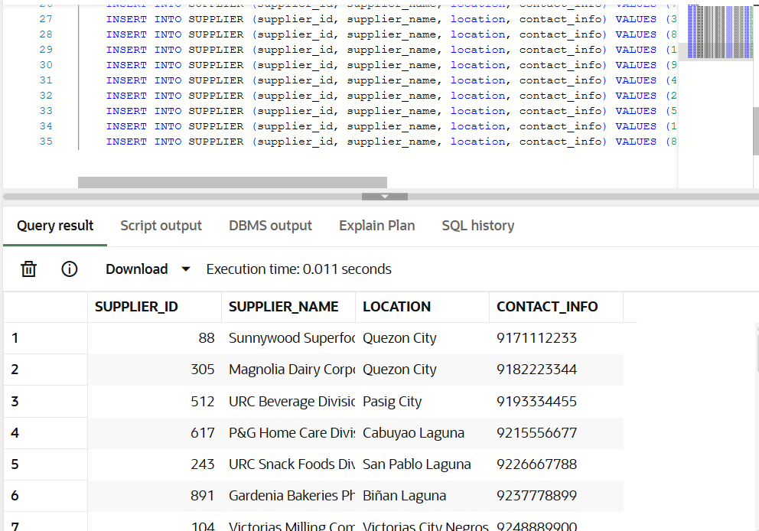

TABLE 9 - PRODUCT_SUPPLIER

INSERT INTO PRODUCT_SUPPLIER (product_id, supplier_id, cost_price) VALUES (42, 88, 200);
INSERT INTO PRODUCT_SUPPLIER (product_id, supplier_id, cost_price) VALUES (815, 305, 76);
INSERT INTO PRODUCT_SUPPLIER (product_id, supplier_id, cost_price) VALUES (23, 512, 95);

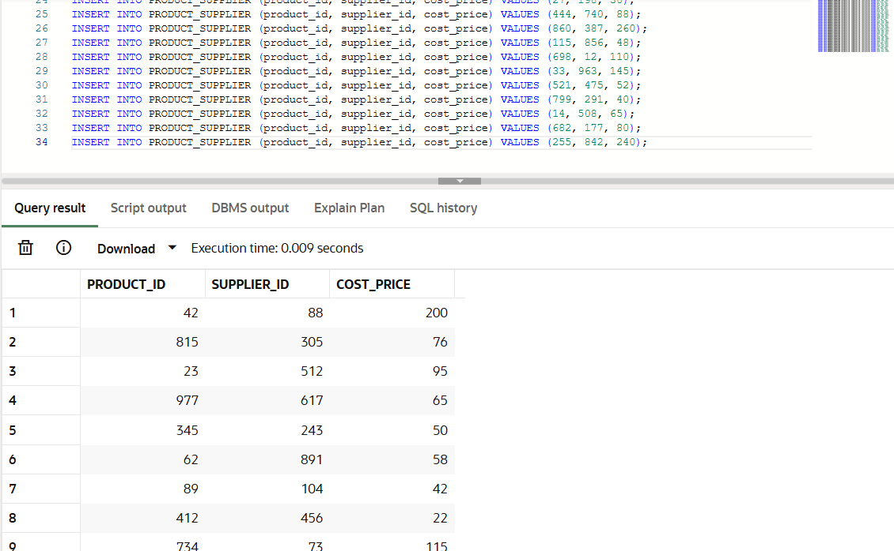

TABLE 10 - SHOP_ORDER

INSERT INTO SHOP_ORDER (order_id, member_id, order_placed_at, subtotal_amount, discount_applied, final_total_applied, order_status, fulfillment_type, pickup_store_id, delivery_address) VALUES (4829, 101, TO_TIMESTAMP('2025-01-20 10:15:00', 'YYYY-MM-DD HH24:MI:SS'), 1000, 50, 950, 'Paid', 'Delivery', NULL, '15A Maginhawa St Quezon City');
INSERT INTO SHOP_ORDER (order_id, member_id, order_placed_at, subtotal_amount, discount_applied, final_total_applied, order_status, fulfillment_type, pickup_store_id, delivery_address) VALUES (7154, 102, TO_TIMESTAMP('2025-02-15 14:30:00', 'YYYY-MM-DD HH24:MI:SS'), 1995, 199.5, 1795.5, 'Pending', 'Pick Up', 'WH-A1B2', NULL);
INSERT INTO SHOP_ORDER (order_id, member_id, order_placed_at, subtotal_amount, discount_applied, final_total_applied, order_status, fulfillment_type, pickup_store_id, delivery_address) VALUES (2938, 103, TO_TIMESTAMP('2025-03-05 9:45:00', 'YYYY-MM-DD HH24:MI:SS'), 1200, 180, 1020, 'Paid', 'Delivery', NULL, '88 Burgos Cir Taguig');

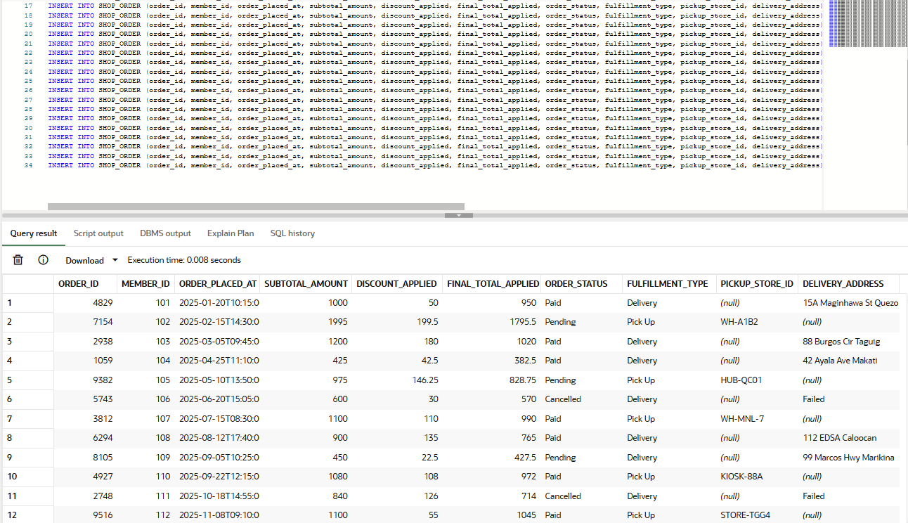

TABLE 11 - ORDER_ITEM

INSERT INTO ORDER_ITEM (order_item_id, order_id, product_id, quantity, unit_price, line_total) VALUES (1, 4829, 42, 4, 250, 1000);
INSERT INTO ORDER_ITEM (order_item_id, order_id, product_id, quantity, unit_price, line_total) VALUES (2, 7154, 815, 21, 95, 1995);
INSERT INTO ORDER_ITEM (order_item_id, order_id, product_id, quantity, unit_price, line_total) VALUES (3, 2938, 23, 10, 120, 1200);

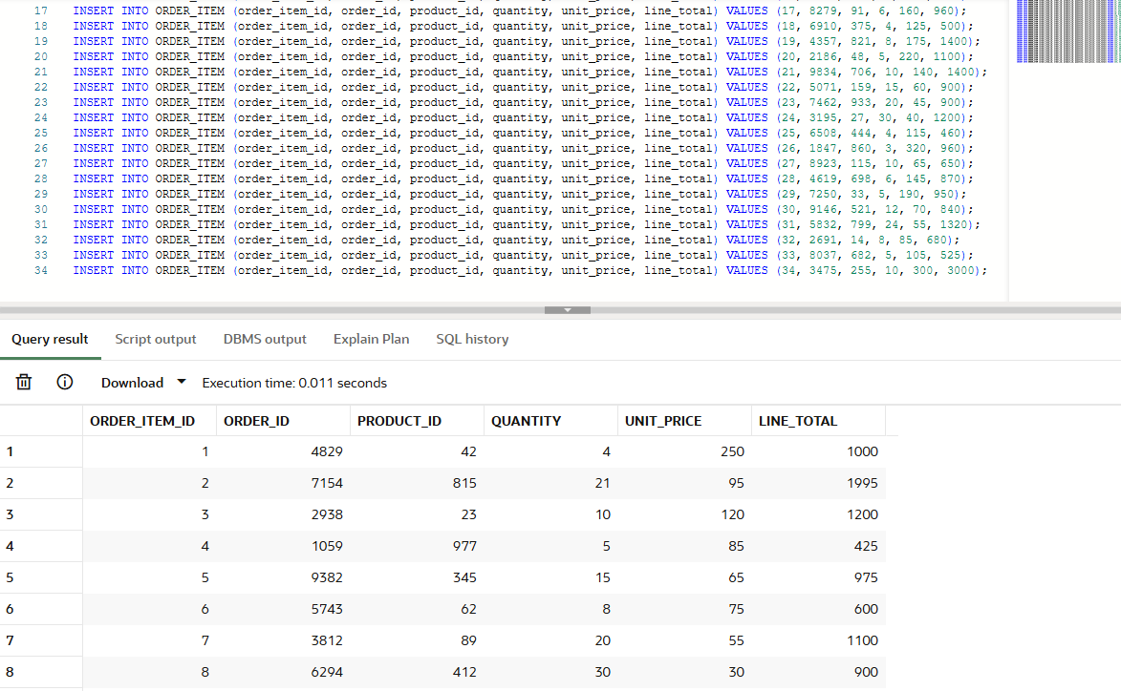

TABLE 12 - PAYMENT_RECORD

INSERT INTO PAYMENT_RECORD (payment_id, order_id, payment_method, gateway_transaction_ref, payment_confirmed_at, status) VALUES ('X7B9Q2', 4829, 'GCash', 'GC-98237190', TO_TIMESTAMP('2025-01-20 10:16:00', 'YYYY-MM-DD HH24:MI:SS'), 'Confirmed');
INSERT INTO PAYMENT_RECORD (payment_id, order_id, payment_method, gateway_transaction_ref, payment_confirmed_at, status) VALUES ('M4V1P8', 7154, 'Cash', NULL, NULL, 'Pending');
INSERT INTO PAYMENT_RECORD (payment_id, order_id, payment_method, gateway_transaction_ref, payment_confirmed_at, status) VALUES ('K2L9T4', 2938, 'Maya', 'MY-55218933', TO_TIMESTAMP('2025-03-05 9:46:00', 'YYYY-MM-DD HH24:MI:SS'), 'Confirmed');

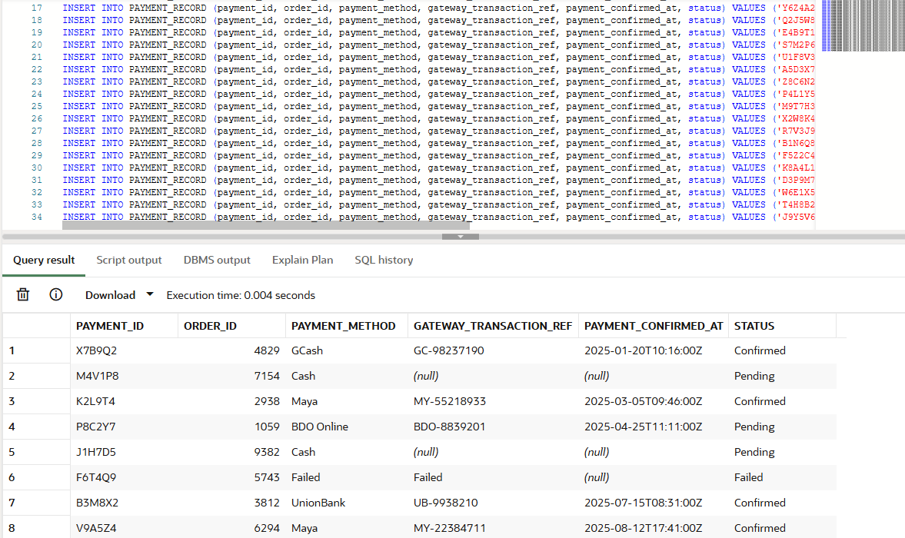

TABLE 13 - SHIPMENT_TRACKING

INSERT INTO SHIPMENT_TRACKING (shipment_id, order_id, courier_id, tracking_number, dispatched_at, delivered_at, shipment_status) VALUES ('S9A2F1', 4829, 4821, 'JNT100293', TO_TIMESTAMP('2025-01-20 15:15:00', 'YYYY-MM-DD HH24:MI:SS'), TO_TIMESTAMP('2025-01-24 10:15:00', 'YYYY-MM-DD HH24:MI:SS'), 'Delivered');
INSERT INTO SHIPMENT_TRACKING (shipment_id, order_id, courier_id, tracking_number, dispatched_at, delivered_at, shipment_status) VALUES ('X1B8N4', 7154, 9182, 'SPX992817', TO_TIMESTAMP('2025-02-15 19:30:00', 'YYYY-MM-DD HH24:MI:SS'), NULL, 'Pending');
INSERT INTO SHIPMENT_TRACKING (shipment_id, order_id, courier_id, tracking_number, dispatched_at, delivered_at, shipment_status) VALUES ('M3P5K9', 2938, 2736, 'LBC339281', TO_TIMESTAMP('2025-03-05 14:45:00', 'YYYY-MM-DD HH24:MI:SS'), TO_TIMESTAMP('2025-03-08 14:00:00', 'YYYY-MM-DD HH24:MI:SS'), 'Delivered');

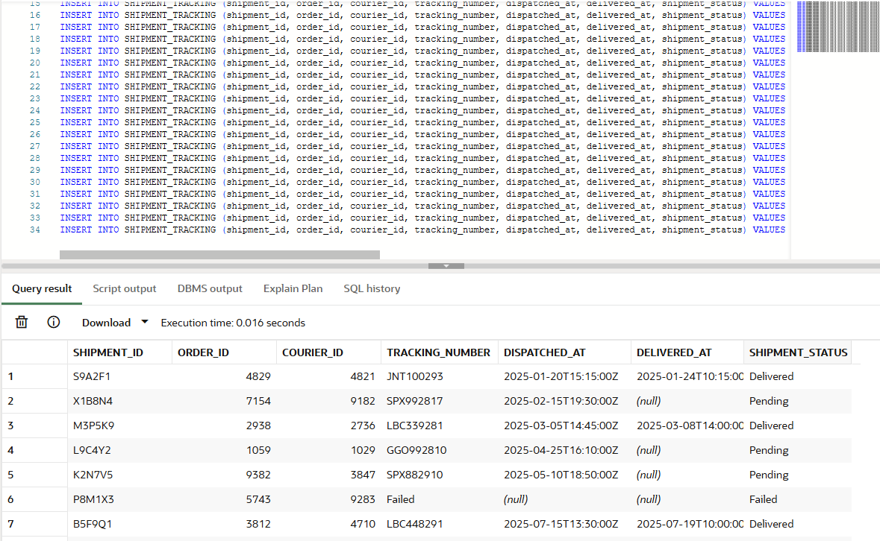

TABLE 14 - COURIER_PARTNER

SET DEFINE OFF; -- THIS WAS USED TO TREAT "&" FUNCTION AS A NORMAL TEXT

INSERT INTO COURIER_PARTNER (courier_id, company_name, service_type, contact_info) VALUES (4821, 'J&T Express', 'Standard', '9178911888');
INSERT INTO COURIER_PARTNER (courier_id, company_name, service_type, contact_info) VALUES (9182, 'SPX Express', 'Standard', '9188880520');
INSERT INTO COURIER_PARTNER (courier_id, company_name, service_type, contact_info) VALUES (2736, 'LBC Express', 'Standard', '9208858599');

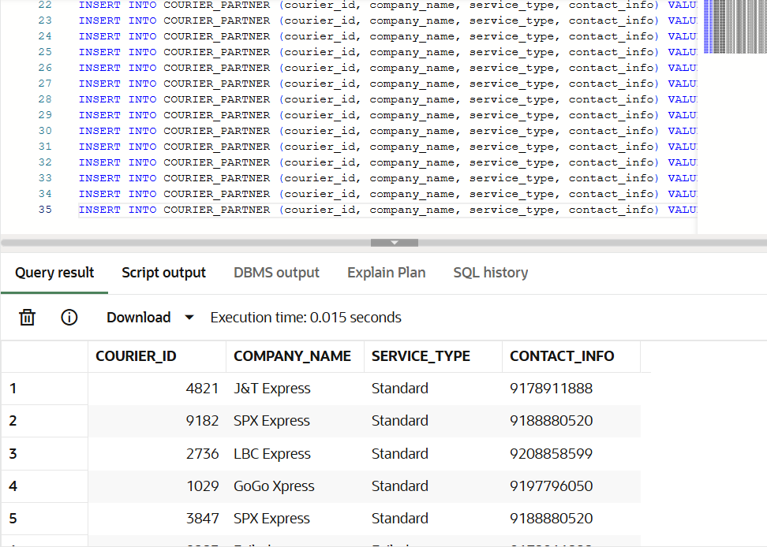

COOPERATIVE ENGAGEMENT MODULE

TABLE 15 - PRODUCT_SUGGESTION

SET DEFINE OFF; -- THIS WAS USED TO TREAT "&" FUNCTION AS A NORMAL TEXT

INSERT INTO PRODUCT_SUGGESTION (suggestion_id, member_id, product_name, description, status, date_submitted, supply_status) VALUES (1, 101, 'Asin Tibuok', 'Rare artisanal Bohol salt', 'Approved', TO_DATE('15/01/2025', 'DD/MM/YYYY'), 'Approved');
INSERT INTO PRODUCT_SUGGESTION (suggestion_id, member_id, product_name, description, status, date_submitted, supply_status) VALUES (2, 102, 'Etag', 'Cordilleran smoked cured meat', 'Pending', TO_DATE('10/02/2025', 'DD/MM/YYYY'), 'Pending');
INSERT INTO PRODUCT_SUGGESTION (suggestion_id, member_id, product_name, description, status, date_submitted, supply_status) VALUES (3, 103, 'Batuan Fruit', 'Visayan souring agent', 'Approved', TO_DATE('01/03/2025', 'DD/MM/YYYY'), 'Pending');

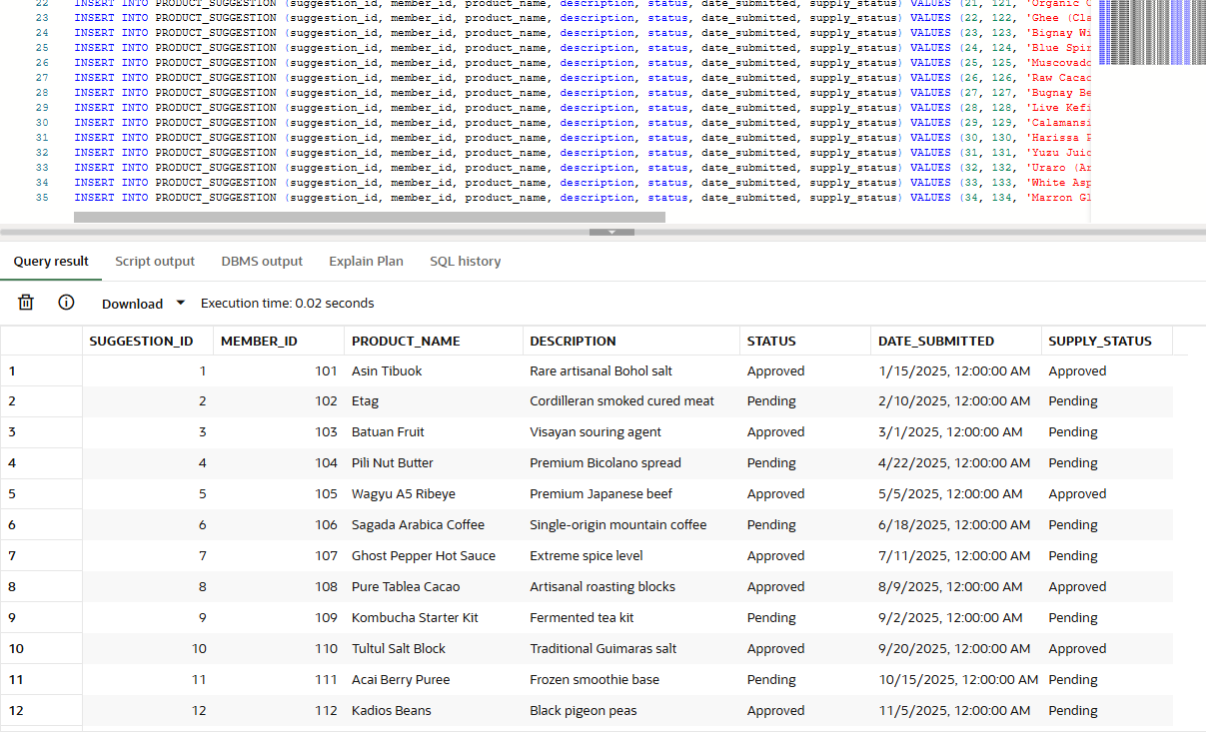

TABLE 16 - VOTING_EVENT

SET DEFINE OFF; -- THIS WAS USED TO TREAT "&" FUNCTION AS A NORMAL TEXT

INSERT INTO VOTING_EVENT (vote_id, title, description, start_date, end_date, created_by_admin) VALUES (1, 'Approve 2025 Dividend Rate', 'Voting to approve 8% dividend payout for fiscal year 2025', TO_DATE('10/01/2025', 'DD/MM/YYYY'), TO_DATE('17/01/2025', 'DD/MM/YYYY'), 23);
INSERT INTO VOTING_EVENT (vote_id, title, description, start_date, end_date, created_by_admin) VALUES (2, 'Add Local Vegetable Supplier', 'Vote to partner with GreenFarm Cooperative for fresh produce', TO_DATE('15/01/2025', 'DD/MM/YYYY'), TO_DATE('22/01/2025', 'DD/MM/YYYY'), 07);
INSERT INTO VOTING_EVENT (vote_id, title, description, start_date, end_date, created_by_admin) VALUES (3, 'Extend Weekend Hours', 'Decide if store should close at 9PM on weekends instead of 7PM', TO_DATE('01/02/2025', 'DD/MM/YYYY'), TO_DATE('08/02/2025', 'DD/MM/YYYY'), 14);

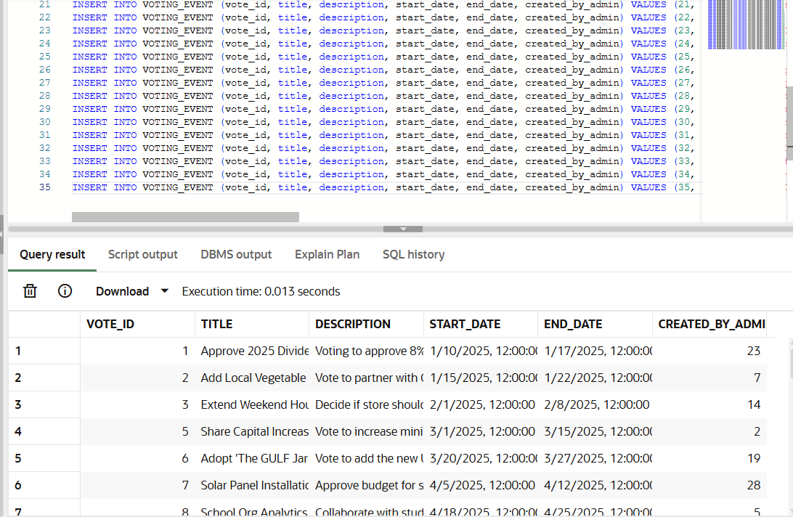

TABLE 17 - VOTE_CAST

INSERT INTO VOTE_CAST (vote_cast_id, vote_id, member_id, choice, date_voted) VALUES (1, 1, 101, 'Yes', TO_DATE('11/01/2025', 'DD/MM/YYYY'));
INSERT INTO VOTE_CAST (vote_cast_id, vote_id, member_id, choice, date_voted) VALUES (2, 1, 102, 'Yes', TO_DATE('12/01/2025', 'DD/MM/YYYY'));
INSERT INTO VOTE_CAST (vote_cast_id, vote_id, member_id, choice, date_voted) VALUES (3, 1, 103, 'No', TO_DATE('12/01/2025', 'DD/MM/YYYY'));

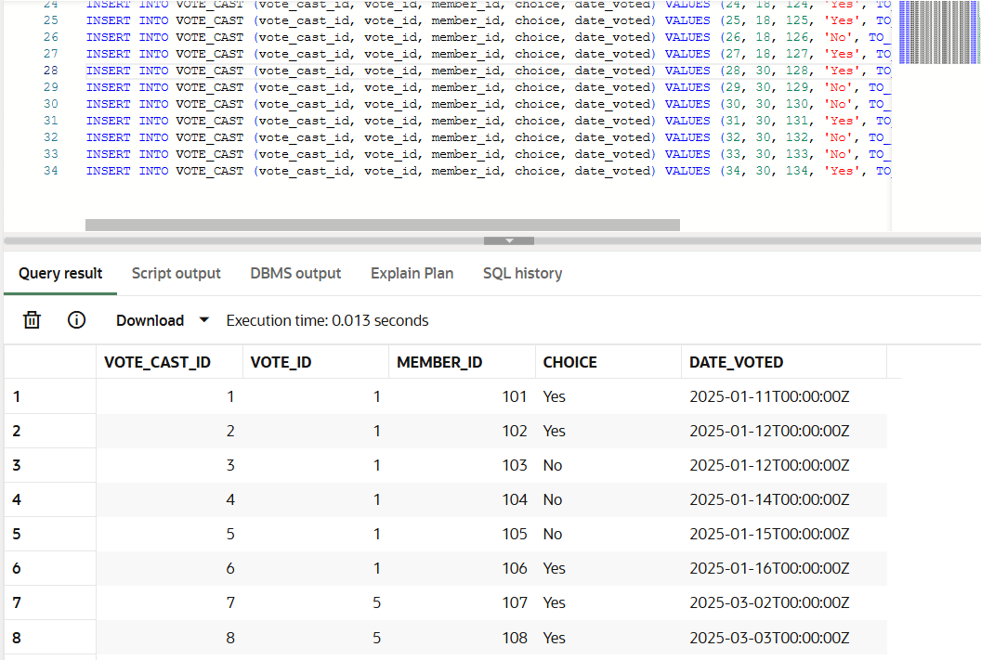

CRM MODULE

TABLE 18 - CRM_SUPPORT_TICKET

SET DEFINE OFF; -- THIS WAS USED TO TREAT "&" FUNCTION AS A NORMAL TEXT

INSERT INTO CRM_SUPPORT_TICKET (ticket_id, member_id, order_id, issue_category, priority, status, created_at, resolved_at, details) VALUES ('3821', 101, 4829, 'Delivery Delay', 'Moderate', 'Close', TO_TIMESTAMP('24/01/2025', 'DD/MM/YYYY'), TO_TIMESTAMP('26/01/2025', 'DD/MM/YYYY'), 'Item late by 2 days');
INSERT INTO CRM_SUPPORT_TICKET (ticket_id, member_id, order_id, issue_category, priority, status, created_at, resolved_at, details) VALUES ('7492', 102, 7154, 'Missing Item', 'High', 'Open', TO_TIMESTAMP('18/02/2025', 'DD/MM/YYYY'), NULL, 'One milk carton missing');
INSERT INTO CRM_SUPPORT_TICKET (ticket_id, member_id, order_id, issue_category, priority, status, created_at, resolved_at, details) VALUES ('1058', 103, 2938, 'Damaged Product', 'High', 'Close', TO_TIMESTAMP('08/03/2025', 'DD/MM/YYYY'), TO_TIMESTAMP('10/03/2025', 'DD/MM/YYYY'), 'Bottle of tea leaked');

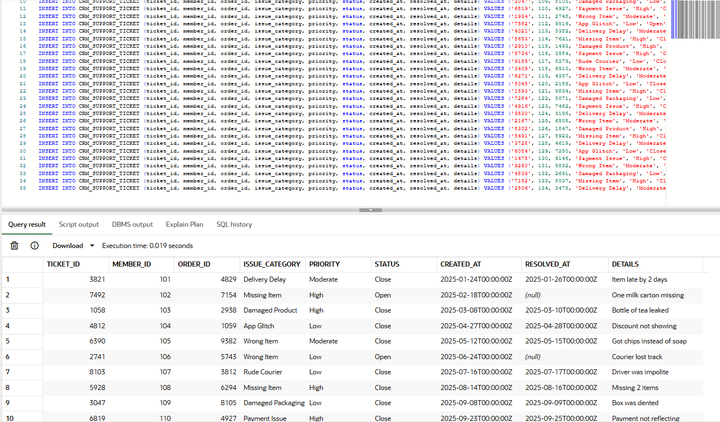

COOPERATIVE FINANCIALS MODULE

TABLE 19 - SHARE_CAPITAL_ACCOUNT

INSERT INTO SHARE_CAPITAL_ACCOUNT (account_id, member_id, share_capital_balance) VALUES (81001, 101, 5000);
INSERT INTO SHARE_CAPITAL_ACCOUNT (account_id, member_id, share_capital_balance) VALUES (81002, 102, 15000);
INSERT INTO SHARE_CAPITAL_ACCOUNT (account_id, member_id, share_capital_balance) VALUES (81003, 103, 30000);

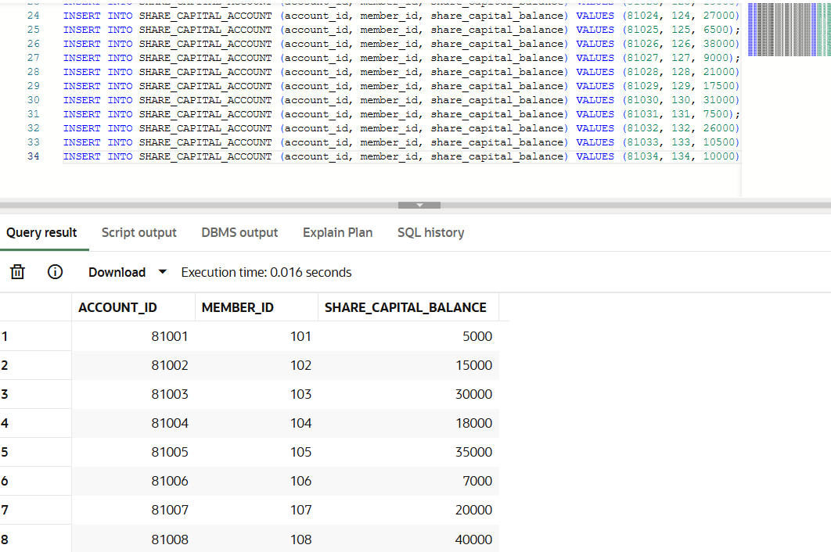

TABLE 20 - SHARE_CAPITAL_TRANSACTION

INSERT INTO SHARE_CAPITAL_TRANSACTION (transaction_id, member_id, transaction_date, transaction_type, amount, running_balance) VALUES (1, 101, TO_DATE('15/03/2025', 'DD/MM/YYYY'), 'Deposit', 1000, 1000);
INSERT INTO SHARE_CAPITAL_TRANSACTION (transaction_id, member_id, transaction_date, transaction_type, amount, running_balance) VALUES (2, 102, TO_DATE('20/03/2025', 'DD/MM/YYYY'), 'Initial Deposit', 5000, 5000);
INSERT INTO SHARE_CAPITAL_TRANSACTION (transaction_id, member_id, transaction_date, transaction_type, amount, running_balance) VALUES (3, 103, TO_DATE('05/04/2025', 'DD/MM/YYYY'), 'Deposit', 5000, 15000);

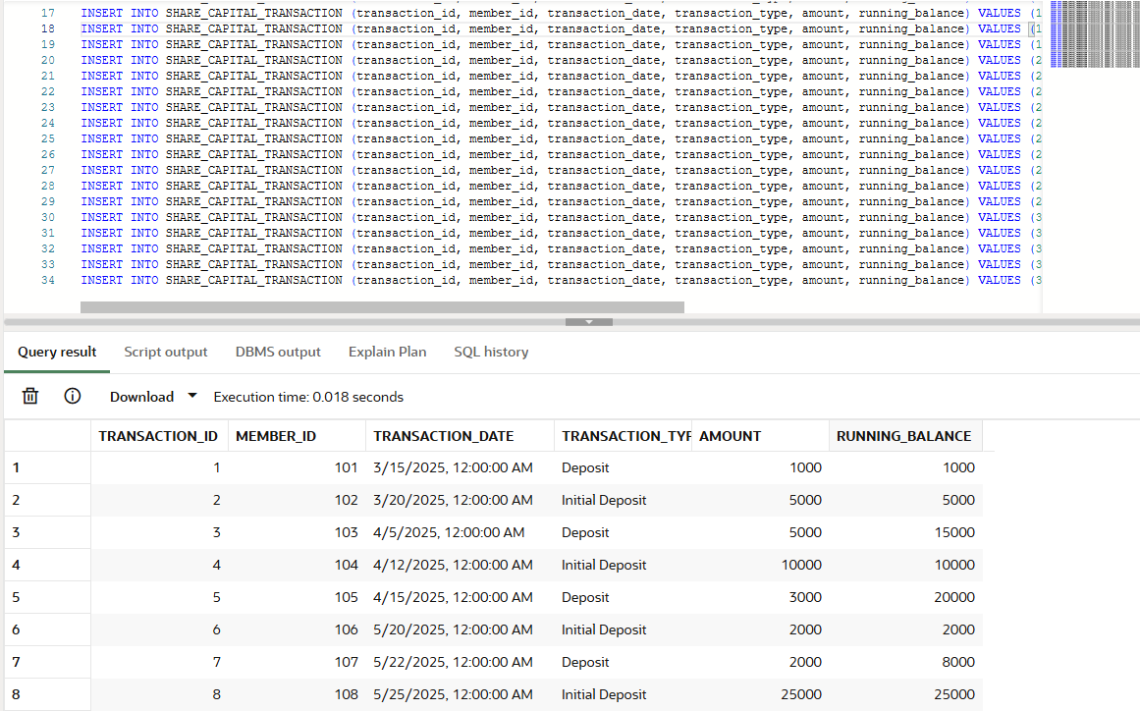

TABLE 21 - COOP_DIVIDEND_PAYOUT

SET DEFINE OFF; -- THIS WAS USED TO TREAT "&" FUNCTION AS A NORMAL TEXT
INSERT INTO COOP_DIVIDEND_PAYOUT (payout_id, member_id, fiscal_year, payout_date, total_payout_amount, payout_breakdown_notes) VALUES (1, 101, 2025, TO_DATE('15/12/2025', 'DD/MM/YYYY'), 375, 'Auto-Credited to Share Capital');
INSERT INTO COOP_DIVIDEND_PAYOUT (payout_id, member_id, fiscal_year, payout_date, total_payout_amount, payout_breakdown_notes) VALUES (2, 102, 2025, TO_DATE('15/12/2025', 'DD/MM/YYYY'), 1125, 'Transferred to Bank Account');
INSERT INTO COOP_DIVIDEND_PAYOUT (payout_id, member_id, fiscal_year, payout_date, total_payout_amount, payout_breakdown_notes) VALUES (3, 103, 2025, TO_DATE('15/12/2025', 'DD/MM/YYYY'), 2250, 'Credited to Coop Savings Account');

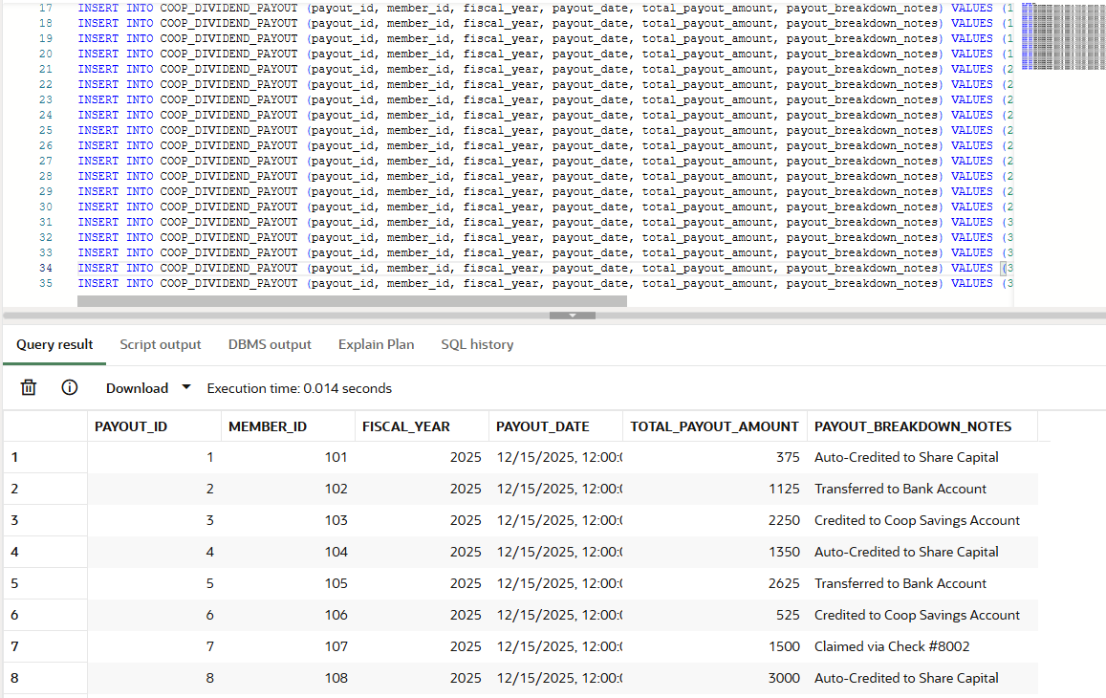

- Graphical User and Admin Interface

Interface | Description
 | Landing Page / Home Interface  Description:  The landing page serves as the main entry point of the AMC CoopMart platform, introducing users to the cooperative’s purpose and branding. It highlights the concept of a membership-based grocery system with benefits such as discounts, cashback, and community profit sharing.  Features:  - Navigation bar (Home, About, Contact, Sign Up, Partner)  - Promotional tagline and branding  - “Shop Now” call-to-action button  - Overview of services and benefits  Module:  User Interface Module (Front Page Navigation & Branding)
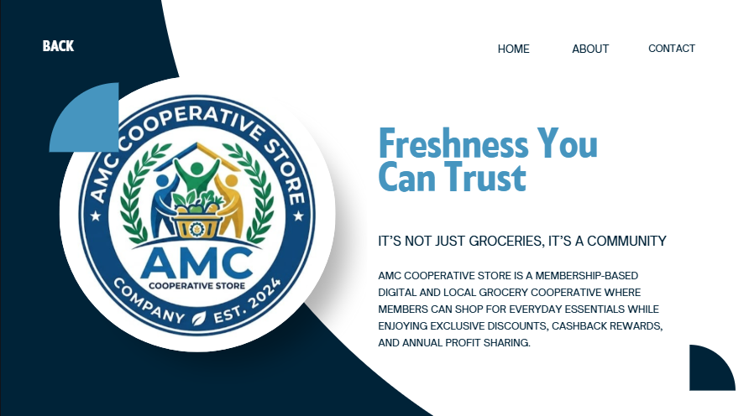  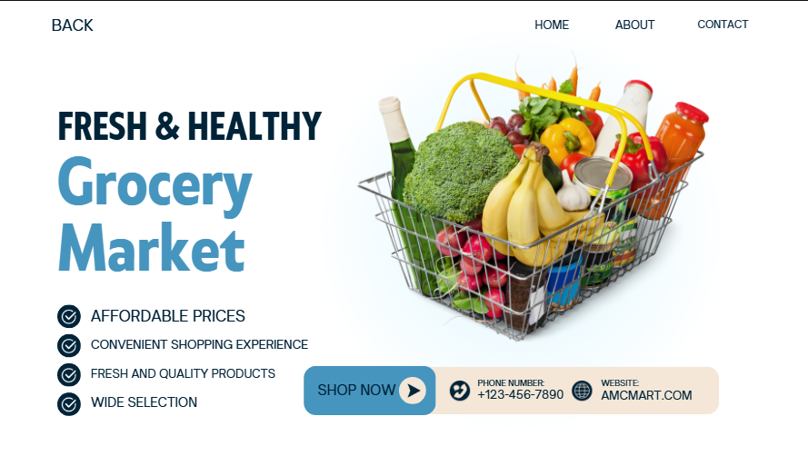 | About / Market Overview Page  Description:  This page provides users with an overview of AMC CoopMart market, emphasizing product quality, affordability, and convenience.  Features:  - Business description  - Key selling points (Fresh products, affordable prices, wide selection)  - Contact details (phone, website)  - Navigation controls
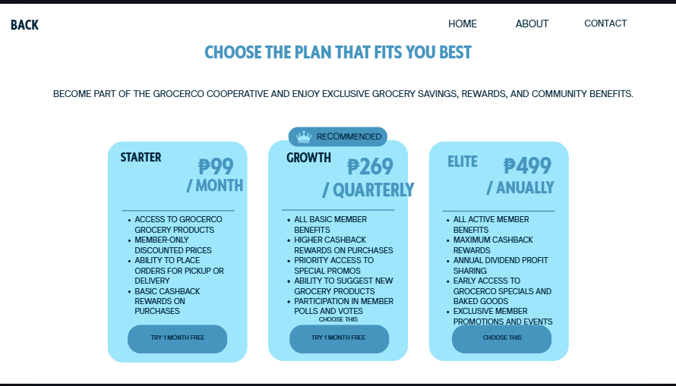 | Membership Plans Page  Description:  This interface allows users to choose between different membership tiers, each offering varying levels of benefits and rewards.  Features:  - Tier options (Starter, Growth, Elite)  - Pricing display (monthly, quarterly, yearly)  - Benefits comparison per plan  - “Choose Plan” button
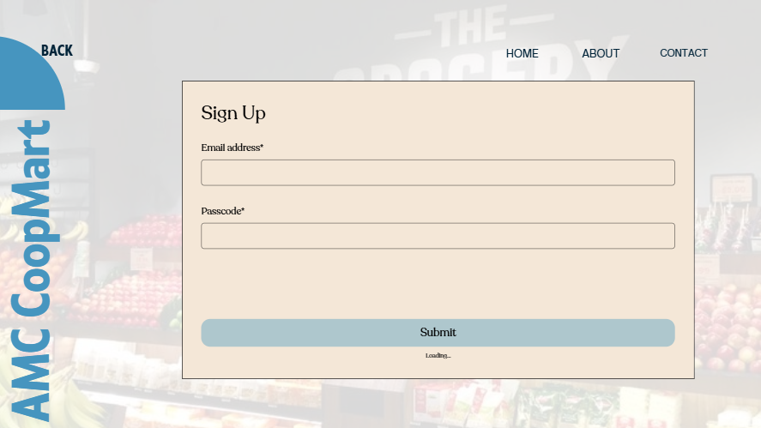 | Sign Up Page  Description:  This page enables new users to register and become members of the platform.  Features:  - Input fields (Email, Passcode)  - Submit button  - Privacy/security notice
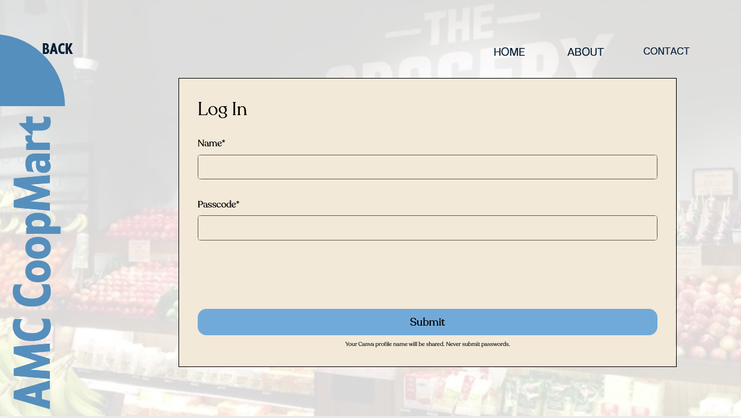 | Log In Page  Description:  The login interface allows existing users to securely access their accounts using their username and their very own unique passcode for their privacy.  Features:  - Input fields (Name, Passcode)  - Submit/Login button  - Security reminder
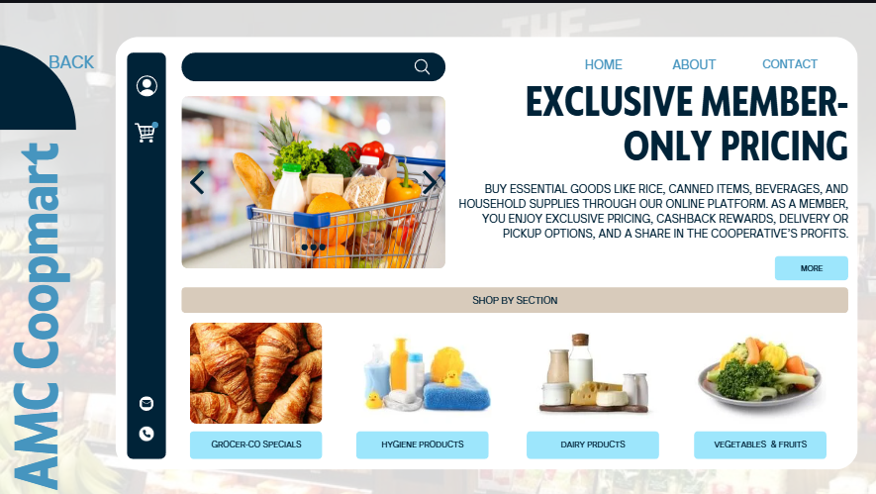 | Shop by Section Page  Description:  This page organizes products into categories, making it easier for users to browse items.  Features:  - Category navigation (Specials, Hygiene, Dairy, Vegetables & Fruits)  - Product browsing interface  - Member-exclusive pricing highlight
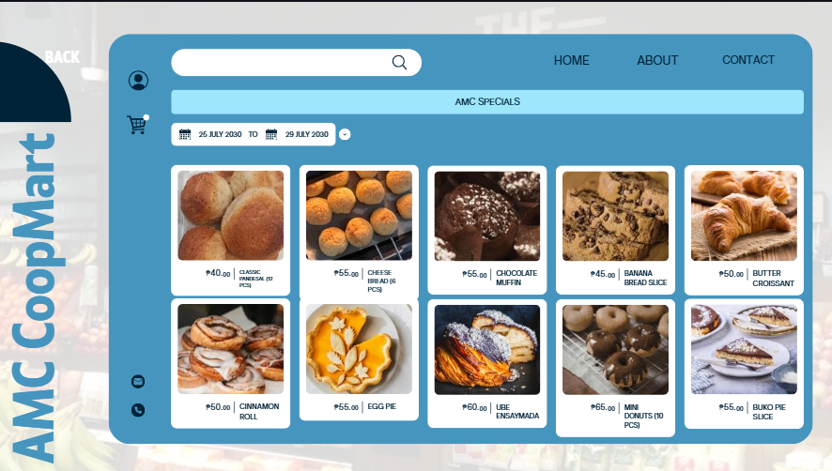 | AMC CoopMart Specials Page  Description:  Displays promotional and limited-time offers available to members.  Features:  - Product listings with prices  - Promotional date range  - Highlighted discounted items
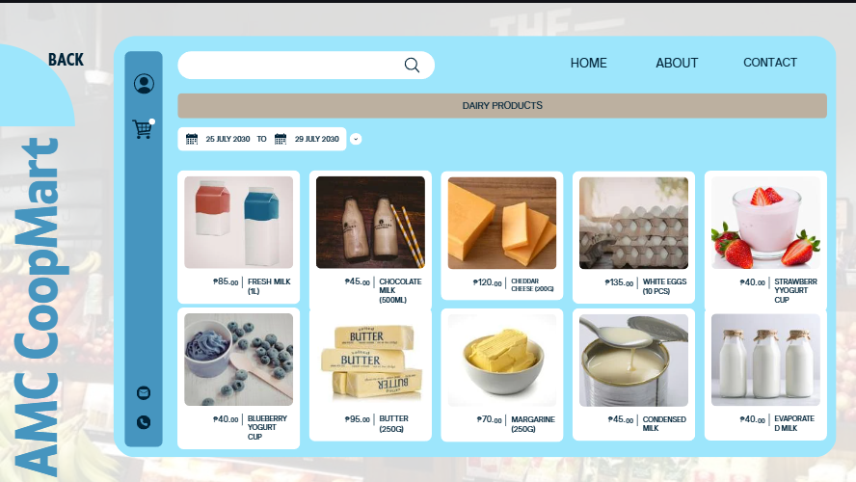 | Dairy Products Page  Description:  Shows all dairy-related items available for purchase.  Features:  - Product list with prices and quantities  - Organized layout for easy selection
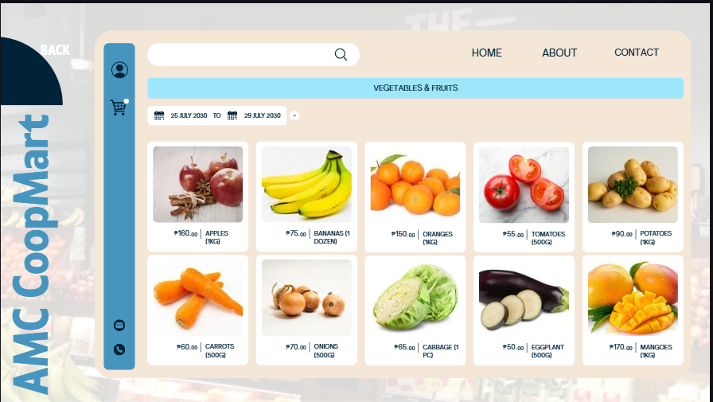 | Vegetables & Fruits Page  Description:  Displays fresh produce available in the store.  Features:  - Categorized fresh items  - Pricing per weight/unit  - Clean product layout
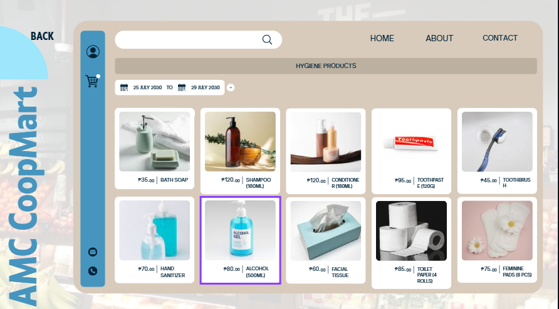 | Hygiene Products Page  Description:  Provides a list of personal care and hygiene products.  Features:  - Product names and prices  - Organized grid layout  - Essential goods listing
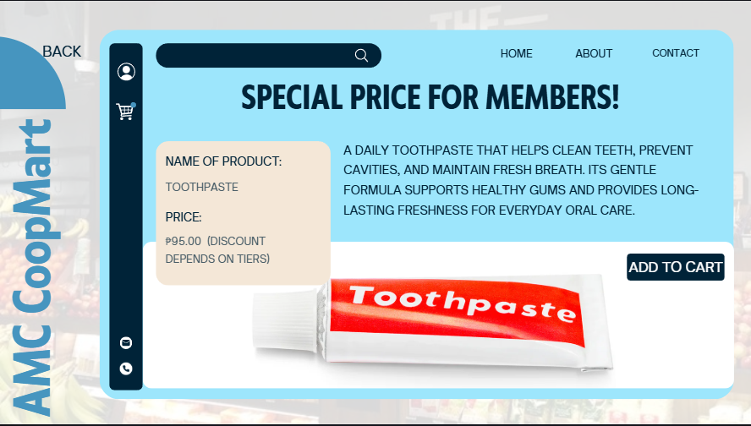 | Product Details Page  Description:  This page shows detailed information about a selected product.  Features:  - Product name and price  - Description of item  - “Add to Cart” button  - Member pricing indication
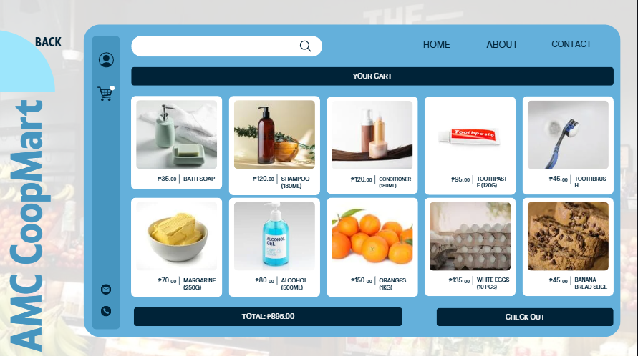 | Cart Page  Description:  Displays all selected items before checkout.  Features:  - List of added products  - Individual prices  - Total cost calculation  - Checkout button
 | Checkout Page  Description:  Allows users to finalize their purchase by selecting delivery and payment options.  Features:  - Order summary  - Delivery method (Pickup / Delivery)  - Payment options (GCash, Bank Transfer, Cash)  - Input fields for delivery details  - Confirm/Cancel buttons
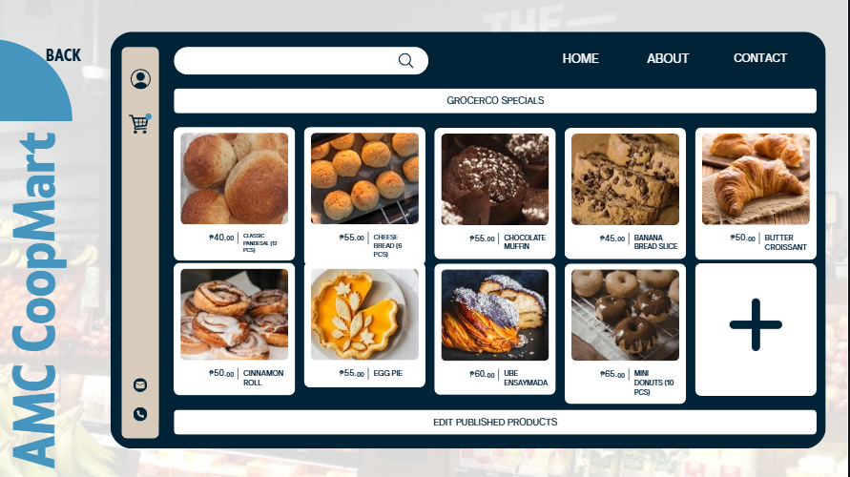 | Admin - Edit Products Page  Description:  This interface allows administrators to modify existing product listings.  Features:  - Edit product details  - Update pricing and descriptions  - Product management controls
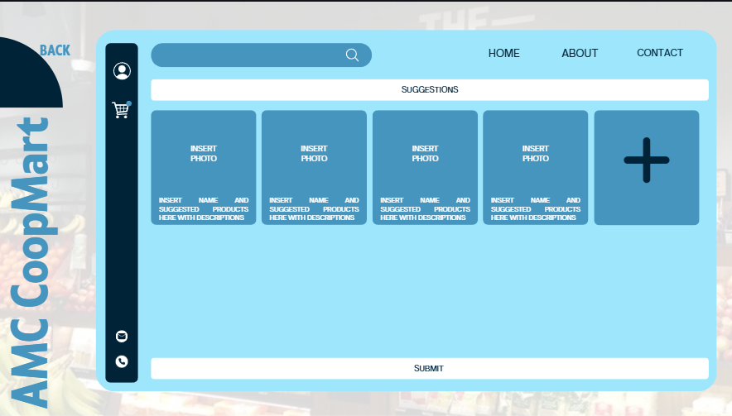 | Suggestions Page  Description:  Allows members to suggest new products to be added to the store.  Features:  - Input fields for product suggestions  - Image upload option  - Submit button
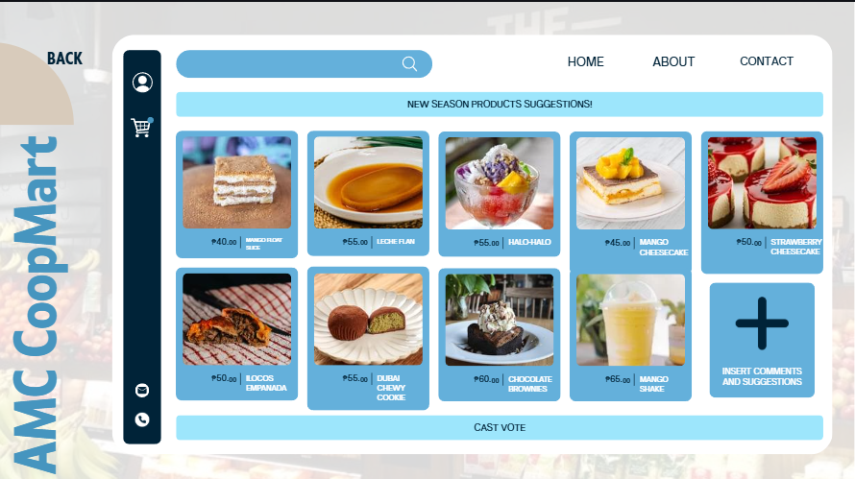 | Voting Page (New Season Products)  Description:  Members can vote on suggested products for future availability.  Features:  - Product suggestions list  - Voting system  - Comment section
 | Product Editing (Keep It Orig)  Description:  Admin interface for refining or replacing product entries.  Features:  - Edit product name, price, description  - Replace product option  - Maintain originality control
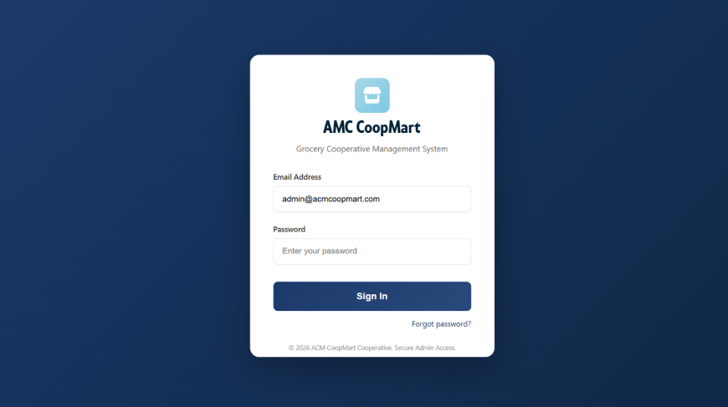 | Statistics Page  Description:  Displays analytical insights about product performance and system usage.  Features:  - Data visualization (implied)  - Product performance tracking  - User activity insights
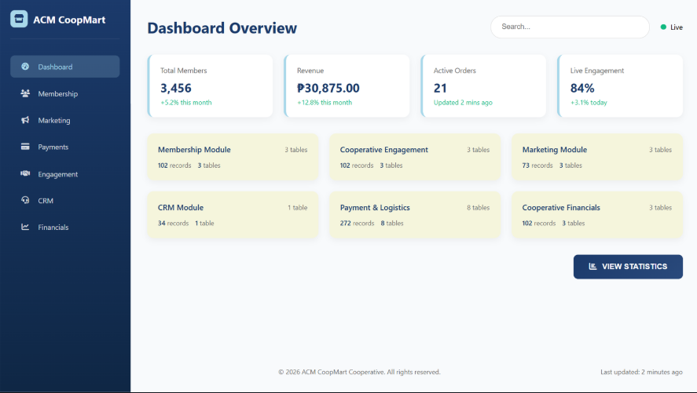 | Admin Dashboard Overview  Description:  This serves as the main control panel for administrators, providing access to all management functions of the system.  Features:  - Navigation to product management, orders, suggestions, and analytics  - Quick overview of system activity  - Admin control access
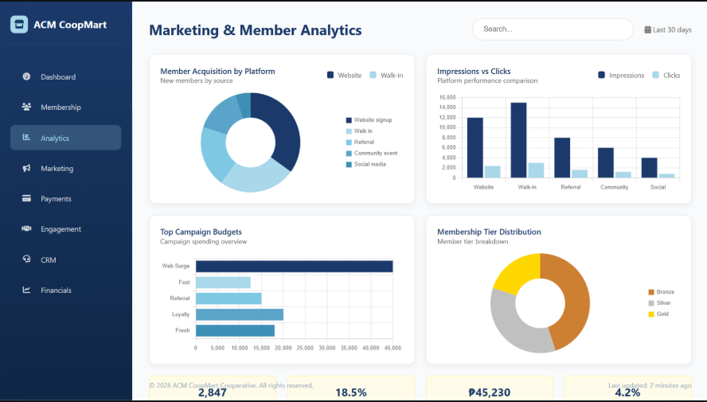 | Marketing & Member Analytics  Description:  A specialized view focusing on growth trends and the effectiveness of different marketing platforms.  Charts & Visuals:  - Member Acquisition by Platform (Donut Chart): Breaks down how members joined, including Website Sign-up, Walk-in, Referral, Community Event, and Social Media.  - Top Campaign Budgets (Bar Chart): Ranks different marketing campaigns based on their allocated budget.  - Impressions vs. Clicks by Platform (Grouped Bar Chart): Compares user engagement across various digital channels.  - Membership Tier Distribution (Donut Chart): Shows the ratio of members across Bronze, Silver, and Gold tiers
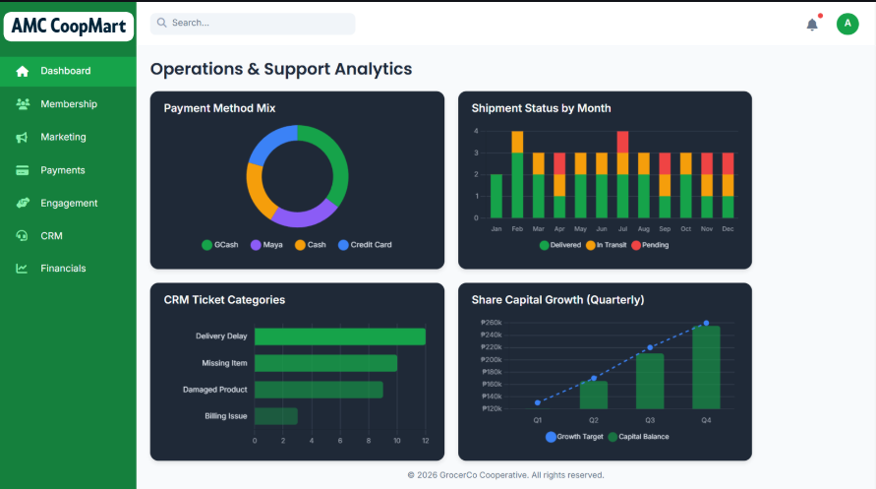 | Operations & Support Analytics  Description: Provides insights into the logistical and support-side performance of the cooperative.  Charts & Visuals:  - Payment Method Mix (Donut Chart): Visualizes the preference between E-Cash, Maya, Cash, and Credit Card.  - Shipment Status by Month (Stacked Bar Chart): Tracks the volume of Delivered, In-Transit, and Pending shipments over time.  - CRM Ticket Categories (Horizontal Bar Chart): Identifies common support issues such as Delivery Delay, Missing Item, Damaged Product, and Billing Issue.  - Share Capital Growth (Line & Bar Combo Chart): Monitors quarterly capital balance against growth targets.
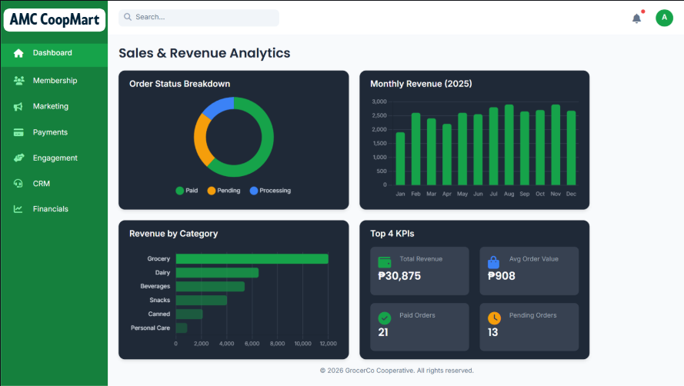 | Sales & Revenue Analytics  Description: Detailed tracking of financial performance and order fulfillment status.  Charts & Visuals:  - Order Status Breakdown (Donut Chart): Categorizes orders into Paid, Pending, and Processing.  - Monthly Revenue 2025 (Bar Chart): Displays revenue trends across the calendar year.  - Revenue by Category (Horizontal Bar Chart): Breaks down income by product types: Grocery, Dairy, Beverages, Snacks, Canned, and Personal Care.  - Top 4 KPIs Card: Summarizes Total Revenue (₱30,875), Avg Order Value (₱908), Total Orders (21), and Pending Orders (13).
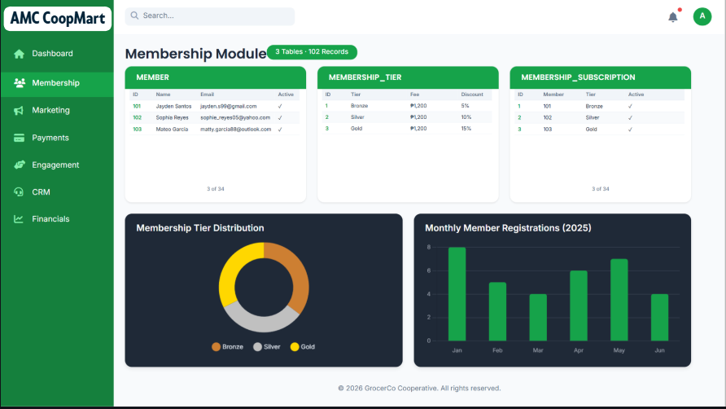 | Membership Module (Data Management)  Description: Allows admins to manage detailed records of all cooperative participants and their subscription statuses.  Features:  - Member Table: Lists individual member details including ID, Name, Email, and Active Status.  - Membership Tier Table: Defines the parameters for different tiers, showing ID, Title, Fee, and Discount percentage.  - Membership Subscription Table: Tracks which member is assigned to which tier and their current status.  - Monthly Member Registrations (Bar Chart): Visualizes new member sign-ups on a month-to-month basis.
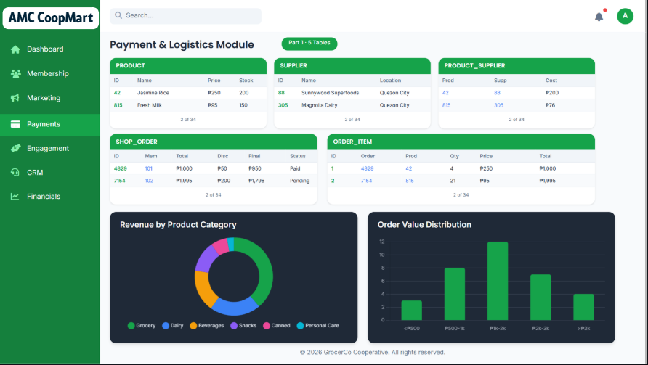  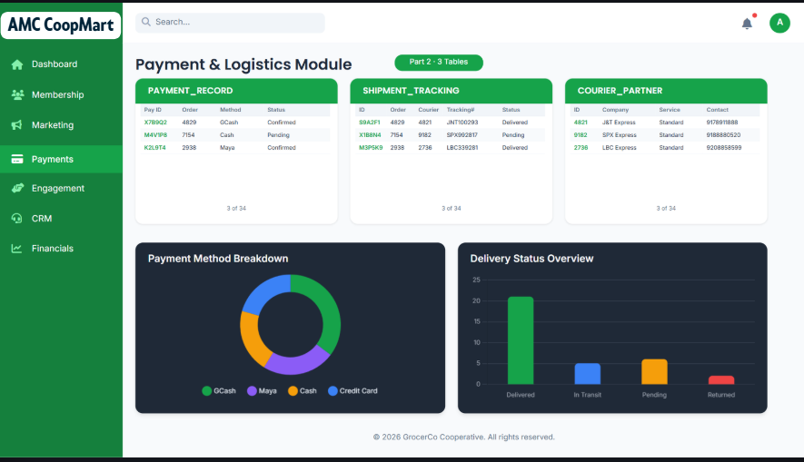 | Payments & Logistics Module (Data Management)  Description: This module is dedicated to the administration of transactional data and the fulfillment process, ensuring all orders are tracked from payment to final delivery.  Features:  Data Summary: Displays that the module consists of 4 tables with a total of 212 records.  PRODUCT Table: Manages the inventory catalog, including fields for ID, Name, Category, and Price.  ORDER Table: Tracks member purchases, showing the Order ID, Member_ID, Total Amount, and current Order Status.  PAYMENT Table: Logs financial transactions with ID, Order_ID, Payment Method (e.g., GCash, Cash), and Status.  SHIPPING Table: Handles logistics details, including ID, Order_ID, Shipment Status, and estimated Delivery Date.  Logistics & Payment Analytics  Description: A visual analytics dashboard that provides real-time insights into payment trends and delivery performance.  Charts & Visuals:  - Payment Method Mix (Donut Chart): Visualizes the distribution of payments across different platforms such as E-Cash, Maya, Cash, and Credit Card.  - Shipment Status by Month (Stacked Bar Chart): Provides a month-to-month comparison of order fulfillment, categorized by "Delivered," "In-Transit," and "Pending" statuses.  - Monthly Revenue 2025 (Bar Chart): Tracks the total revenue generated each month to identify seasonal peaks and growth.  - Order Status Breakdown (Donut Chart): Shows the percentage of orders that are currently Paid, Pending, or still in Processing.
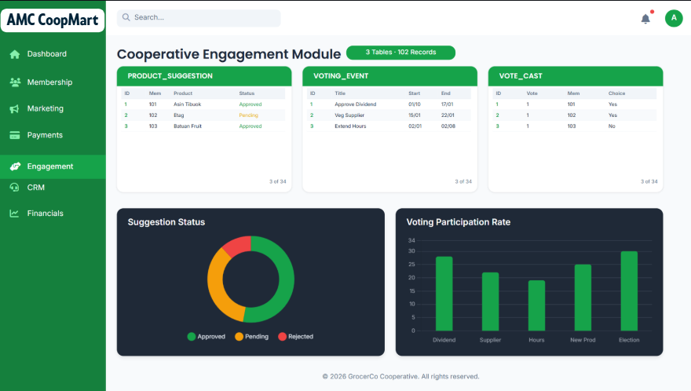 | Engagement & Suggestions Module  Description:  This module allows administrators to manage member-submitted product ideas and community voting initiatives.  Features:  - Data Summary: Displays that there are 3 tables with a total of 102 records.  - SUGGESTION Table: Lists member-submitted products with fields for ID, Member_ID, Name, and Category.  - VOTING_EVENT Table: Manages active polls, showing the ID, Title, Start Date, and End Date.  - VOTE_CAST Table: Tracks individual votes with ID, Member_ID, and Voting_Event_ID.  - Monthly Engagement Activity (Area Chart): Visualizes the volume of member suggestions and votes over the course of the year.  - Top Suggested Categories (Horizontal Bar Chart): Ranks the most popular product categories suggested by the community
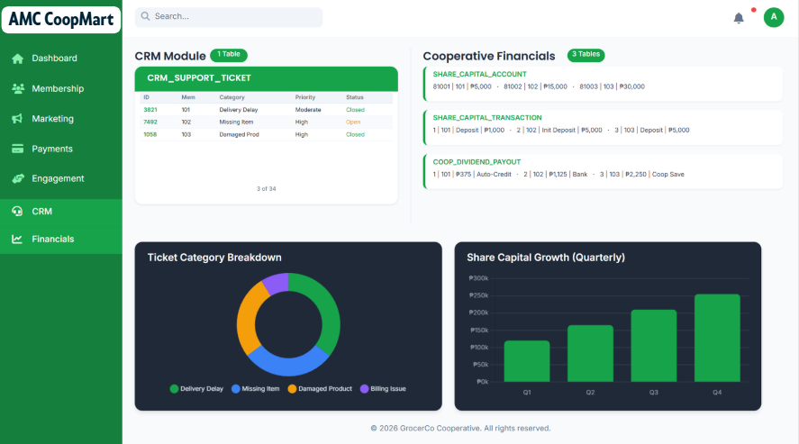  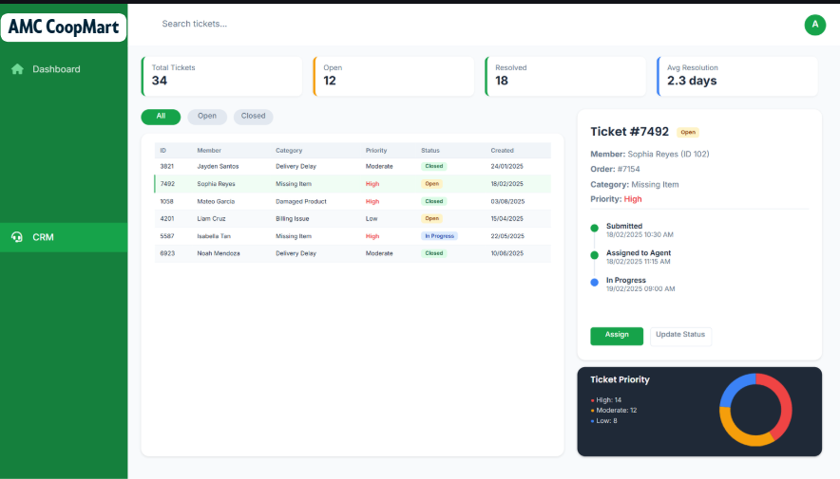  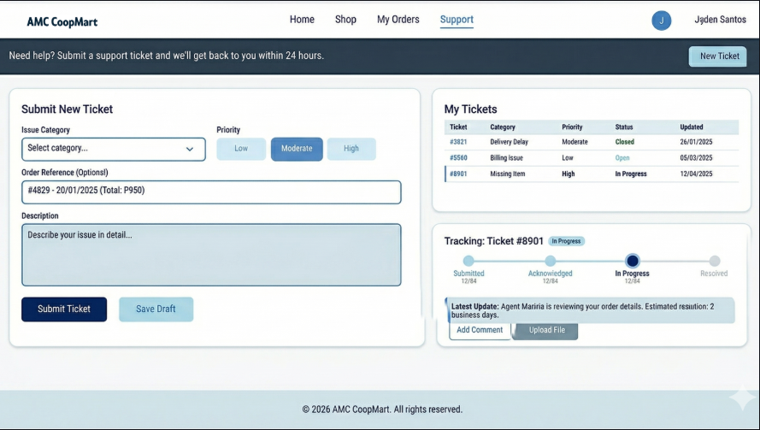 | CRM & Support Module  Description:  A dedicated interface for managing member inquiries and resolving support tickets.  Features:  - Data Summary: Indicates 1 table containing 14 total records.  - CRM_SUPPORT_TICKET Table: A centralized log of all issues, including Ticket ID, Member_ID, Category (e.g., Billing, Delivery), and Status (e.g., Pending, Resolved).  - Monthly Support Tickets (Line Chart): Tracks the frequency of support requests over time to identify seasonal trends.  - Ticket Resolution Status (Donut Chart): Provides a quick visual of the percentage of Resolved versus Pending tickets.
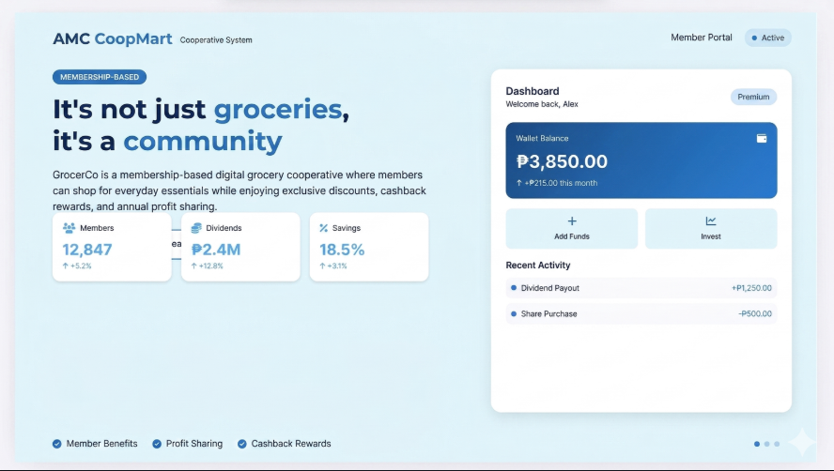  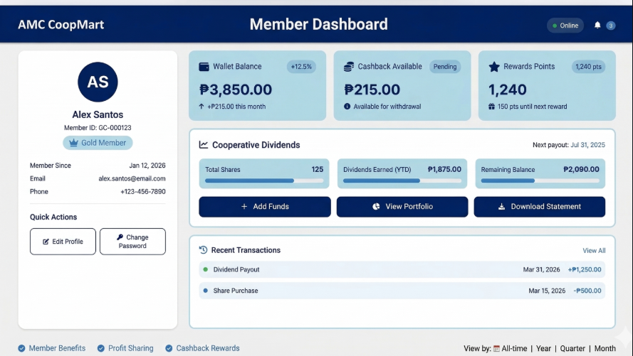  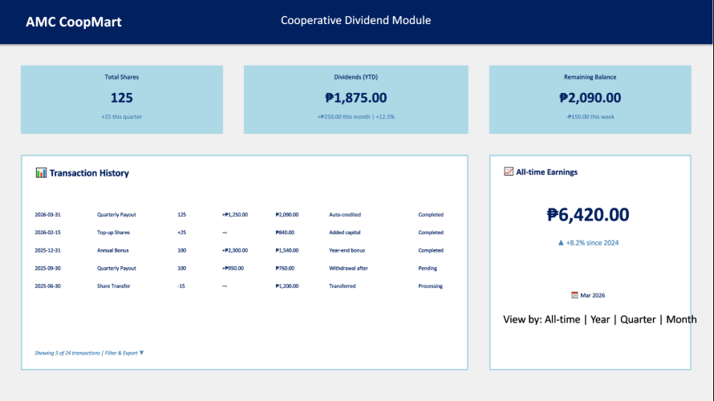  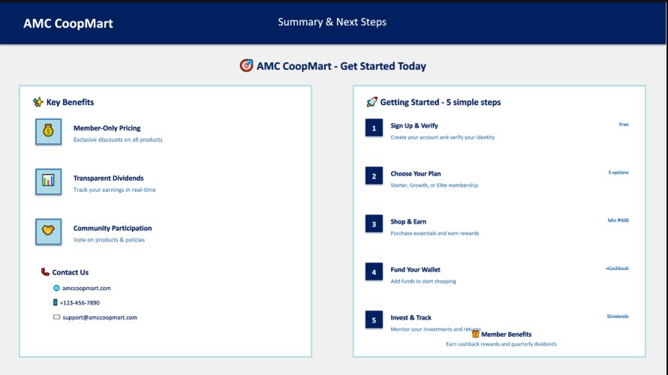   | Financials & Dividend Module  Description: Provides transparency into the cooperative's capital growth and the distribution of annual dividends to its members.  Features:  - Data Summary: Shows 3 tables with 102 records.  - SHARE_CAPITAL Table: Records the capital contributions with ID, Member_ID, and Amount.  - DIVIDEND Table: Manages the profit-sharing payouts, listing ID, Member_ID, and the specific Dividend Amount.  - TRANSACTION Table: A master log of financial moves including ID, Member_ID, Amount, and Date.  - Share Capital Growth (Combo Chart): A line and bar graph showing actual capital balance against growth targets.  - Monthly Dividend Distributions (Bar Chart): Visualizes the total dividends paid out to members each month.

- Proof of Data Gathering

To ensure the validity, authenticity, and ethical use of data in this study, the researchers secured official authorization from AMC Cooperative Store prior to data collection. A formal request was submitted to the cooperative, and upon review, permission was granted to access selected operational datasets relevant to the objectives of the study.

The proof of data access and information release, as documented in the attached certification, confirms that the dataset was obtained directly from AMC Cooperative Store, located in Matandang Balara, Quezon City. The document was duly prepared and endorsed by the Data Management Officer and subsequently approved by the Operations Manager and released by the Chief Administrative Officer, thereby establishing the legitimacy of the data source.

The dataset provided includes multiple structured tables essential for analysis, namely: (1) product data containing product identifiers, descriptions, pricing, stock quantities, and categories; (2) product suggestion records reflecting supply considerations and approval statuses; (3) share capital account and transaction logs detailing member financial activities; (4) cooperative dividend payout records; and (5) a registry of accredited cooperatives. These datasets collectively support comprehensive data analysis, including descriptive analytics, clustering, and pattern identification.

All data were obtained in a controlled and authorized manner, with strict adherence to confidentiality and data privacy protocols. The cooperative explicitly stated that the dataset is to be used solely for academic purposes. No personally identifiable information (PII) was disclosed, and all data handling procedures complied with ethical standards in data management.

This formal acquisition process ensures that the study is grounded on reliable, real-world data, thereby enhancing the credibility and integrity of the research findings.

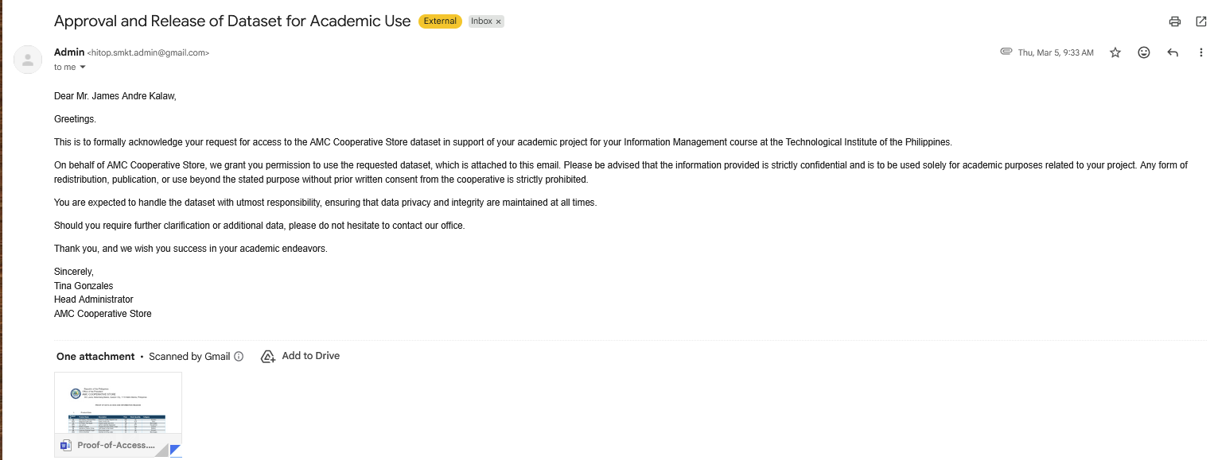
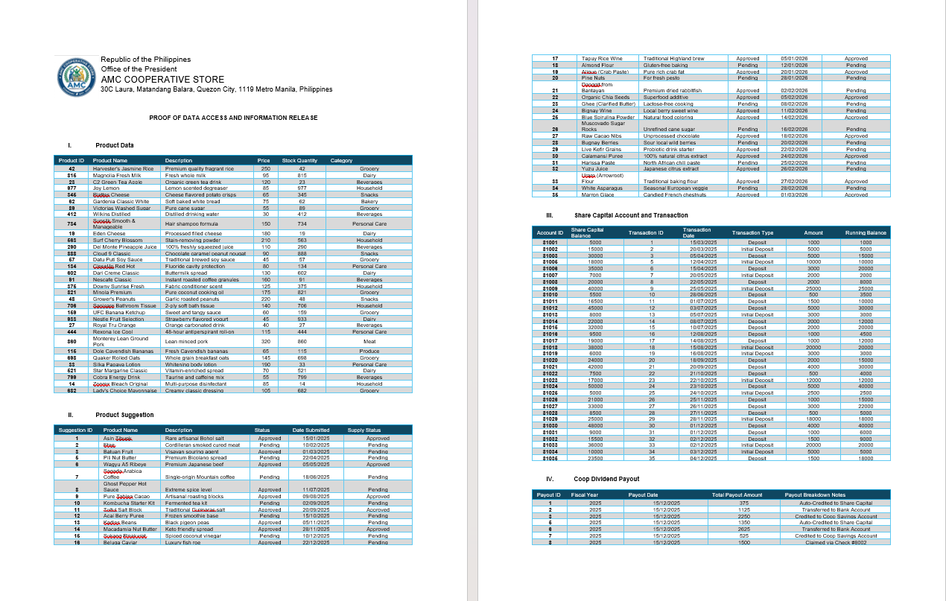
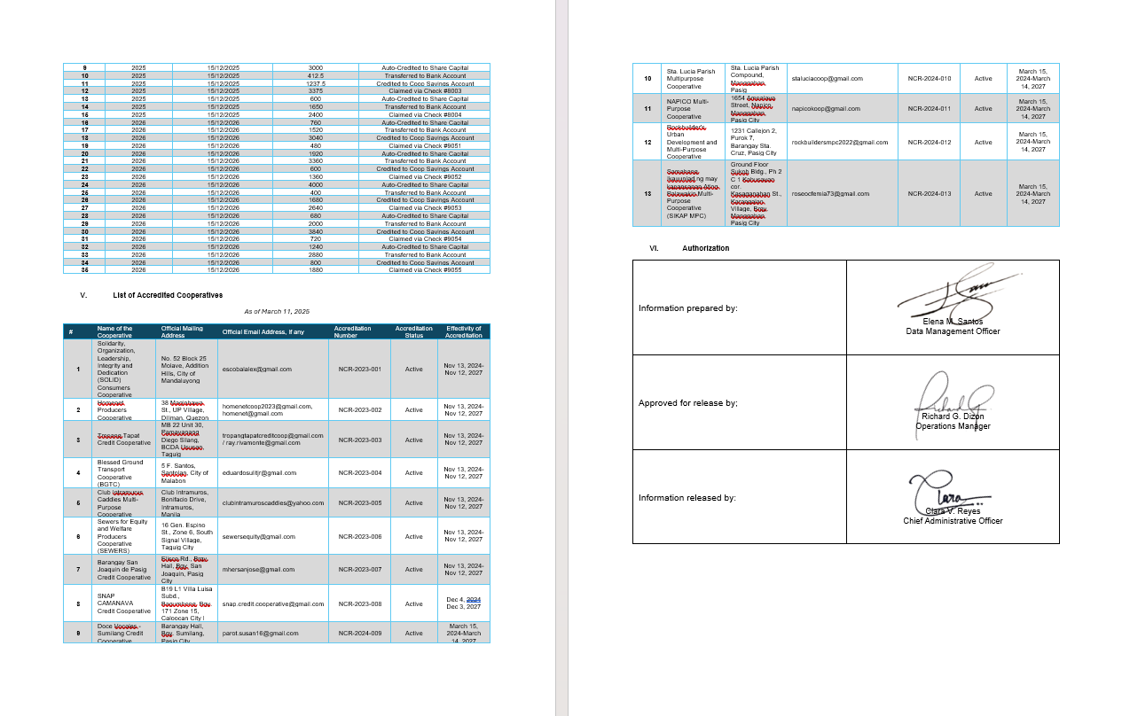

- Problem and Solutions

- Restricting and Sorting Data - WHERE clause, Comparison Condition, Logical Condition

Problem:
- The cooperative wants to find active members who joined in 2025 and registered through a specific platform which is by website, then sort them by join date.

Tables Used:
- MEMBER
- ACQUISITION_PLATFORM
Applied SQL Functions:
- WHERE
- Comparison (=, >=)
- Logical Condition (AND)
- ORDER BY
- JOIN (Additional)

Solution:

Query:

SELECT
m.member_id,
m.full_name,
m.email,
m.join_date,
a.platform_name
FROM
member m
INNER JOIN
acquisition_platform a ON m.acquisition_platform_id = a.platform_id
WHERE -- WHERE clause initiates the filtering of the data
m.is_active = 1 -- Comparison Condition: Checks for exact mathematical equality (=)
AND -- Logical Condition: Mandates that the next rule must ALSO be true
m.join_date >= TO_DATE('2025-01-01', 'YYYY-MM-DD') -- Comparison Condition: Checks if the date is greater than or equal to (>=)
AND -- Logical Condition: Mandates that the final rule must ALSO be true
a.platform_name = 'Website signup' -- Comparison Condition: Checks for an exact text match (=)
ORDER BY -- ORDER BY sorts the output
m.join_date DESC;

Output:
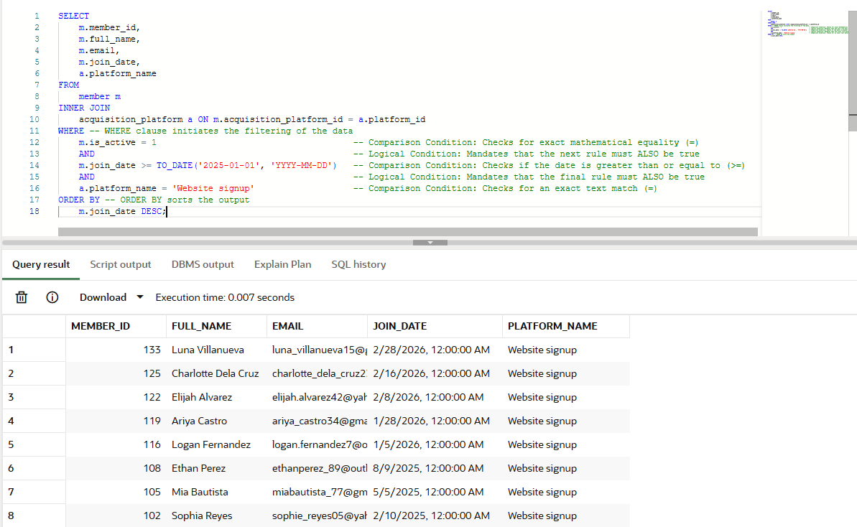

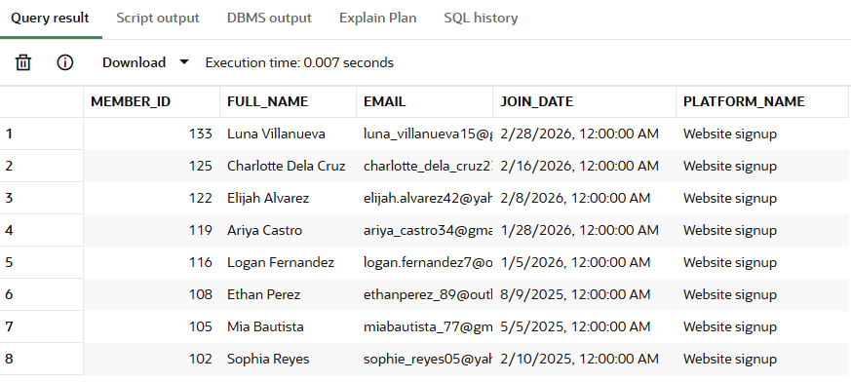
Description:
- This query retrieves a precise list of active members who joined in 2025 specifically via the "Website Sign Up" channel by linking the member records directly to the platform catalog. It ensures accurate filtering by explicitly converting the date format and performing an exact text match, ultimately sorting the newest sign-ups to the top of the list.

Insight
- Marketing and data analytics teams rely heavily on this exact type of query to calculate the Return on Investment (ROI) of their digital campaigns, allowing them to confidently track exactly how many retained, active users were successfully generated by their website over a specific financial quarter.

- Using Single-Row Functions to Customize Output - General, Character, Number, Conversion, Date Functions

Problem:
- The cooperative wants a cleaner membership report with readable names, masked contact numbers, and formatted dates for presentation.

Tables Used:
- MEMBER
- MEMBERSHIP_SUBSCRIPTION
- MEMBERSHIP_TIER

Applied SQL Functions:
- NVL
- UPPER
- SUBSTR
- ROUND
- TO_CHAR

Solution:

Query:

SELECT m.member_id,
UPPER(m.full_name) AS member_name, -- character function
NVL(m.phone_number, 'NO NUMBER') AS contact_number, -- general function
SUBSTR(m.email, 1, 5) || '***' AS masked_email, -- character function
ROUND(t.annual_fee, 2) AS annual_fee, -- number function
TO_CHAR(m.join_date, 'Month DD, YYYY') AS formatted_join_date -- date function
FROM member m
JOIN membership_subscription s
ON m.member_id = s.member_id
JOIN membership_tier t
ON s.tier_id = t.tier_id;

Output:

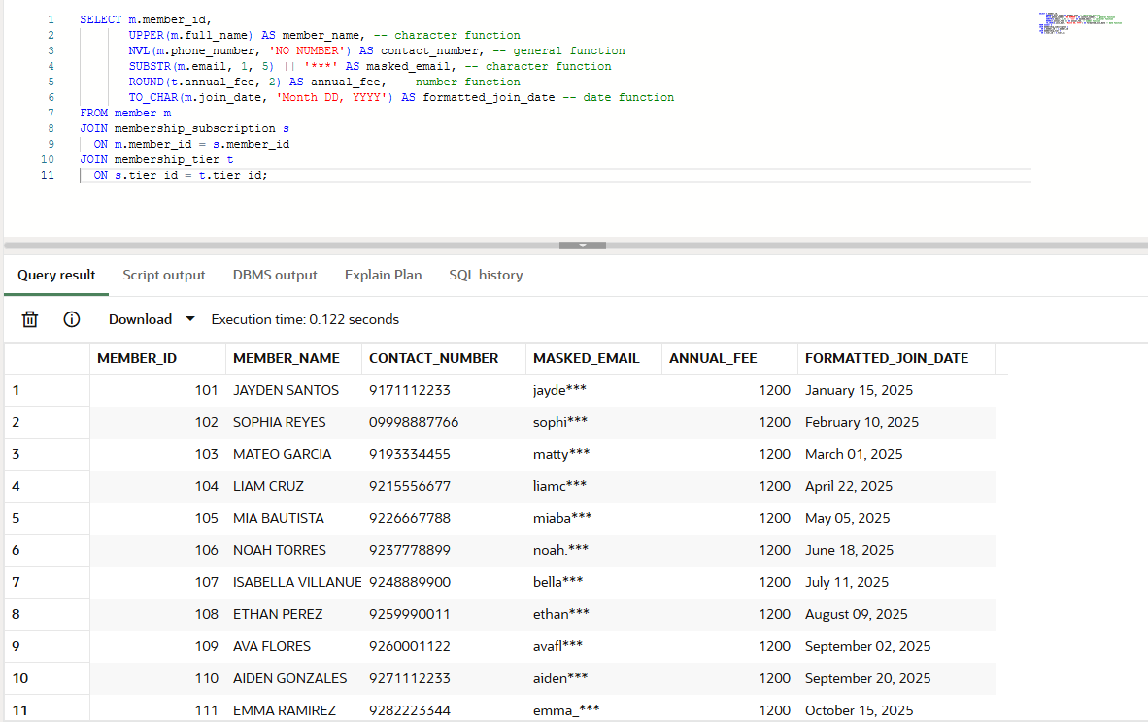
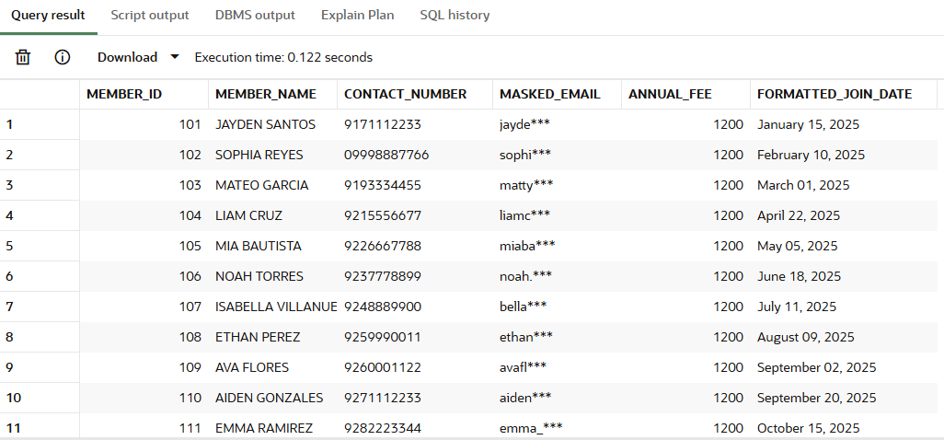
Description
- This query creates a formatted report for members and their membership tier. It converts names to uppercase, hides part of the email, shows a default value if the phone number is missing, rounds the annual fee, and formats the join date into a more readable form.
Insights
- This is useful for printed reports, dashboards, and presentations because the output looks cleaner and easier to read. It also shows how single-row functions can improve display without changing the stored data. The cooperative can use this for membership summaries and admin review.

- Using Implicit and Explicit Data Type Conversion - TO_CHAR, TO_NUMBER, TO_DATE

Problem:
- The finance team wants to display orders and dates in a readable format while also using a numeric threshold written as text in the query.

Tables Used:
- SHOP_ORDER

Applied SQL Functions:
- TO_CHAR
- TO_NUMBER
- TO_DATE

Solution:

Query:

SELECT o.order_id,
TO_CHAR(o.order_placed_at, 'YYYY-MM-DD') AS order_date_text, -- date to text
TO_NUMBER('300') AS minimum_amount, -- text to number
o.final_total_applied
FROM shop_order o
WHERE o.final_total_applied > TO_NUMBER('300') -- explicit conversion
AND TRUNC(o.order_placed_at) BETWEEN TO_DATE('2025-01-01', 'YYYY-MM-DD')
AND TO_DATE('2025-12-31', 'YYYY-MM-DD'); -- text to date

Output:
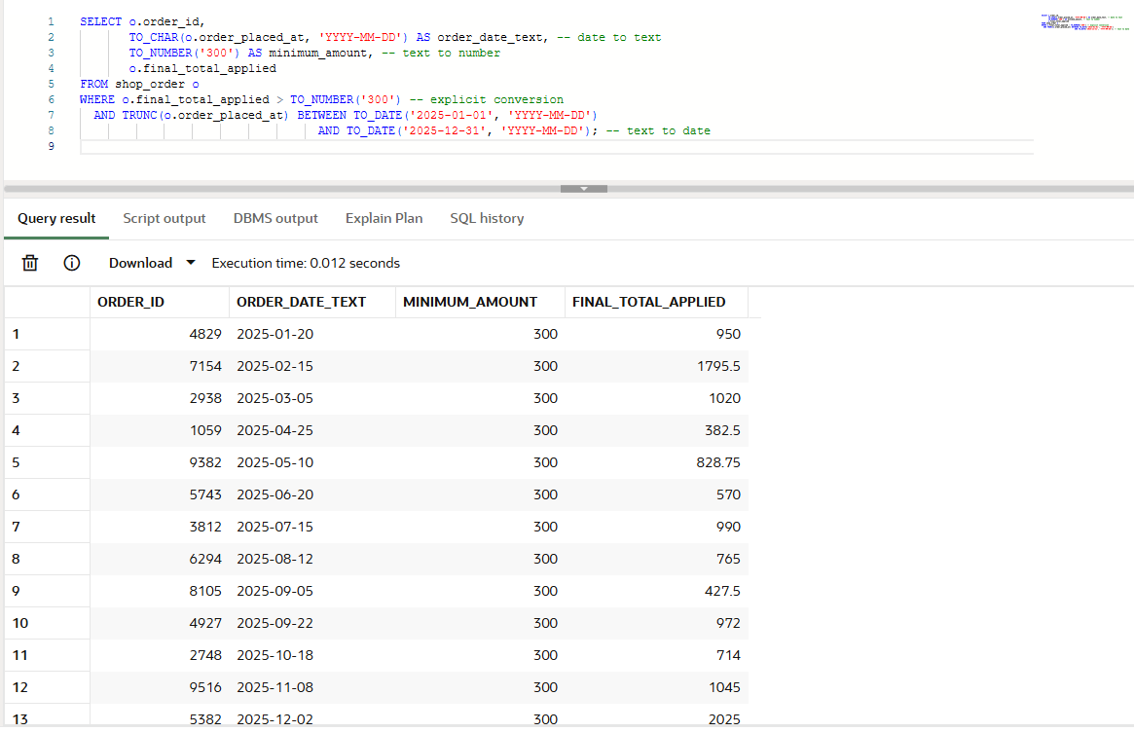
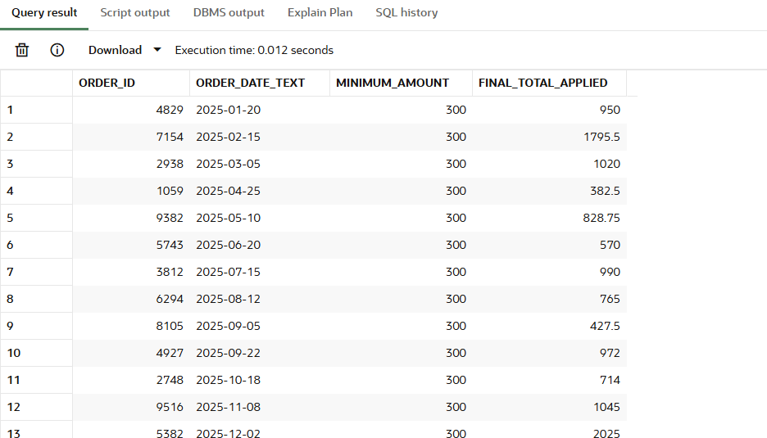

Description
- This query converts the order date to text for display, converts a string value into a number for comparison, and filters orders within a specific year.
Insights
- This demonstrates how Oracle can convert values when needed, which is useful when user input or imported data comes in text form. It is practical for reports, filters, and date-based summaries. It also shows that data can be displayed differently without changing the actual stored values.

- Using Multiple-Row Functions to Customized Output -

Problem:
- The cooperative wants to know the most expensive product in the store.

Tables Used:
- PRODUCT

Applied SQL Functions:
- PRODUCT

Solution:

Query:

SELECT product_name, price
FROM product
WHERE price = (SELECT MAX(price) FROM product); -- finds the highest product price


Output:

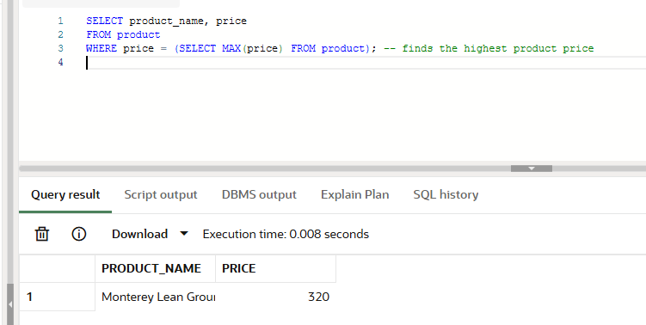
Description
- This query finds the product with the highest price by using the MAX function in a subquery.
Insights
- This helps the cooperative identify premium items and understand which products are at the top of the price range. It is useful for pricing analysis, comparison with supplier costs, and checking whether expensive products are still reasonable for members. It can also guide future product selection.

- Reporting Aggregated Data Using Group Functions

Problem:
- The cooperative wants to see how many orders exist under each order status and how much money each status represents.

Tables Used:
- SHOP_ORDER

Applied SQL Functions:
- COUNT
- SUM
- GROUP BY

Solution:

Query:

SELECT o.order_status,
COUNT(o.order_id) AS total_orders, -- counts orders per status
SUM(o.final_total_applied) AS total_sales -- totals sales per status
FROM shop_order o
GROUP BY o.order_status
ORDER BY total_sales DESC;

Output:
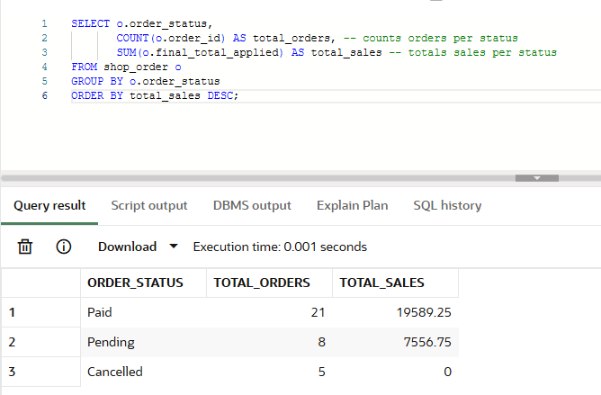
Description
- This query groups orders by status and calculates both the number of orders and the total sales amount for each status.
Insights
- This shows which order status appears most often and which one contributes the most money. It helps the cooperative understand whether many orders are still pending, already paid, or already completed. It can also be used to monitor operational flow and sales activity.

- Displaying Data from Multiple Tables - Oracle Proprietary Syntax and ANSI/SQL 99 Syntax

Problem:
- The cooperative wants to see which member bought which product and how much was ordered.

Tables Used:
- MEMBER
- SHOP_ORDER
- ORDER_ITEM
- PRODUCT

Applied SQL Functions:
- Oracle proprietary join syntax
- ANSI/SQL 99 join syntax

Solution:

Query:

Oracle Proprietary Syntax

SELECT m.full_name,
o.order_id,
p.product_name,
oi.quantity,
oi.line_total
FROM member m, shop_order o, order_item oi, product p
WHERE m.member_id = o.member_id
AND o.order_id = oi.order_id
AND oi.product_id = p.product_id;

Output:

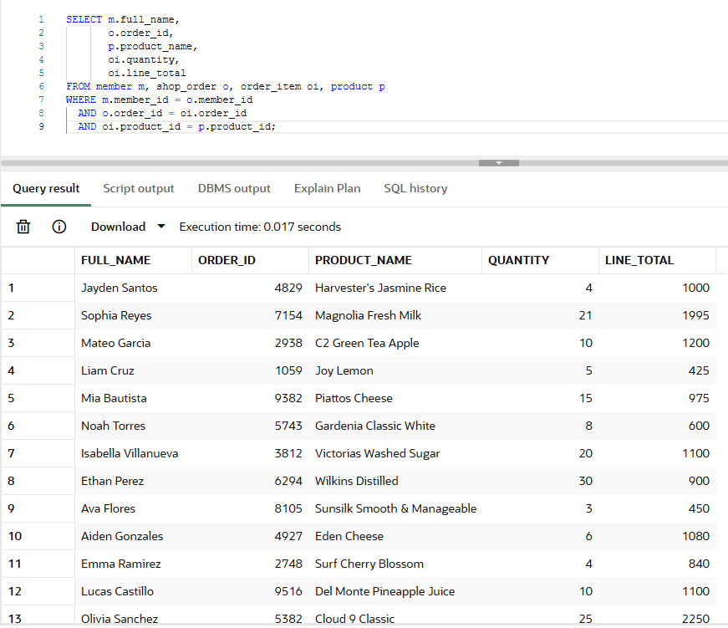

ANSI/SQL 99 Syntax
SELECT m.full_name,
o.order_id,
p.product_name,
oi.quantity,
oi.line_total
FROM member m
JOIN shop_order o
ON m.member_id = o.member_id
JOIN order_item oi
ON o.order_id = oi.order_id
JOIN product p
ON oi.product_id = p.product_id;

Output:
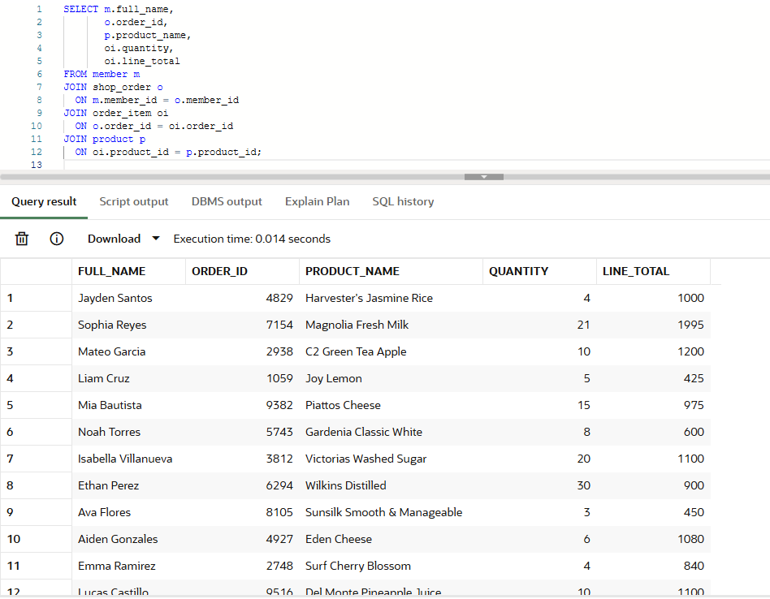

Description
- Both queries show the same information: member name, order ID, product name, quantity, and line total. The first uses the older Oracle join style, while the second uses ANSI join syntax.
Insights
- This creates a full transaction view that is useful for sales reports and order checking. It shows how data from several tables can be combined to tell the full story of a purchase. The cooperative can use this to inspect buying patterns, product movement, and member activity.

- Using Single-Row Subqueries to Solve Queries

Problem:
- The cooperative wants to find members whose share capital balance is higher than the average member balance.

Tables Used:
- SHARE_CAPITAL_ACCOUNT

Applied SQL Functions:
- AVG
- Single-row subquery

Solution:

Query:

SELECT member_id,
share_capital_balance
FROM share_capital_account
WHERE share_capital_balance >
(SELECT AVG(share_capital_balance)
FROM share_capital_account); -- compares each balance to the average

Output:
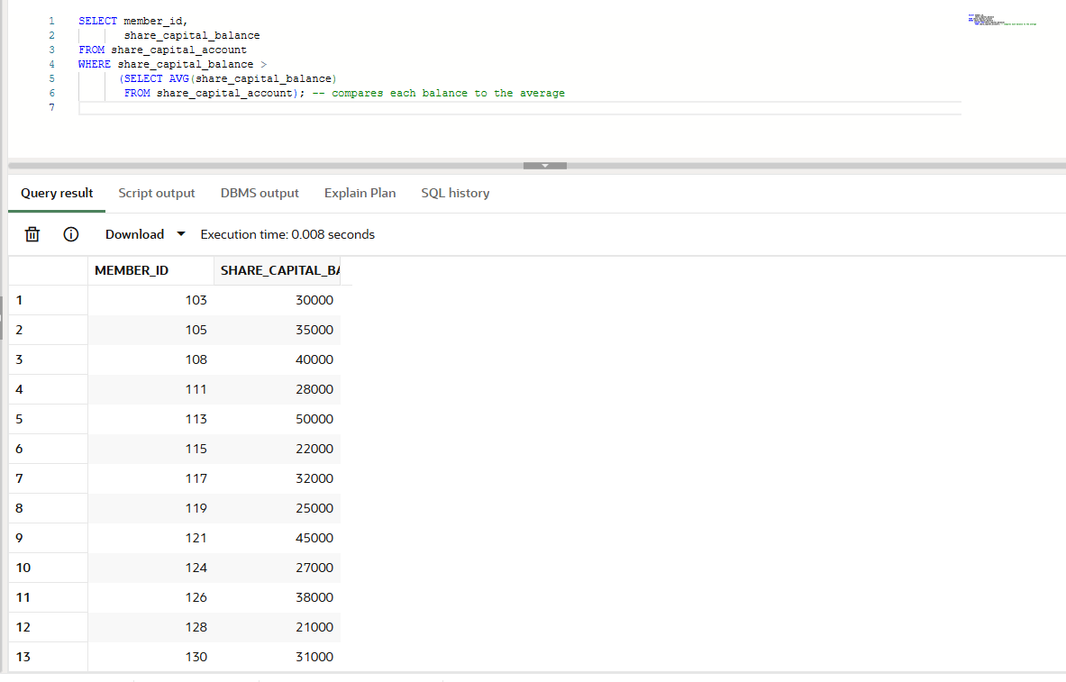
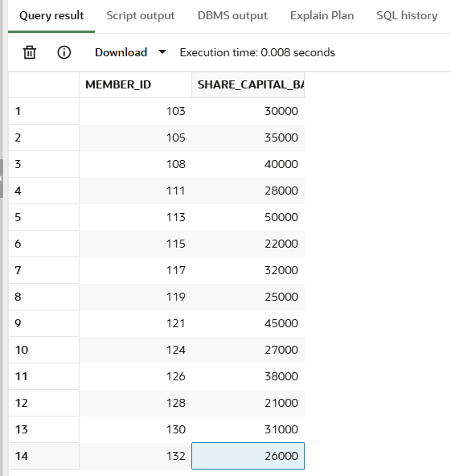
Description
- This query calculates the average share capital balance first, then finds all members whose balance is greater than that average.
Insights
- This identifies the stronger investors or more active capital contributors in the cooperative. It can help management understand who is building more equity in the organization. It also supports financial reporting and member classification.

- Using Multiple-Row Subqueries to Solve Queries

Problem:
- The cooperative wants to know which products were included in any non-cancelled orders.

Tables Used:
- PRODUCT
- ORDER_ITEM
- SHOP_ORDER

Applied SQL Functions:
- IN
- Multiple-row subquery

Solution:

Query:

SELECT product_id,
product_name
FROM product
WHERE product_id IN (
SELECT product_id
FROM order_item
WHERE order_id IN (
SELECT order_id
FROM shop_order
WHERE order_status <> 'Cancelled' -- keep only valid order records
)
);

Output:
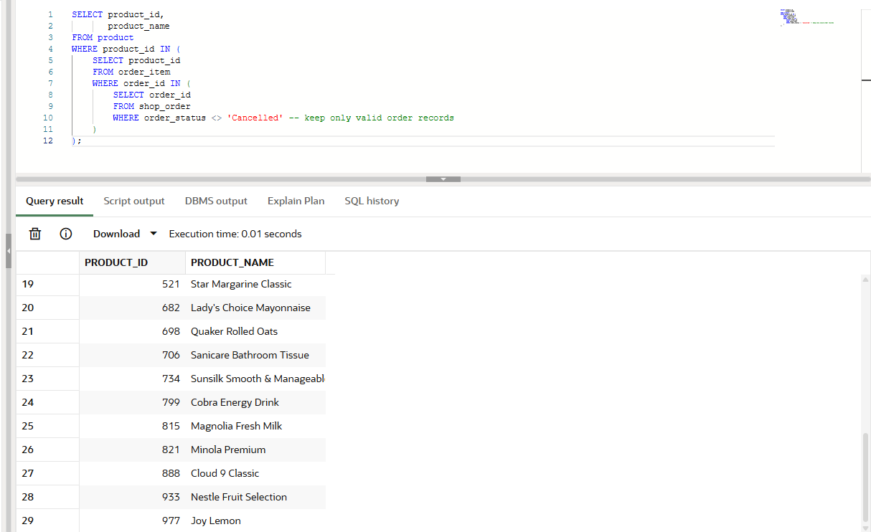
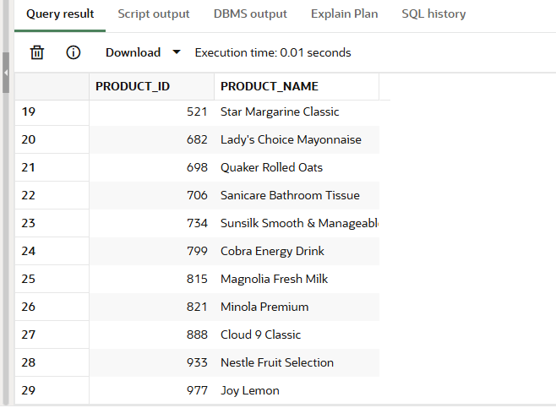
Description
- This query first finds all order IDs that are not cancelled, then gets all product IDs from those orders, and finally shows the product names that were actually purchased. As we can see, it only has 29 values, since in our previous problem, we identified that only 5 orders were cancelled out of 34 orders.
Insights
- This is useful for finding products with real demand, not just items stored in the database. It helps the cooperative identify which products are moving and which ones are actually part of completed business activity. This can guide inventory planning and purchasing decisions.

- Using the Set Operators

Problem:
- The cooperative wants one combined list of contact points from members and suppliers.

Tables Used:
- MEMBER
- SUPPLIER

Applied SQL Functions:
- UNION

Solution:

Query:

SELECT
full_name AS entity_name,
phone_number AS primary_contact,
'Member' AS stakeholder_type
FROM
member
WHERE
is_active = 1

UNION -- This combines the member and supplier table

SELECT
supplier_name AS entity_name,
contact_info AS primary_contact,
'Supplier' AS stakeholder_type
FROM
supplier
ORDER BY
stakeholder_type, entity_name;

Output:

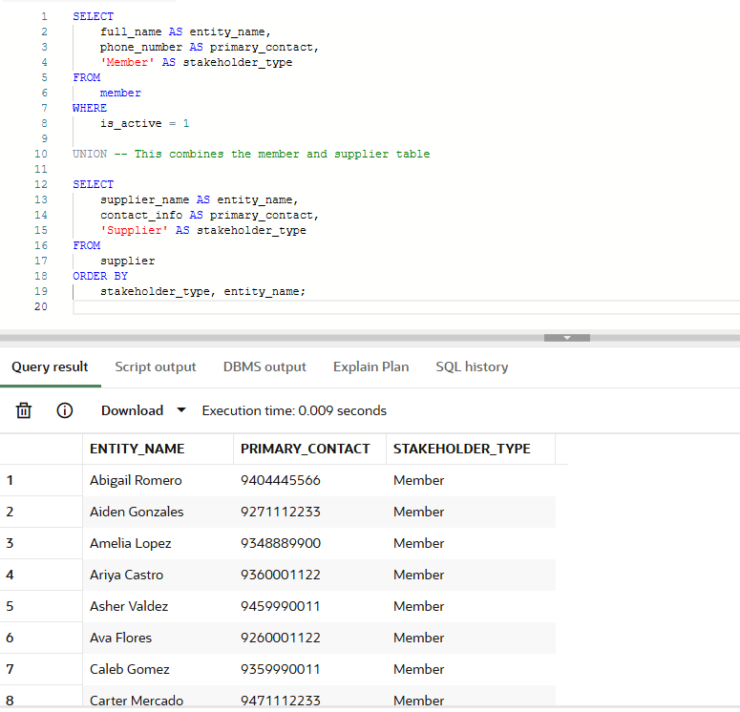
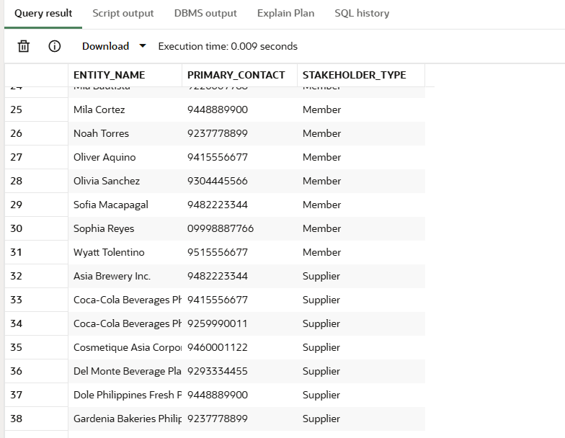
Description
- This query uses the UNION operator to merge two different tables into a single, unified "Master Directory" by aligning the names and phone numbers of both members and suppliers. It also injects a custom text label (stakeholder_type) into the results so the reader can instantly distinguish whether the contact belongs to a customer or a business partner.
Insights
- Administrators use this exact type of query during cooperative emergencies (like a sudden warehouse closure or typhoon) to export a clean, consolidated phonebook so they can send out mass SMS text alerts to everyone involved in the supply chain at the same time.

- Manipulating Data - INSERT, UPDATE, DELETE, SELECT

Problem:
- A brand-new customer (Member #135) registers with the cooperative specifically to suggest that we sell "Organic Wild Honey". The admin logs this new member and their 'Pending' request. Later, the honey is successfully sourced, so the admin updates the status to 'Completed'. Finally, the admin views the record to confirm the update, and then deletes the suggestion to keep the cooperative's historical data clean.

Tables Used:
- MEMBER (Parent Table)
- PRODUCT_SUGGESTION (Child Table)

Applied SQL Functions:
- INSERT
- UPDATE
- SELECT
- DELETE

Solution:

Query:

-- INSERT THE PARENT: Register the new member FIRST
INSERT INTO member (member_id, email, password_hash, full_name, phone_number, address, join_date, acquisition_platform_id, is_active)
VALUES (135, 'honey.lover@test.com', 'hashedpwd123', 'Juan Dela Cruz', '09171234567', 'Quezon City', SYSDATE, 1, 1);

-- INSERT THE CHILD: Make Suggestion 35, initializing BOTH statuses as 'Pending'
INSERT INTO product_suggestion (suggestion_id, member_id, product_name, description, status, date_submitted, supply_status)
VALUES (35, 135, 'Organic Wild Honey', 'Requesting pure, locally sourced organic honey for the store.', 'Pending', SYSDATE, 'Pending');

-- UPDATE: The item was sourced! Change BOTH statuses to 'Completed'
UPDATE product_suggestion
SET status = 'Completed',
supply_status = 'Completed'
WHERE suggestion_id = 35;

-- SELECT: Verify the dual-column update was successful
SELECT suggestion_id, product_name, status, supply_status, date_submitted
FROM product_suggestion
WHERE suggestion_id = 35;

-- DELETE: Clean up the data! (Child first, then Parent)
DELETE FROM product_suggestion WHERE suggestion_id = 35;

Output:
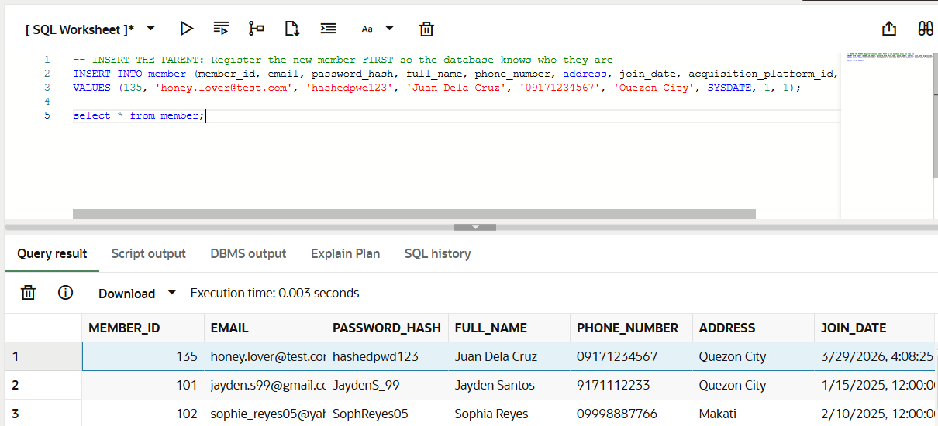
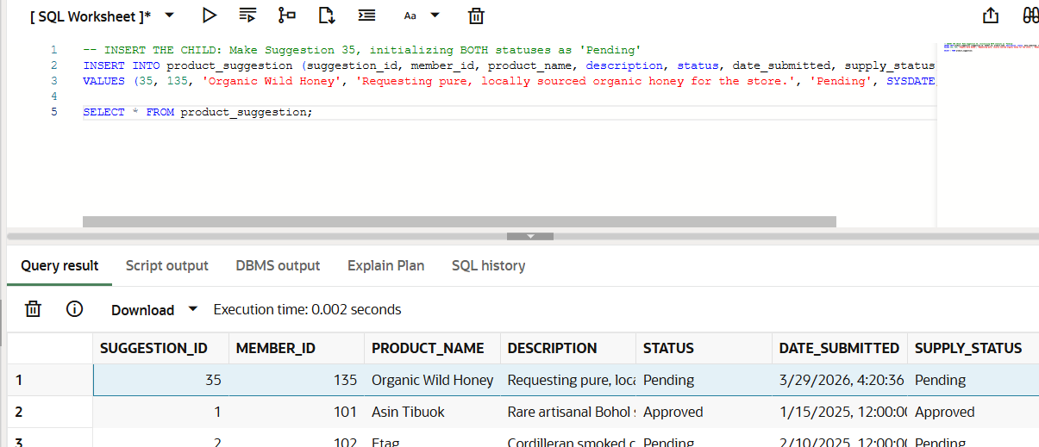
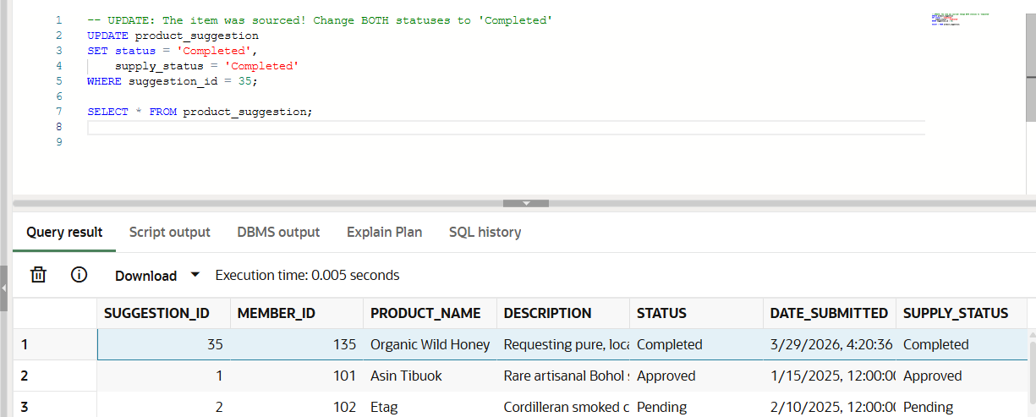
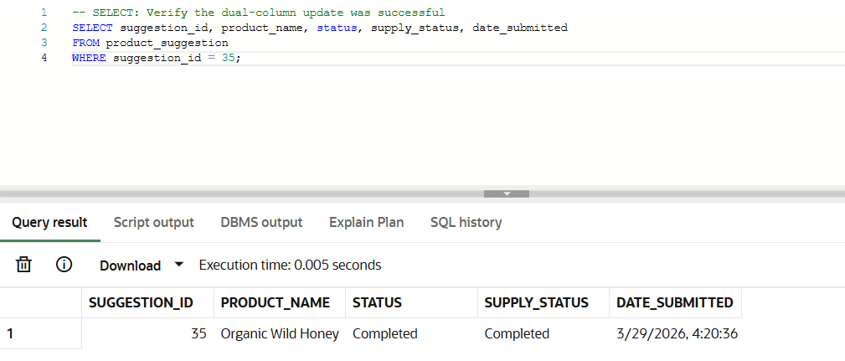
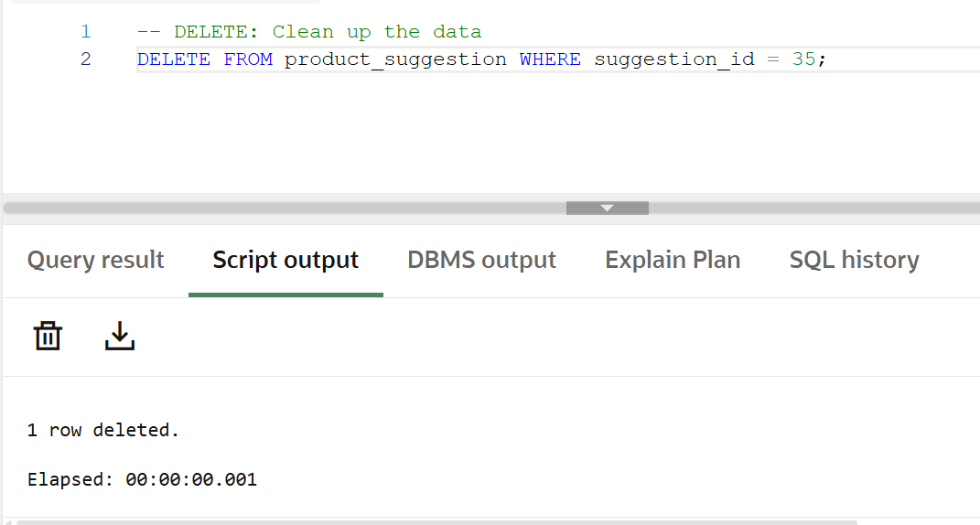

Description
- This script demonstrates relational data flow and multi-column modification. The INSERT commands register a new user and log their product request with initial 'Pending' values, establishing a valid Foreign Key relationship. The UPDATE statement simultaneously modifies two separate columns (status and supply_status) to 'Completed' to reflect the sourced request. The SELECT statement fetches the updated row for visual confirmation. Finally, the two DELETE statements remove the test records in the correct constraint-safe order to leave the original dataset untouched.
Insights
- This sequence highlights the strict enforcement of referential integrity in a relational database. It proves that the system realistically mirrors business logic—requiring user registration before system interaction and properly initializing column states—while successfully demonstrating how to update multiple data points at once during the complete CRUD l(Create, Read, Update, and Delete) lifecycle.

- Using DDL Statements to Create and Manage Tables

Problem:
- The cooperative wants to add a store branch table for pickup locations and link it to orders.

Tables Used:
- PICKUP_STORE
- SHOP_ORDER

Applied SQL Functions:
- CREATE TABLE
- ALTER TABLE
- RENAME
- DROP

Solution:

Query:

-- CREATE: Build the new pickup store table
CREATE TABLE pickup_store (
store_id NUMBER PRIMARY KEY,
store_name VARCHAR2(120) NOT NULL UNIQUE,
location VARCHAR2(255) NOT NULL
);

-- ALTER (Add Column): Add a new column to the existing shop_order table
ALTER TABLE shop_order
ADD store_id NUMBER;

-- ALTER (Add Constraint): Link the two tables together using a Foreign Key
ALTER TABLE shop_order
ADD CONSTRAINT fk_order_store
FOREIGN KEY (store_id)
REFERENCES pickup_store(store_id);

-- RENAME: The cooperative rebrands "Pickup Stores" to "Branch Stores"
RENAME pickup_store TO branch_store;

-- DROP & CLEANUP: The program is cancelled. Remove the dummy data safely.
-- Drop the foreign key constraint first
ALTER TABLE shop_order
DROP CONSTRAINT fk_order_store;

-- Drop the column we added to shop_order so it goes back to normal
ALTER TABLE shop_order
DROP COLUMN store_id;

-- Finally, drop the new dummy table completely
DROP TABLE branch_store;

Output:
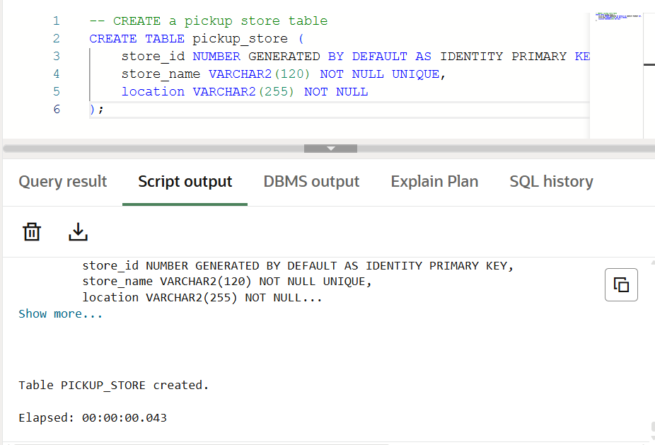
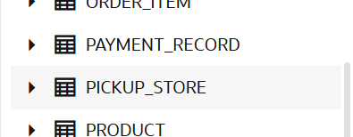
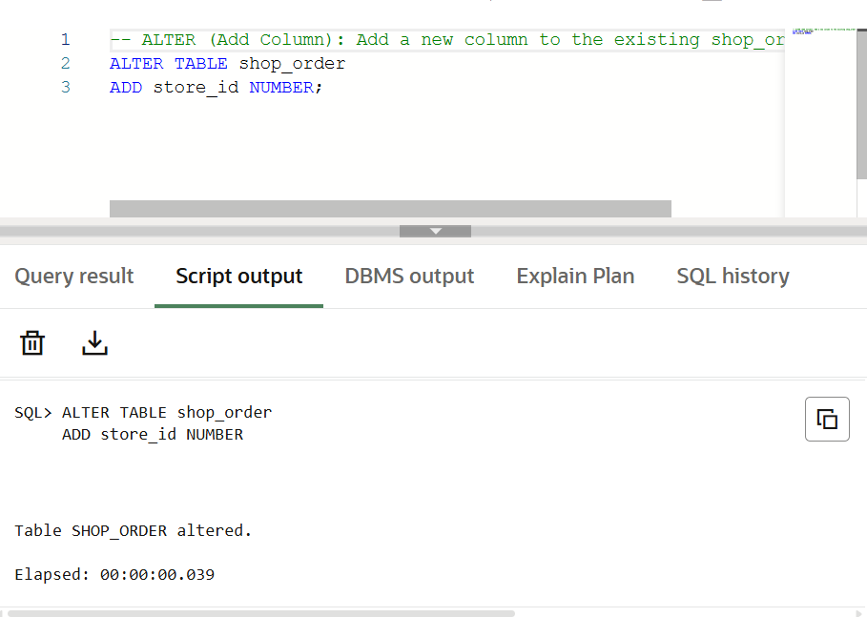
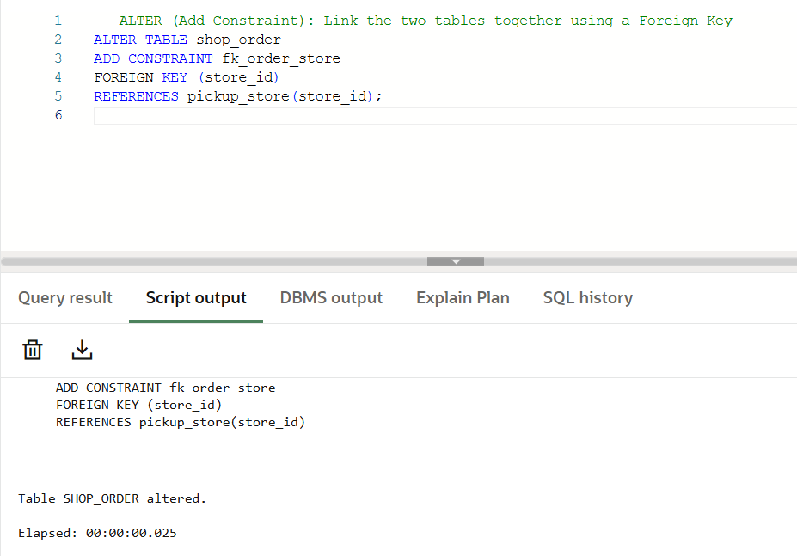
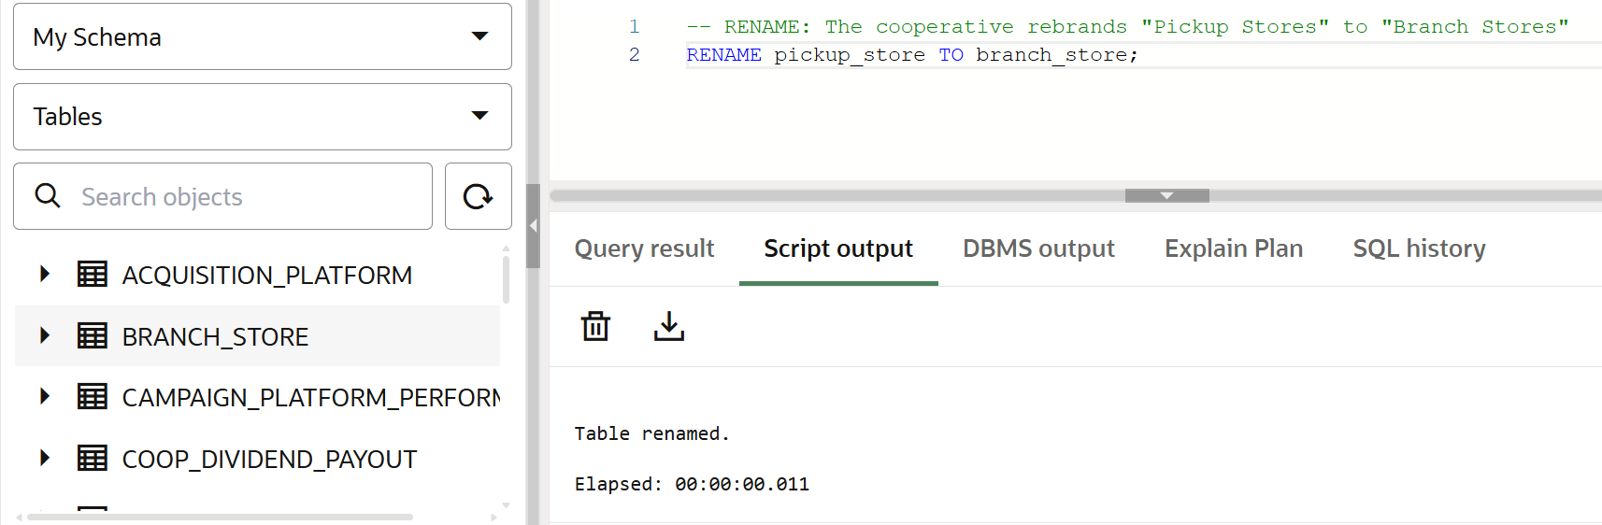
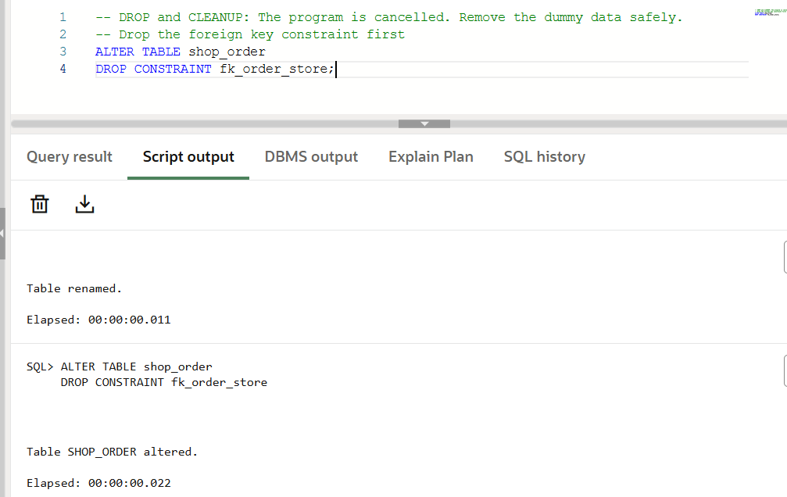
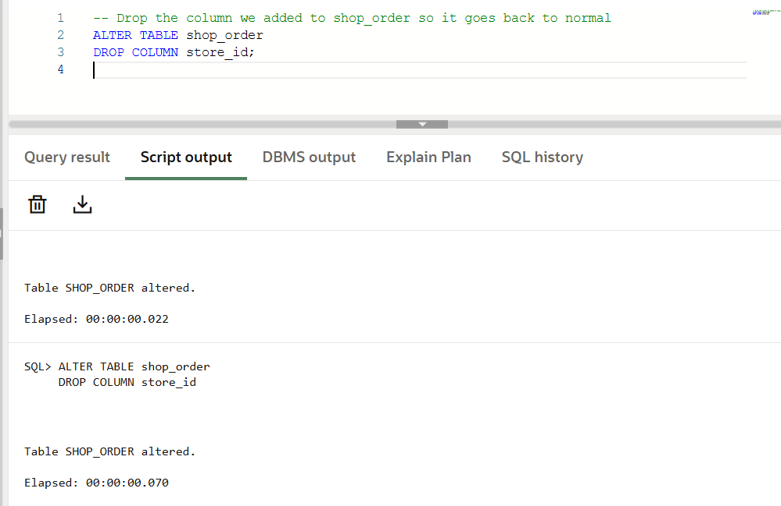
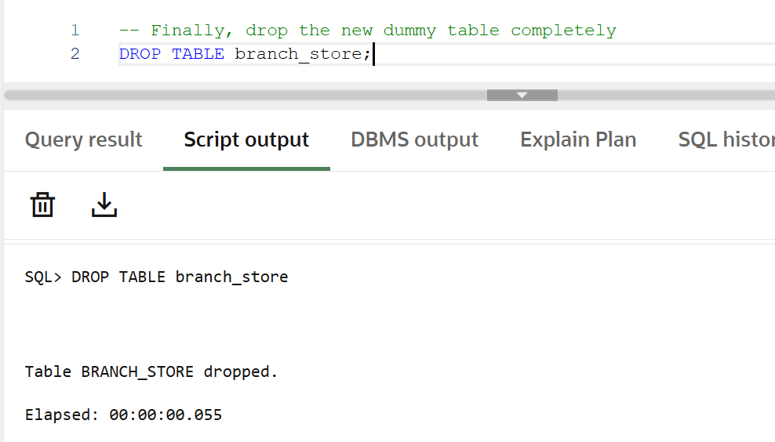

Description
- This script demonstrates the complete lifecycle of database schema modifications. CREATE TABLE establishes a brand-new architectural entity. The ALTER TABLE command is used sequentially: first to physically add a new column (store_id) to an existing table, and second to enforce referential integrity by making that column a Foreign Key. RENAME alters the object's identifier at the database level. Finally, DROP commands are carefully sequenced to remove the constraint, the altered column, and the table itself, perfectly restoring the schema to its original state.
Insights
- DDL is important because it changes the structure of the database itself. This is useful when the cooperative expands, adds new features, or redesigns a part of the system. It also shows how relationships are enforced through constraints.

- Creating Other Schema Objects - Table, View, Sequence, Index, Synonym

Problem:
- The cooperative wants reporting objects and helper objects that make querying faster and easier..

Tables Used:
- MEMBER
- SHOP_ORDER
- PRODUCT
- SUPPORT objects

Applied SQL Functions:
- CREATE TABLE
- CREATE VIEW
- CREATE SEQUENCE
- CREATE INDEX
- CREATE SYNONYM

Solution:

Query:

-- TABLE: Stores audit log for order changes
CREATE TABLE order_audit_log (
log_id NUMBER GENERATED BY DEFAULT AS IDENTITY PRIMARY KEY,
order_id NUMBER NOT NULL,
action_taken VARCHAR2(100) NOT NULL,
action_date TIMESTAMP DEFAULT SYSTIMESTAMP NOT NULL
);

-- VIEW: Summarizes purchases per member
CREATE VIEW member_order_summary AS
SELECT m.member_id,
m.full_name,
COUNT(o.order_id) AS total_orders,
SUM(o.final_total_applied) AS total_spent
FROM member m
JOIN shop_order o ON m.member_id = o.member_id
GROUP BY m.member_id, m.full_name;

-- SEQUENCE: Generates sequential numbers (e.g., for support tickets)
CREATE SEQUENCE seq_support_log
START WITH 1
INCREMENT BY 1;

-- INDEX: Speeds up searching orders by their status
CREATE INDEX idx_shop_order_status
ON shop_order(order_status);

-- SYNONYM: Creates a shorter alias for the shop_order table
CREATE SYNONYM orders FOR shop_order;

-- Test Table: Insert a log and view it
INSERT INTO order_audit_log (order_id, action_taken) VALUES (5001, 'Status manually verified');
SELECT * FROM order_audit_log;

-- Test View: Query the virtual summary table directly
SELECT * FROM member_order_summary ORDER BY total_spent DESC;

-- Test Sequence: Generate the first ticket number from the sequence
SELECT seq_support_log.NEXTVAL AS new_ticket_number FROM dual;

-- Test Index: Querying by status now uses the index behind the scenes for faster retrieval
SELECT order_id, order_status FROM shop_order WHERE order_status = 'Completed';

-- Test Synonym: Query the table using our new, shorter nickname
SELECT order_id, final_total_applied FROM orders;

-- CLEAN UP AND DROP OBJECTS
DROP TABLE order_audit_log;
DROP VIEW member_order_summary;
DROP SEQUENCE seq_support_log;
DROP INDEX idx_shop_order_status;
DROP SYNONYM orders;

Output:
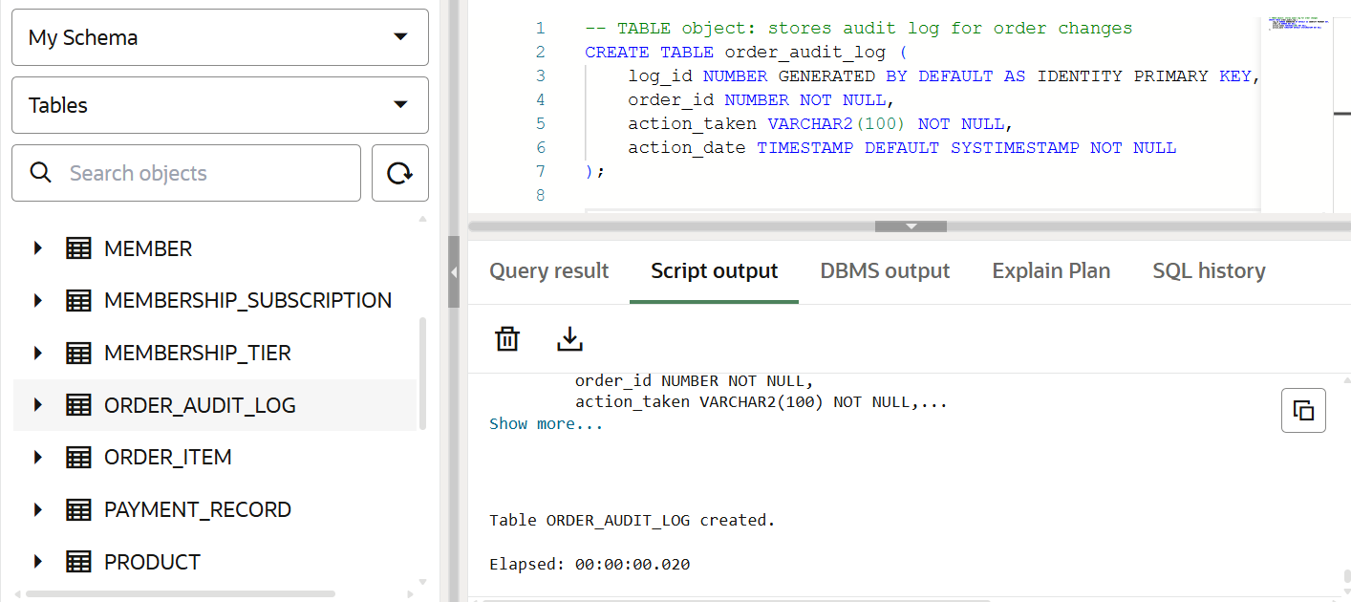
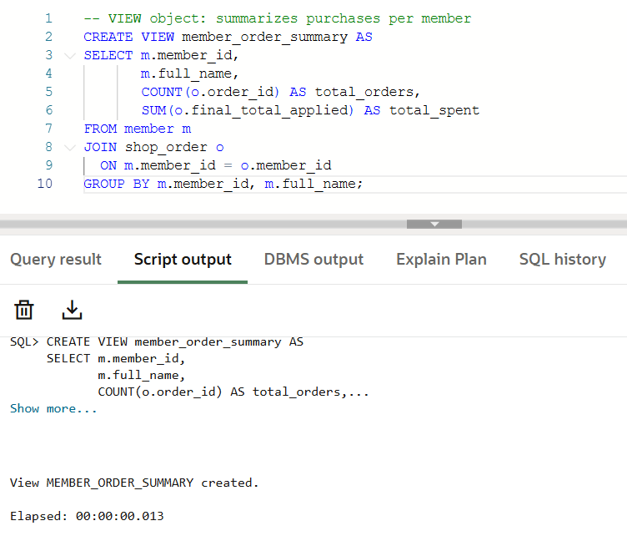
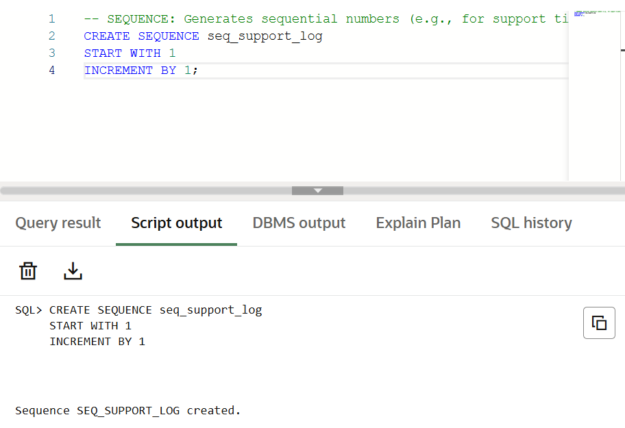
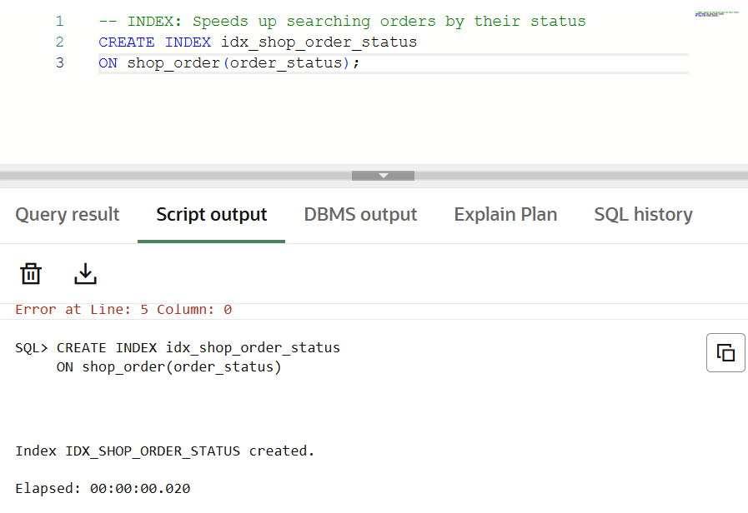
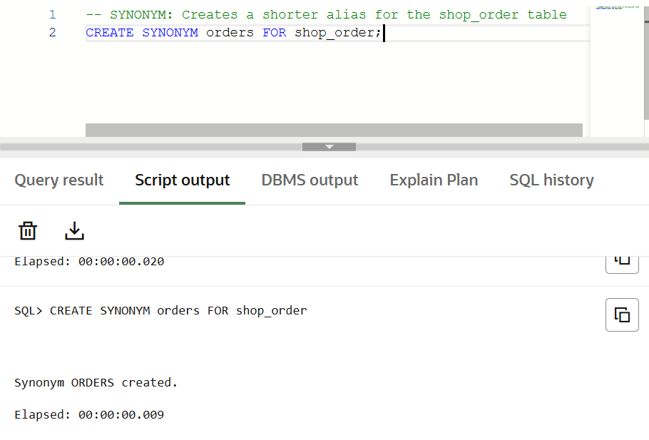
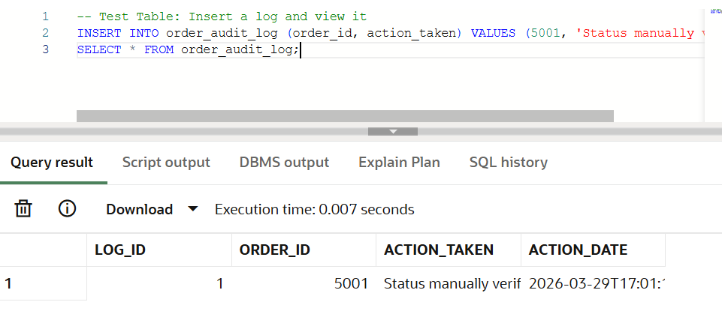
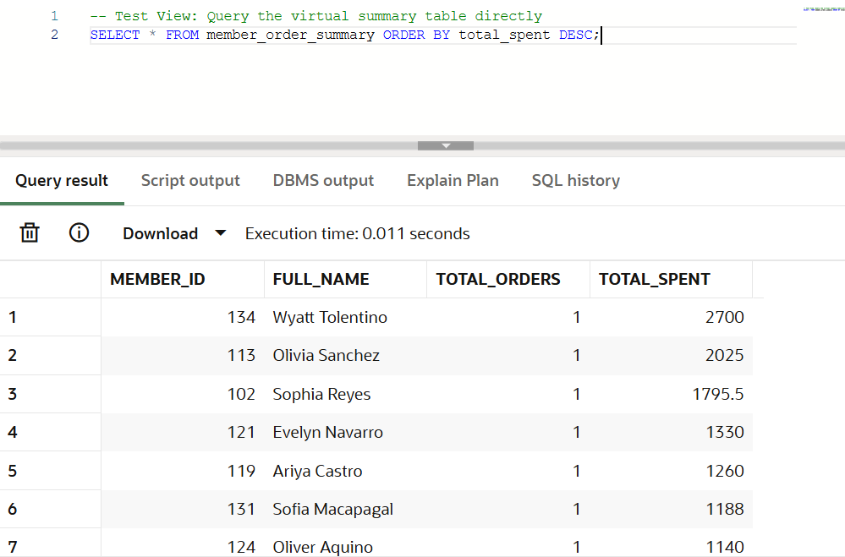
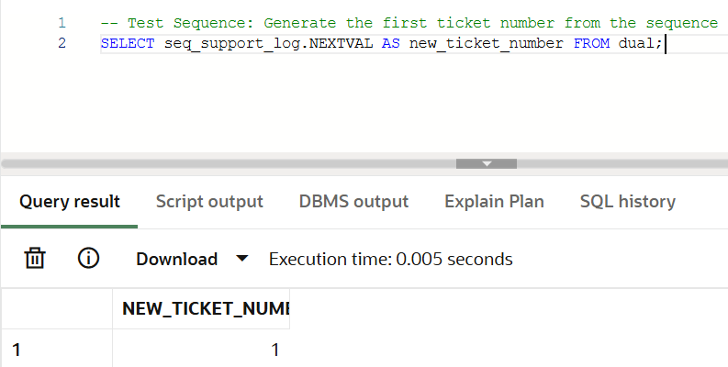
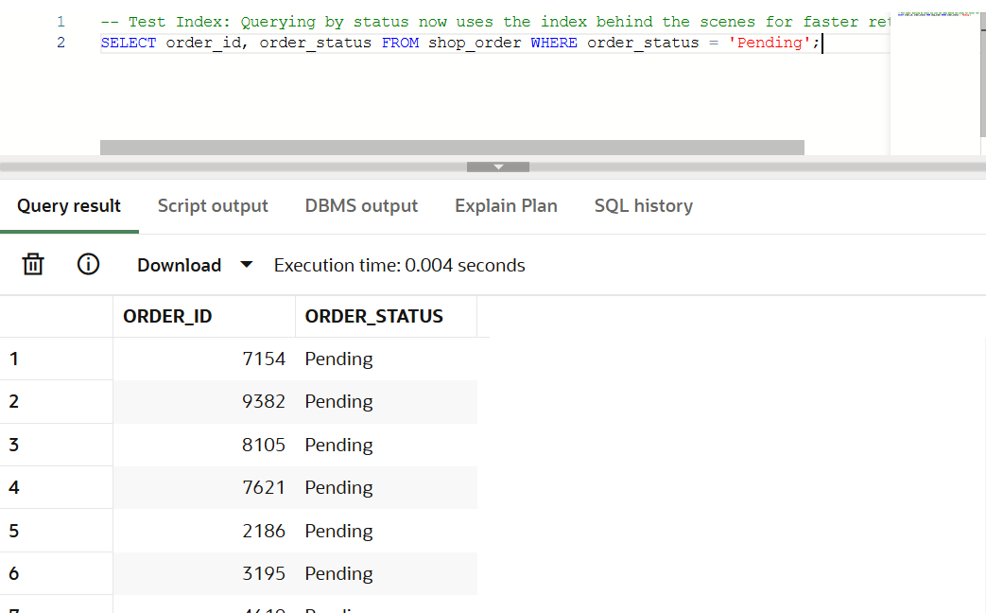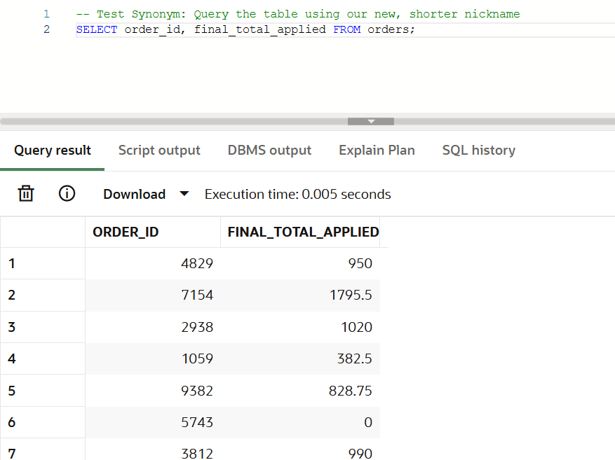
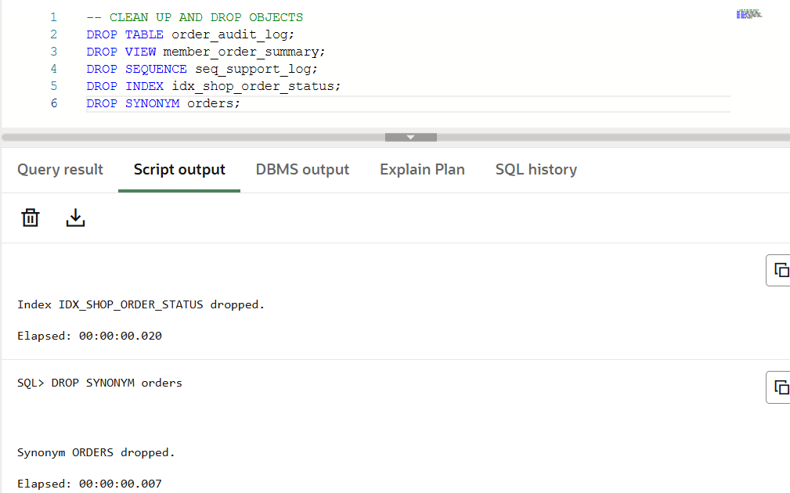

Description
- This comprehensive script executes in three phases. Phase 1 uses CREATE statements to generate five distinct database schema objects: a physical table, a virtual table (View), a number generator (Sequence), a performance booster (Index), and an alternate name (Synonym). Phase 2 uses INSERT and SELECT to interact with each object, proving they function correctly within the database ecosystem. Phase 3 uses DROP statements to safely remove all five objects, restoring the database to its exact original state. The table stores audit logs, the view summarizes member purchases, the sequence provides auto-numbering for a demo object, the index improves searching, and the synonym gives a shorter name for the orders table.
Insights
- These schema objects improve performance, simplify reports, and make the database easier to use. A view is helpful for frequent summaries, an index improves searching speed, and a synonym makes SQL shorter and cleaner. Even though your main tables already use identity columns, the sequence is still useful as a schema-object demonstration for the course requirement.

- Compilation of Errors
Problem 1: Foreign Key mapping failures during transaction entry Error: ORA-02291: integrity constraint violated - parent key not found Failing Query:
-- Attempting to create an order for a member_id (9999) that does not exist in the MEMBER table
-- Note: Ensuring all NOT NULL columns from the ERD are populated to isolate the FK error
INSERT INTO SHOP_ORDER (member_id, order_placed_at, subtotal_amount, discount_applied, final_total_applied, order_status, fulfillment_type)
VALUES (9999, SYSTIMESTAMP, 500.00, 0.00, 500.00, 'Pending', 'Delivery');
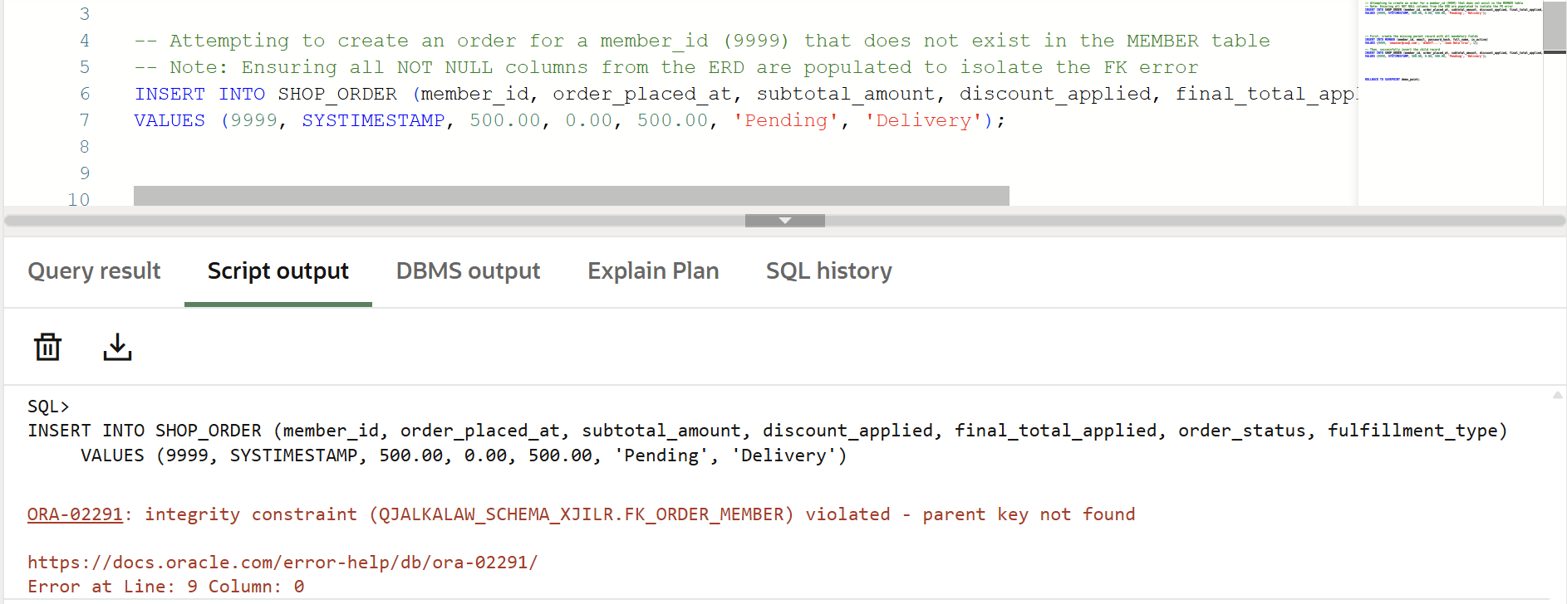
Recommended Solutions: Solution 1: Verify and insert the missing parent record first before executing the child transaction. Corrected Query:
-- First, create the missing parent record with all mandatory fields
INSERT INTO MEMBER (member_id, email, password_hash, full_name, is_active)
VALUES (9999, 'newuser@coop.com', 'd3a5f7...', 'Juan Dela Cruz', 1);

-- Then, successfully insert the child record
INSERT INTO SHOP_ORDER (member_id, order_placed_at, subtotal_amount, discount_applied, final_total_applied, order_status, fulfillment_type)
VALUES (9999, SYSTIMESTAMP, 500.00, 0.00, 500.00, 'Pending', 'Delivery');
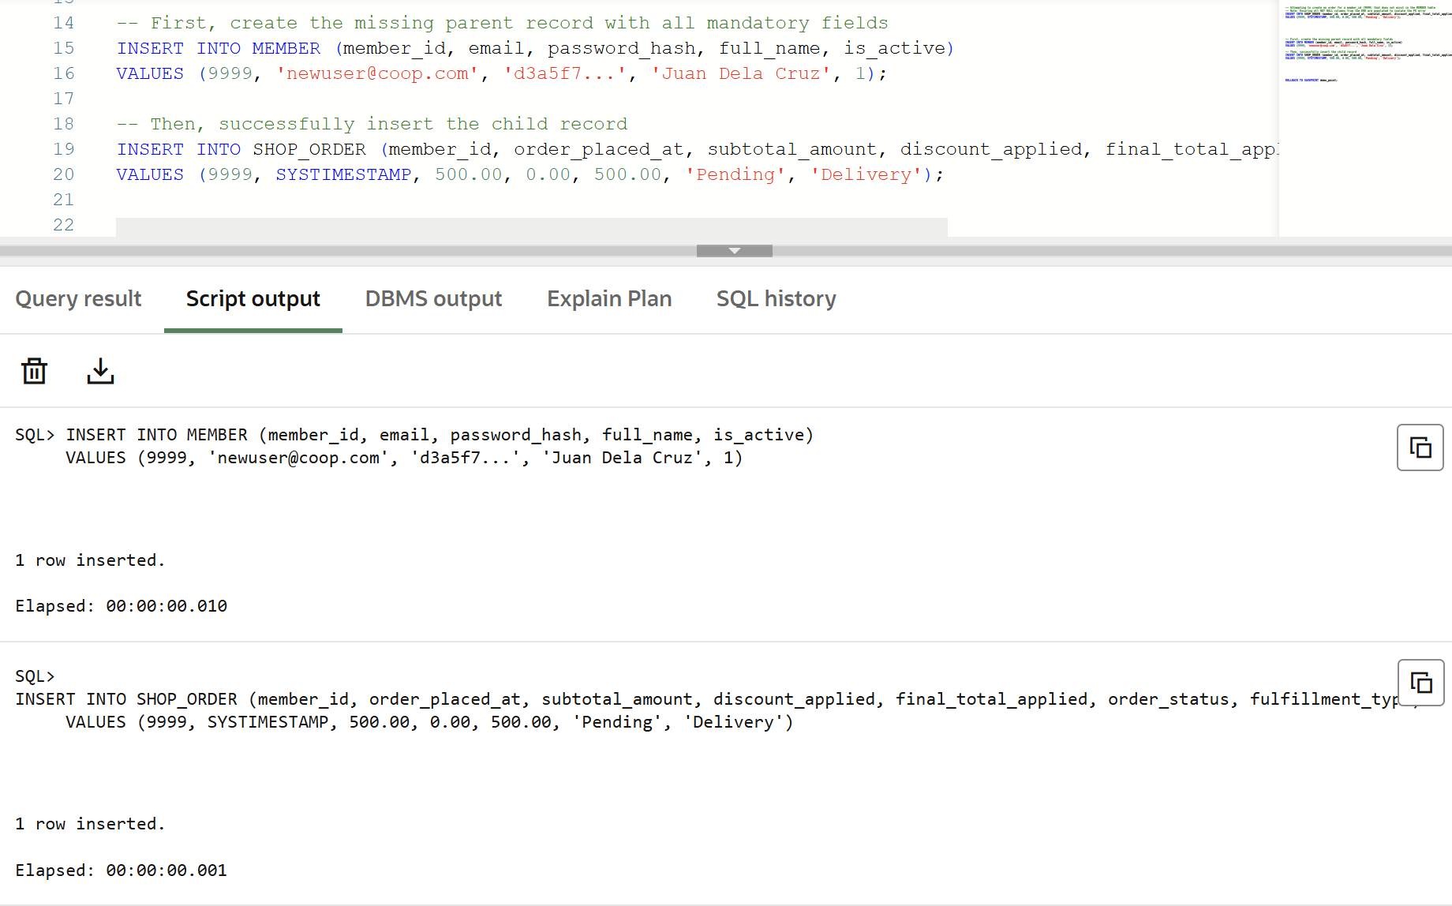
Reference: https://docs.oracle.com/en/error-help/ora/ora-02291/ Solution 2: Ensure you are using a known, existing member_id currently loaded in your Live SQL session. Corrected Query:
-- Query existing members first to ensure statistical integrity of the reference data
SELECT member_id FROM MEMBER;

-- Use a valid ID from the result (e.g., ID 1)
INSERT INTO SHOP_ORDER (member_id, order_placed_at, subtotal_amount, discount_applied, final_total_applied, order_status, fulfillment_type)
VALUES (1, SYSTIMESTAMP, 500.00, 0.00, 500.00, 'Pending', 'Delivery');
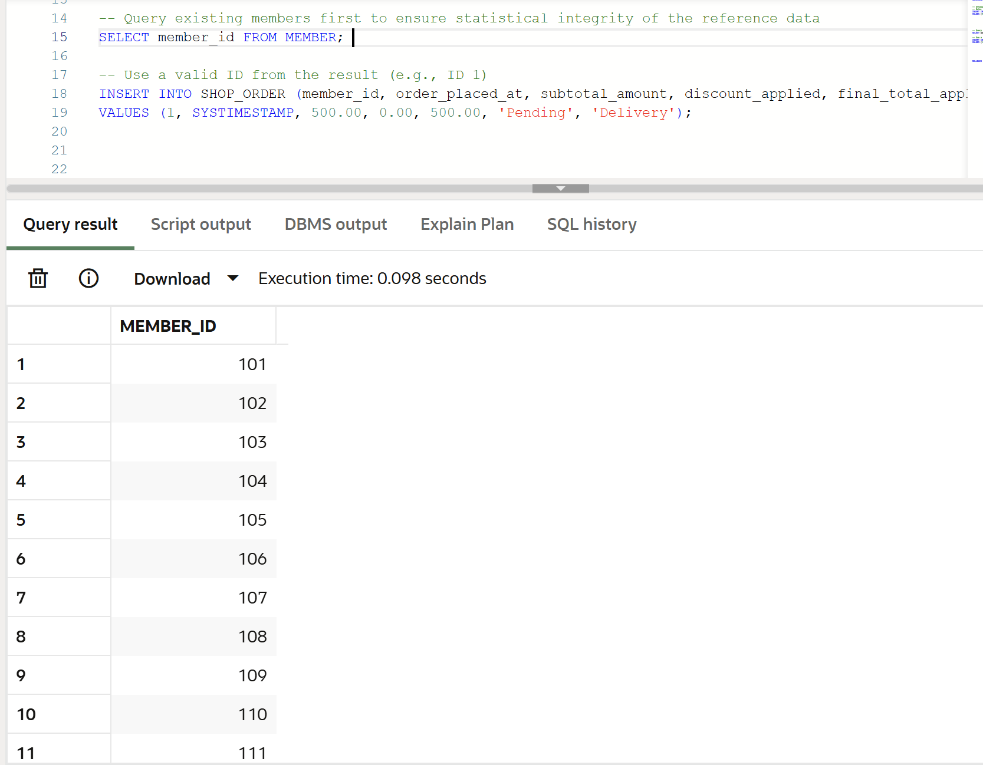
Reference: https://docs.oracle.com/database/121/SQLRF/statements_7002.htm#SQLRF01402
Problem 2: Accidental deletion of master reference data Error: ORA-02292: integrity constraint violated - child record found Failing Query:
-- Attempting to delete a member who already has active transactions in the SHOP_ORDER table
DELETE FROM MEMBER WHERE member_id = 1;
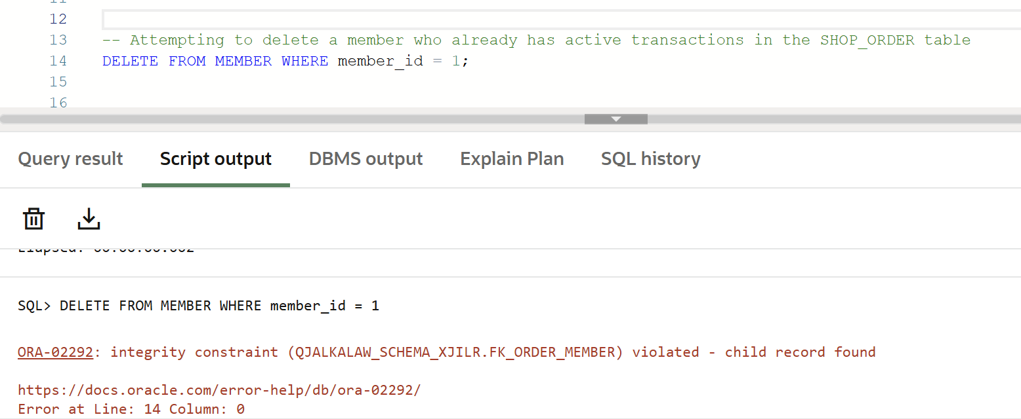
Recommended Solutions:
Solution 1: Perform a logical deletion (Soft Delete) by updating the is_active status flag to preserve historical analytics and prevent skewed aggregated data. Corrected Query:
-- Instead of deleting, deactivate the user to maintain descriptive statistics
UPDATE MEMBER
SET is_active = 0
WHERE member_id = 1;
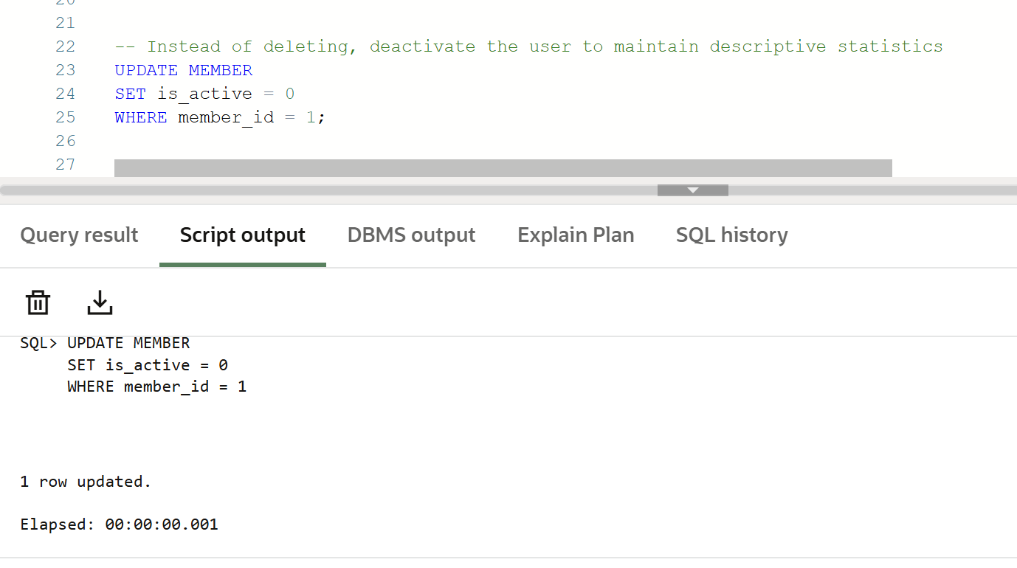
Reference: https://docs.oracle.com/en/error-help/ora/ora-02292/
Solution 2: If physical deletion is required, alter the specific table constraint (fk_order_member) to use ON DELETE CASCADE so dependent child records are automatically removed. Corrected Query:
-- Drop the restrictive constraint mapped in Phase 3 of the ERD
ALTER TABLE SHOP_ORDER DROP CONSTRAINT fk_order_member;

-- Re-add with CASCADE
ALTER TABLE SHOP_ORDER ADD CONSTRAINT fk_order_member
FOREIGN KEY (member_id) REFERENCES MEMBER(member_id) ON DELETE CASCADE;

-- The delete will now work and erase the member AND their orders
DELETE FROM MEMBER WHERE member_id = 1;
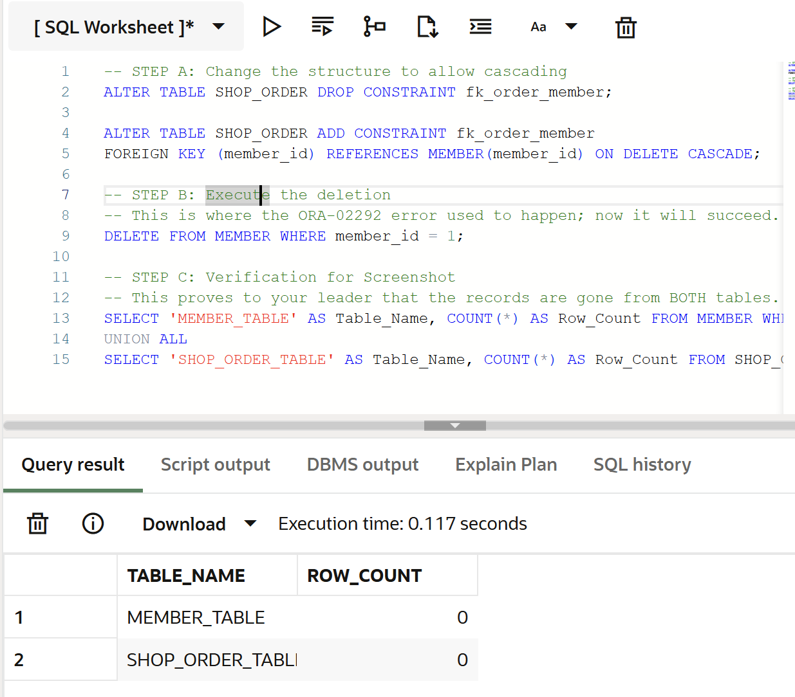
Reference: https://docs.oracle.com/database/121/SQLRF/clauses002.htm#SQLRF52208
Problem 3: Analytical subquery cardinality mismatch Error: ORA-01427: single-row subquery returns more than one row Failing Query:
-- Attempting to find orders for members in a specific region using an equal sign (=)
SELECT order_id, subtotal_amount
FROM SHOP_ORDER
WHERE member_id = (SELECT member_id FROM MEMBER WHERE address LIKE '%Quezon City%');
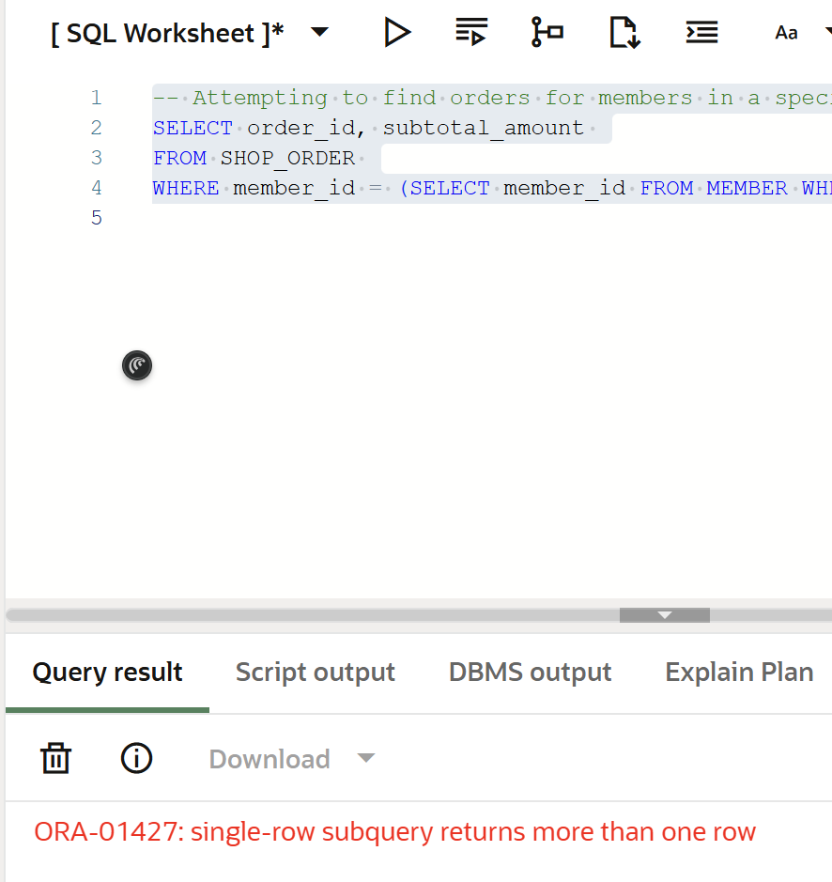
Recommended Solutions: Solution 1: Change the equality operator (=) to a multiple-row operator like IN. Corrected Query:
-- The IN operator correctly handles a set of IDs returned by the subquery
SELECT order_id, subtotal_amount
FROM SHOP_ORDER
WHERE member_id IN (SELECT member_id FROM MEMBER WHERE address LIKE '%Quezon City%');
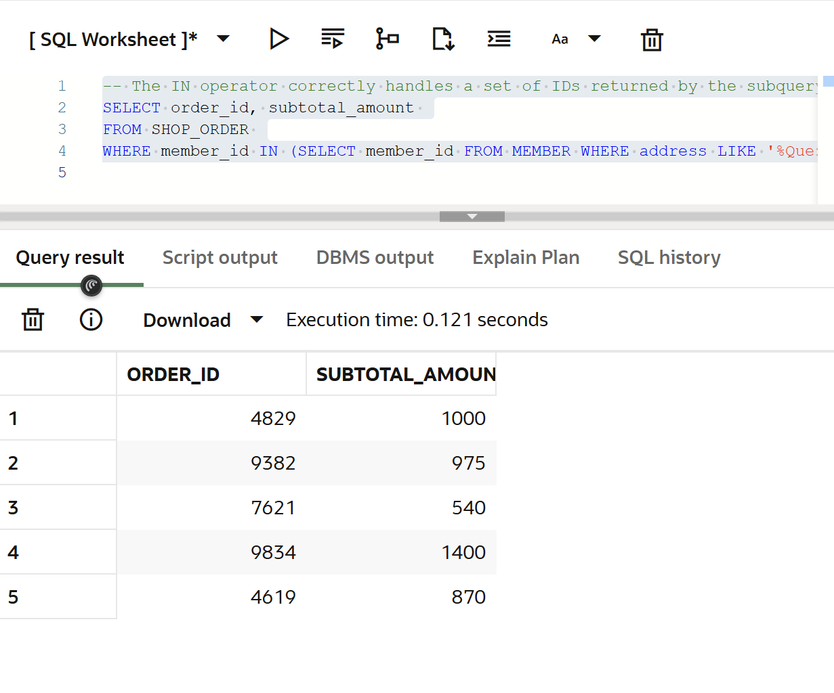
Reference: https://docs.oracle.com/en/error-help/ora/ora-01427/ Solution 2: Utilize an aggregation group function (e.g., MAX()) to mathematically guarantee only a single value is returned, though this introduces a deliberate bias into the selection. Corrected Query:
-- Forces the subquery to return only the single highest member_id in the target location
SELECT order_id, subtotal_amount
FROM SHOP_ORDER
WHERE member_id = (SELECT MAX(member_id) FROM MEMBER WHERE address LIKE '%Quezon City%');
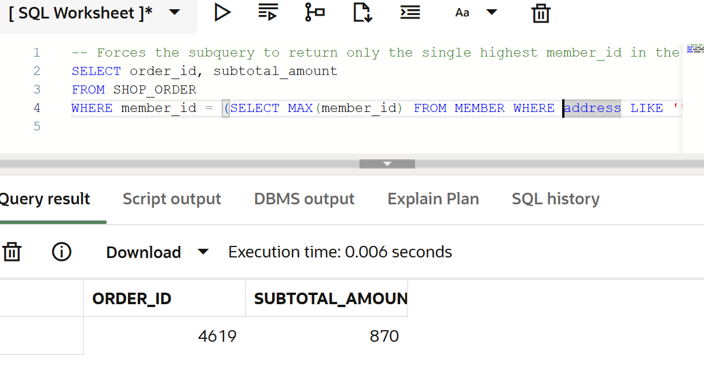
Reference: https://docs.oracle.com/database/121/SQLRF/queries007.htm#SQLRF52357
Problem 4: Misaligned column counts in set operations Error: ORA-01789: query block has incorrect number of result columns Failing Query:
-- Attempting to UNION two tables where the SELECT lists do not match in dimensional length
SELECT member_id, full_name, email FROM MEMBER
UNION
SELECT supplier_id, supplier_name FROM SUPPLIER;
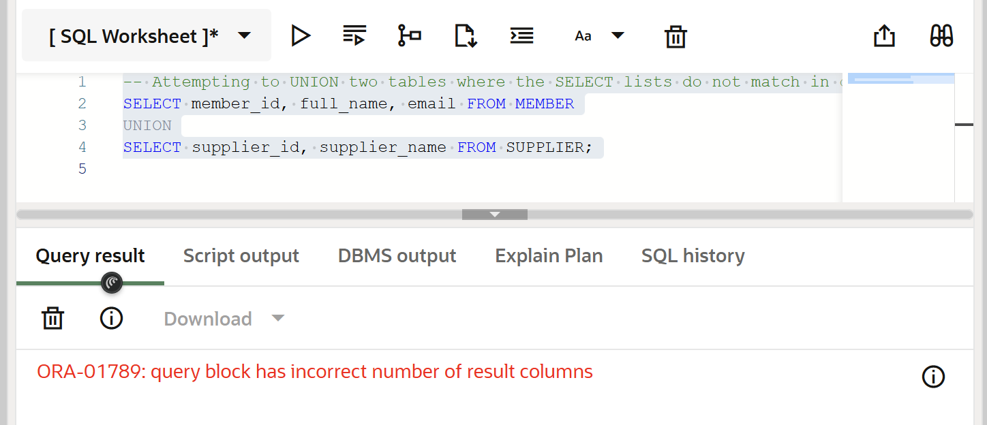
Recommended Solutions: Solution 1: Use dummy literal values (like NULL or 'N/A') to artificially match the column counts across the queries. Corrected Query:
-- Padding the second query with a NULL column to match the 3 columns of the first
SELECT member_id, full_name, email FROM MEMBER
UNION
SELECT supplier_id, supplier_name, NULL FROM SUPPLIER;
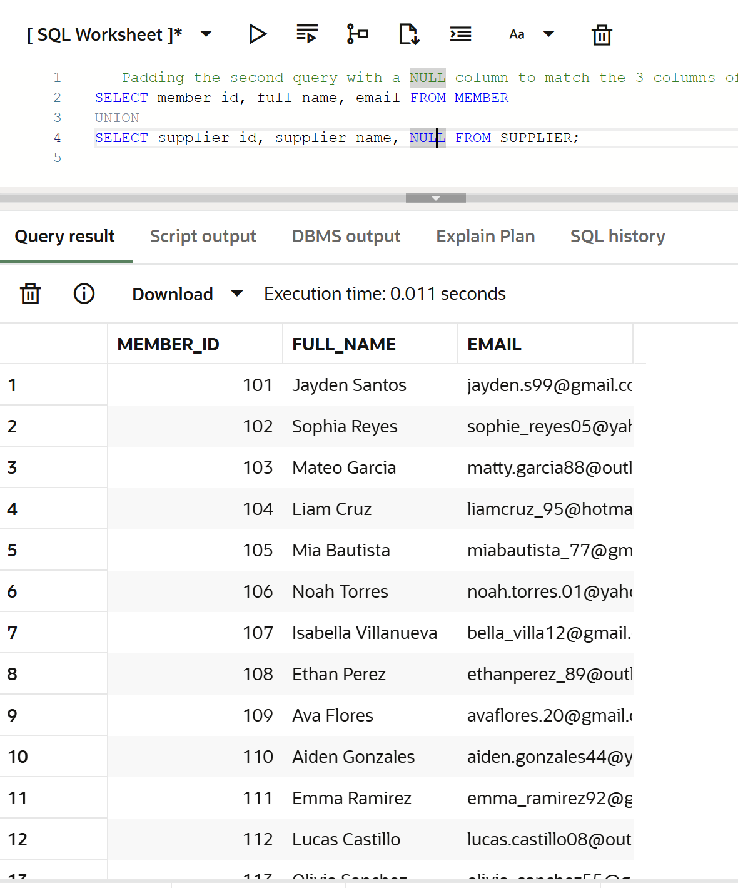
Reference: https://docs.oracle.com/en/error-help/ora/ora-01789/ Solution 2: Ensure data types and column counts match explicitly by converting data types to maintain strict type consistency. Corrected Query:
-- Only pulling the exact same number of columns with matching data types
SELECT TO_CHAR(member_id) AS id, full_name AS name FROM MEMBER
UNION
SELECT TO_CHAR(supplier_id) AS id, supplier_name AS name FROM SUPPLIER;
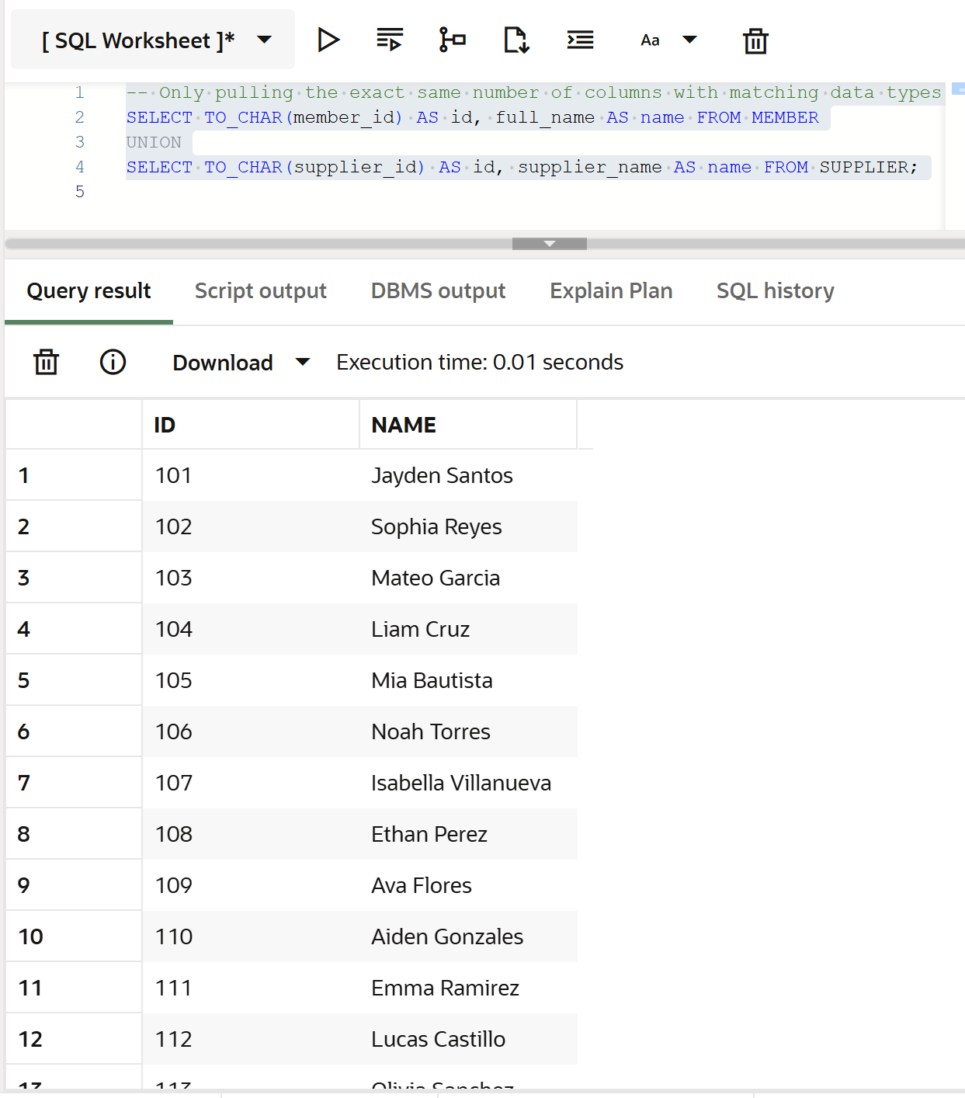
Reference: https://docs.oracle.com/database/121/SQLRF/queries004.htm#SQLRF52341
Problem 5: Sequence retrieval out of bounds in a transient session Error: ORA-08002: sequence CURRVAL is not yet defined in this session Failing Query:
-- Trying to check the current value of a custom sequence immediately after logging in
-- (Note: The ERD utilizes IDENTITY columns which handle this natively, but if a manual sequence is used for batching:)
CREATE SEQUENCE batch_seq START WITH 100;
SELECT batch_seq.CURRVAL FROM dual;
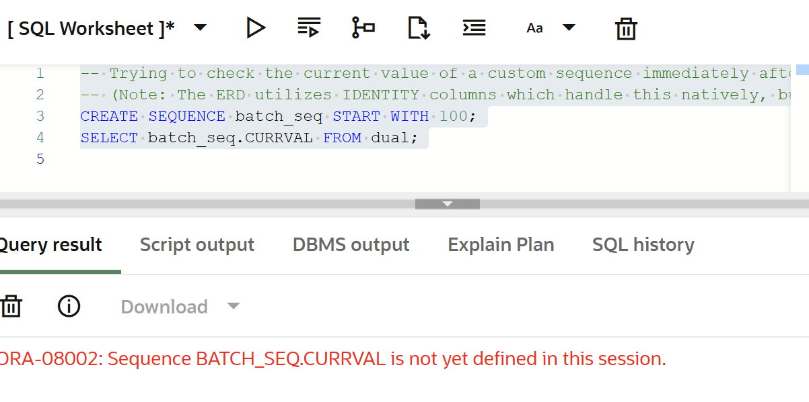
Recommended Solutions: Solution 1: Always execute NEXTVAL at least once in your current Live SQL session before attempting to call CURRVAL. Corrected Query:
-- Initialize the sequence logic in the session
SELECT batch_seq.NEXTVAL FROM dual;

-- Safely retrieve the current state
SELECT batch_seq.CURRVAL FROM dual;
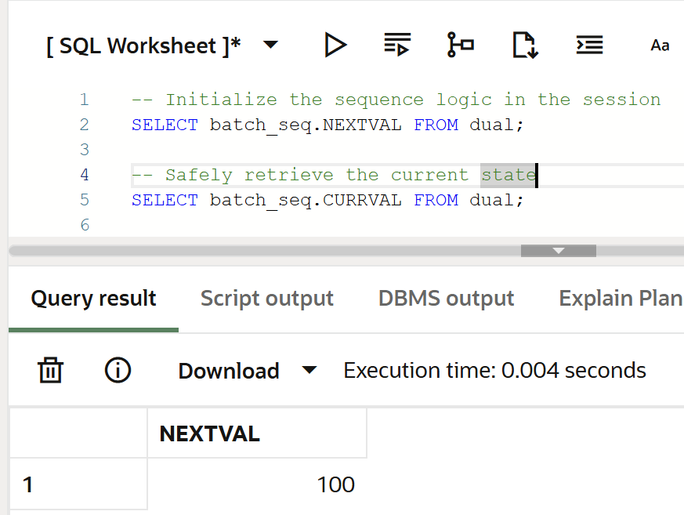
Reference: https://docs.oracle.com/en/error-help/ora/ora-08002/ Solution 2: Rely entirely on the ERD's exact architecture rather than manual sequences. Corrected Query:
-- Bypass manual sequences and utilize the GENERATED BY DEFAULT AS IDENTITY established in the ERD
INSERT INTO MEMBER (email, password_hash, full_name)
VALUES ('analytics@coop.com', 'h4sh...', 'Data Scientist');
-- The system automatically increments and assigns the member_id
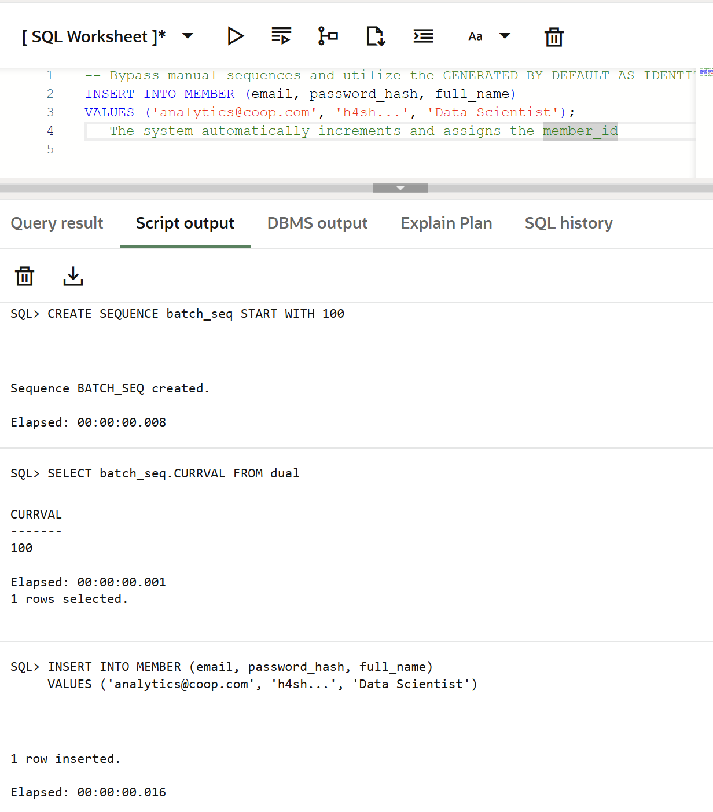
Reference: https://docs.oracle.com/database/121/SQLRF/statements_7002.htm#SQLRF52051
Problem 6: Modifying restricted analytical views Error: ORA-01402: view WITH CHECK OPTION where-clause violation Failing Query:
-- Creating an analytical view strictly for Active members
CREATE VIEW active_members_vu AS
SELECT * FROM MEMBER WHERE is_active = 1 WITH CHECK OPTION;

-- Attempting to insert an INACTIVE member (is_active = 0) through this view
INSERT INTO active_members_vu (email, password_hash, full_name, is_active)
VALUES ('johndoe@email.com', 'h4sh123', 'John Doe', 0);
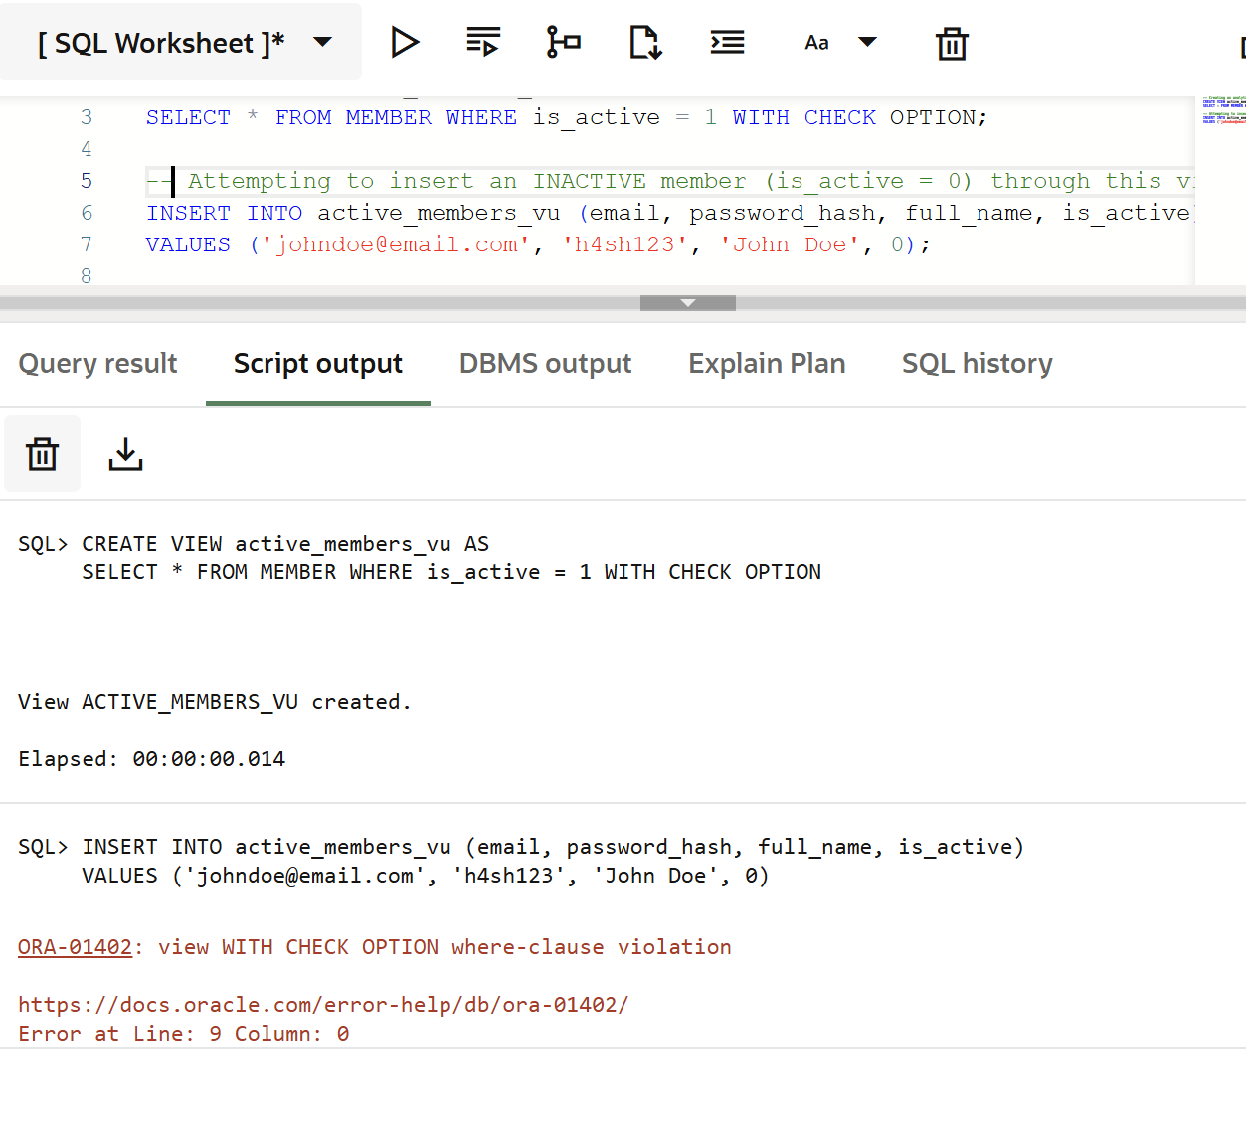
Recommended Solutions: Solution 1: Modify the target data in your statement to strictly comply with the view's WHERE condition. Corrected Query:
-- Insert the record with an is_active status of 1 to comply with the CHECK OPTION
INSERT INTO active_members_vu (email, password_hash, full_name, is_active)
VALUES ('johndoe@email.com', 'h4sh123', 'John Doe', 1);
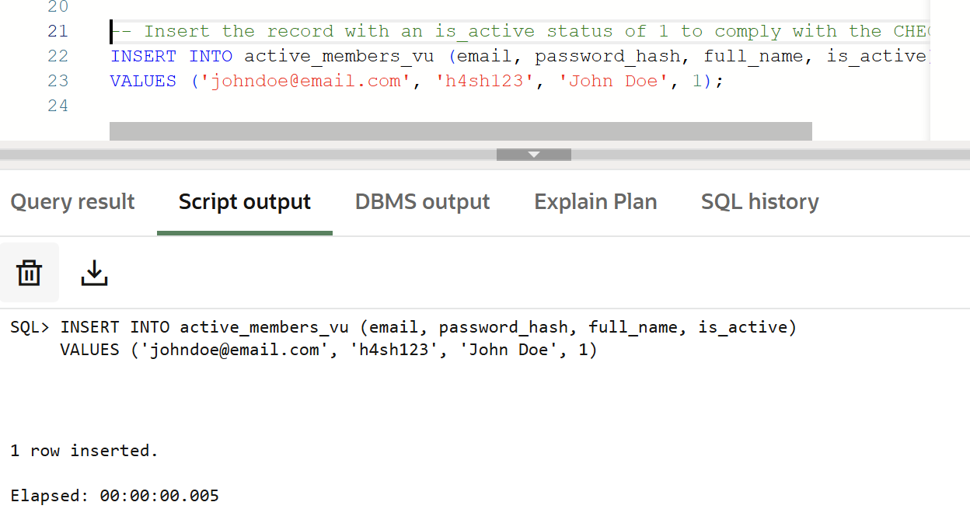
Reference: https://docs.oracle.com/en/error-help/ora/ora-01402/ Solution 2: If you must record out-of-bounds data to prevent sampling bias, bypass the restricted view and execute the DML directly on the underlying base table. Corrected Query:
-- Insert the inactive user directly into the master table instead of the restricted view
INSERT INTO MEMBER (email, password_hash, full_name, is_active)
VALUES ('johndoe_test2@email.com', 'h4sh123', 'John Doe', 0);
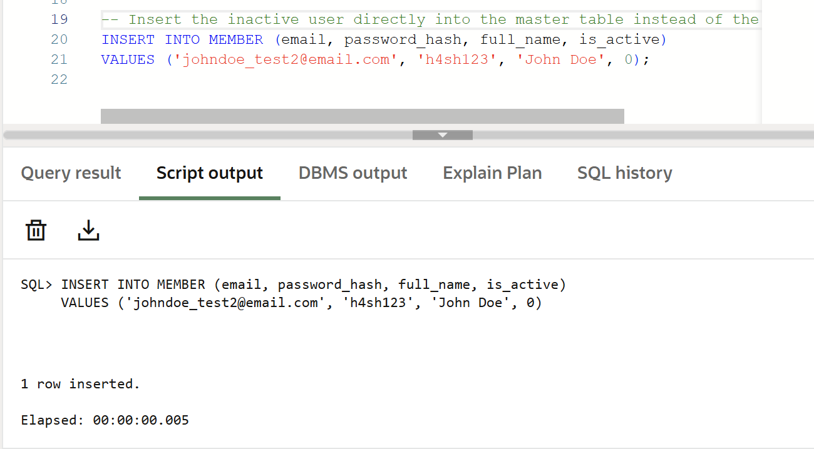
Reference: https://docs.oracle.com/database/121/SQLRF/statements_8004.htm#SQLRF01504

- References
Amsler, S. (2023). What is Inventory Management? Definition & Overview. [online] SearchERP. Available at: https://www.techtarget.com/searcherp/definition/inventory-management.
IBM (2022). Supply chain management. [online] Ibm.com. Available at: https://www.ibm.com/think/topics/supply-chain-management.
International Cooperative Alliance (2024). Cooperative identity, Values & Principles | ICA. [online] www.ica.coop. Available at: https://ica.coop/en/cooperatives/cooperative-identity.
LucidChart (2024). What is an Entity Relationship Diagram (ERD)? [online] Lucidchart. Available at: https://www.lucidchart.com/pages/er-diagrams.
Perera, N. (2025). ER Diagram Symbols Explained | A Beginner’s Guide | Creately. [online] Creately. Available at: https://creately.com/guides/er-diagram-symbols/.
Salesforce (2024). What is CRM? [online] Salesforce. Available at: https://www.salesforce.com/crm/what-is-crm/.
W3Schools (2019). SQL Constraints. [online] W3schools.com. Available at: https://www.w3schools.com/sql/sql_constraints.asp.

- Members’ contribution
Members Contributions
Members | ID Picture | Assigned Task
LEADER  Kalaw, James Andre |  | Creating tables, population of tables, Database Manager, Database Design, ERD, Module 4 SQL queries
Detera, Juliana Ysabel |  | Database Schema, Data gathering, Module 1 SQL queries
Ituralde, Josh Andrei |  | Data verifier, Data flow diagram, Compilation of errors, Module 5 SQL queries
Semilla, Mia Ysabel |  | Main GUI, Documentation, Database Verifier, Module 2 SQL queries
Palijado, Joseph Jennard |  | Context diagram, Documentation, Database table structure, Module 3 SQL queries

